Woolston Learning village Incorporating: Green Lane Community Special School, Foxwood Community Special School, Woolston Six Form College
Fire Risk Assessment Report
Woolston learning village
Adele Partridge, cmiosh, mifsm
Table of Contents
Introduction 2
Significant Findings – action plan 4
Fire Fighting Hazards - 1 4
1. School Description 6
2. Fire Detection System 9
3. Emergency Lighting 11
4. Fire Fighting Equipment 12
Fire Fighting Hazards - 1 13
5. Work Equipment 14
6. Sources of ignition allowing fire to start 15
7. Sources of fuel that may assist fire growth 16
8. Rapid fire and smoke spread 18
9. People cannot safely evacuate in the event of a fire 19
Safe Evacuation Hazards - 1 22
10. Emergency planning 23
11. Prioritising the fire safety recommendations 25
12. Review, revise & monitor on a regular basis. 25

Introduction
School Name | Woolston Learning Village
Address | Holes Lane  Woolston  WA1 4LS
Name of Head Teacher / Principle | Paul King, Head Teacher: Green Lane School  Lucinda Duffy, Head Teacher: Fox Wood School  Lynne Ledyard, Head Teacher: Six Form College
Name of Facilities Managers | Steve Dodd, Green Lane School  Gary Hall, Fox Wood School
Date of Inspection | Virtual interview 22/02/2021  Physical inspection 01/03/21
Date of Review – Annual; unless there are any changes to prompt earlier review | March 2022
Date of last inspection | 18/09/2019
Employer: | WBC
Who assisted with the audit? | Paul King, Steve Dodd and Gary Hall
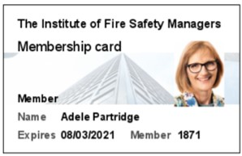
By
Adele Partridge, CMIOSH. MIFSM
M: 07894 860292
E: adele@hsincare.co.uk

Purpose of this report: Regulatory Reform (Fire Safety) Order 2005.

Under the Order there is a duty on the responsible person to ensure that general fire precautions are implemented to protect employees and others at the school. This will include ensuring that a suitable and sufficient fire risk assessment has been carried out. The Government document, Fire Safety Risk Assessment Educational Premises, is a guide that was developed to assist schools in meeting their legal duties by providing advice on both Fire Risk Assessments and Fire Precautions.

Fire Risk Assessment Process:

The Fire Risk Assessment has been carried out by a competent third party, who will be also responsible for subsequent reviews. To ensure that fire risk assessments are suitable and sufficient, the procedures have been broken down as follows:
1. Indication of Fire Hazards – Within or surrounding a building and identifying materials and/or substances that could start or fuel a fire. This includes any arson risks.
2. Persons at Risk – Every person within a building is considered to be at risk if a fire occurs. The need to identify persons who are likely to be at the building is essential in order that appropriate methods of evacuation can be established and implemented.
3. Identification of Defects & Breaches in Fire Safety – This will identify defects that will impact directly on the safe evacuation and performance of the building if a fire was to occur.
4. Review of Evacuation Procedures Testing Documentation - In order that all detection equipment is maintained in accordance with current regulations and recommendations and records of testing, maintenance and evacuation is reviewed.
5. Reviews of Fire Risk Assessments - Carrying out a full Fire Risk Assessment is not a one-off exercise. The introduction of new materials, processes, machinery and structural alterations to the premises may alter the risks to which employees are exposed.

It is essential that the Fire Risk Assessment is reviewed annually and updated accordingly when there are any material and significant changes. This report therefore incorporates such relevant information, significant findings and recommended actions that are considered necessary to demonstrate compliance with The Regulatory Reform (Fire Safety} Order 2005.

Information Source

Information for the completion of this assessment was obtained by a non-invasive physical inspection of the premise and inspection of records and drawings (where available). Information is provided within the report detailing which areas have been accessed and form part of the assessment. For accurate identification of hazard location, digital photographs are enclosed to 'pin-point' the specified hazard.

Significant Findings – action plan
Fire Risk Assessment Action Plan  Deficiency/Rectification summary | Due by date | Action by | Completion date
2. Fire Detection System
2.1 Contact Black Box and request an inventory of all smoke detectors across the whole site and ask for evidence that each detector, including void detectors in gym and the high level ones in sports hall, are tested on annual basis | 30/05/21 | SD/GH
4. Fire-fighting equipment
Fire Fighting Hazards - 1  Green Lane: Obtain the correct signage to be displayed above the fire extinguishers at top of 2nd staircase. | 31/03/21 | SD | 10/03/2021
6. Sources of ignition allowing fire to start
6.1 Sixth Form: Confirm that fixed appliances and portable appliances (plus frequency of testing) are inspected in the Sixth form kitchen. | 31/03/21 | GH
7. Sources of fuel allowing fire to grow
7.1 Green Lane School: Remove the damaged chair in corridor C27, which is no longer fire retardant. Remaining chairs to be sprayed with fire retardant solution. | 30/03/21 | SD | 01/03/21
7.2 Sixth Form: Chairs in corridor outside school office to be sprayed with fire retardant solution. | 30/03/21 | GH
9. People cannot safely evacuation in the event of a fire
9.1 Green Lane: Door no. 1 and Door no.2 should change direction leading to exit by the Head Teachers Office. | 31/08/21 | SD | TBA 23/08/2021?

Fire Risk Assessment Action Plan  Deficiency/Rectification summary | Due by date | Action by | Completion date
10. Emergency Planning
10.1 – All schools to review Fire Warden refresher training in 2021. Additional staff needed in Sixth form and all SLT’s that have become FW’s since October 2018 will require training. | 31/08/21 | HT/SBM

1. School Description
Description of School Premises
Fox Wood School, Green Lane Community Special School and Woolston Sixth Form College are all located in one building forming the Woolston Learning Village. Foxwood School and Green Lane School caters for pupils between the ages of 4 to 16. Woolston Sixth Form College is an educational establishment for 16 – 19 year old’s.

Fox Wood School and the Six Form College were both built in 2014 and are single story buildings. The Sixth Form building was part of the old Woolston High School – science and technology block but was totally refurbished in 2014. Part of Green Lane Community Special School dates back to the early 70’s, but underwent a complete refurbishment in 2014. The schools are linked by internal corridors and share some facilities such as the main kitchen facilities, Hydro pool and sports hall. The external play areas are segregated for each building.

The class sizes vary from 8 to 10 children in both Fox Wood School and Green Lane Special School, with approximately 140 staff split between both schools. Other persons working in the two schools on a daily basis include those employed through WBC LA including Cleaners and Kitchen Staff plus independent Teaching Staff and nursing / medical professionals. The Sixth Form consists of 33 students, with a total of 25 members of staff.

Parking areas are located at the front of each school entrance with allocated parking bays for school buses and a separate car park for staff and visitors. The site is accessed through a gated entrance, which is locked during out of school hours. Both schools are typical educational buildings consisting of teaching rooms, craft rooms, music rooms, cloakrooms, home economics room, cookery room, and extensive playgrounds. Additionally there is a sensory equipment room, medical room and hydro pool in Fox Wood Special School.

With regards to the Sixth Form this consists of 6 classrooms, Sensory room, Student Kitchen, Therapy rooms, Medical room, offices and a Staff room.

Electrical Equipment supplied throughout the building comprises of numerous PC’s, television display screens, microwaves, fridges, washing machine, dishwasher and sensory room equipment. Under floor heating is installed in some classrooms within Fox Wood School. Sources of ignition in the building will be derived primarily from electrical sources such as portable appliances, lighting, cooking equipment and the mains electrical system itself.

Description of Escape routes

Foxwood School: Emergency exit doors lead from all teaching rooms directly to the fire assembly points at the front of the school. The other rooms in the building, including administration rooms, cloakrooms, medical rooms and therapy rooms lead to the main corridor where there is no distance greater than 30m (including change of direction) for persons to reach the final point of exit. The structural fire protection has been achieved by creating a main corridor through the center of the building, with half hour fire rated doors separating all rooms. The electrical service cupboards are positioned behind 30-minute fire-rated doors.

Green Lane School: There are two staircases that lead people from the first floor to ground floor. There are ground floor emergency exit doors set along the corridors and further exit door from ground floor teaching rooms. The structural fire protection has been achieved by creating corridors on each floor i.e. half hour fire rated doors separating the staircases from the corridor and then further half hour door separating teaching rooms and offices.

Sixth Form College: Central corridors run from reception entrance to the student kitchen, with one additional corridor leading to an exit door at the front of the school premises. Suitable double door protection is provided along all corridors. Exit doors from the dining hall lead directly outside into a courtyard which has gated access to the front of the building.

The shared kitchen located in the middle of the building is protected with fire doors and two automatic closing shutters at the serving hatches – one serving Fox Wood pupils and the opposite side serving Green Lane pupils. Exit doors lead catering staff to the external yard and on to the front of the school.

Internal corridors surrounding the spa pool and large hall lead to the assembly point nearest to Green Lane School assembly area. Additional external exit points are sited off the large hall taking persons to the Green Lane assembly area.

Ground floor classrooms in Fox Wood and Green lane are fitted with emergency exit doors leading directly to the fire assembly points. There are two staircases in Greenlane that provide evacuation routes from the 1st floor, directly to the external areas. Some of the ground floor classrooms in Sixth Form college do not have external doors, but all lead onto the circulation corridor. There are several exit points along the circulation corridors so there is no distance greater than 45m (including change of direction) for a person to reach the final point of exit.

Description of Structural protection.

Greenlane school and Sixth form is constructed with brick wall and bitumen covered roof. Fox Wood school is constructed in FR-MDF (Formica cladding) set onto steel frame. The roof is metal clad onto steel frame. Internal walls are mainly block with plasterboard covering. All buildings would provide a fire resistancy to protect occupants and to allow a means of escape.

The structural fire protection has been achieved by isolating the main hall and dining hall from classrooms and offices by use of 30-minute fire resistant doors segregating evacuation routes.

The other rooms in the building, including administration rooms, cloakrooms, medical rooms, and therapy rooms lead to the main corridor where there is no distance greater than 30m (including change of direction) for persons to reach the final point of exit. The electrical service cupboards are positioned behind 30-minute fire-rated doors in the Fox Wood reception corridor and in the main plant room. There is an electrical switchboard unit in Class Q1 (C15) store cupboard, Green Lane school.

The fixtures and fittings installed in the school have been carefully chosen in compliance with current building regulations, encompassing fire safety measures. The composition of the floor surface in most corridors is a fire-rated floor covering, set onto a concrete base. A majority of lighting used in the school is fire-rated low voltage down lighting or strip lighting.

Number of Staff - including teachers, support staff, midday assistants | Green Lane: 90 including cleaners and MDA’s  Fox Wood: TBC  Sixth Form: TBC
Number of pupils | Green Lane: 175  Fox Wood: TBC  Sixth Form: TBC
Other people on premises

Actions carried out since last assessment. | The following action were identified in the last report, which have now been rectified:  4.6.1 Sixth Form: Door seal replaced on door leading to pupil kitchen.  4.6.2 Green Lane: Door seal replaced on double doors from entrance corridor to D Block.  4.7.1 Main Kitchen: Self-Closing device fitted to the office door  4.7.2 Green Lane: Self-Closing device fitted to the Staff Room door.  4.7.3 Green Lane: Self-Closing device fitted to the door exiting from Willow Green  7.15.1 Green Lane: Top of stairs leading to Willow Block –Evac Slide positioned near the top of the stairs  9.3.1 Sixth Form: copy of the Zone Plan positioned near to the fire panel.  9.5.1 Sixth Form: Head Teacher aware of how to operate the Fire Panel.
Have all H&S actions been carried out since the last risk assessment? | Due to current lockdown restrictions I was unable to access the follow location to check status or remedial action:  6.4.1 Main Kitchen: Install a smoke detector in the kitchen office.  6.4.1 Green Lane: Install a smoke detector in the cupboard within Class Q1 / C15.  The doors at the bottom of the stairs in C Block corridor remain the same: 7.8.1 Green Lane: Look at changing direction of fire doors in Corridor C Block.
1. Further comments | At the time of the visit the school building was only in 50% occupancy due to current lockdown. Staffing levels were as normal and the catering team were still creating hot meals on the lunchtime menu. Green Lane pupils were eating lunch in classrooms, with catering staff taking food on trolleys to each room. Fox Wood pupils were eating in the hall in bubble groups.  Some of the storage areas in Fox Wood (such as the one in main entrance corridor housing the electrical switchboard units) were more congested than normal. This is due to the current Covid RA, and reducing excessive material around the building to create environments easier to clean.  The Hydrotherapy school is not currently being used.  The school corridors and communal areas are very well kept and Site Managers take pride in the upkeep of building as well as testing of fire detection equipment.
Actions planned for the next academic year | Nothing discussed that would affect the fire risk assessment for this building.

2. Fire Detection System
Description of Fire Alarm system | There is a fully addressable fire alarm panel in both Green Lane reception area and Sixth Form reception area which identifies the area in the building where alarm has been activated. The panel in Fox Wood is a repeater panel which will show location of smoke detector/call point activation in Fox Wood school only.
The electrical fire alarm system comprises of break glass call points strategically placed around the building by final exit points, automatic fire detection in all rooms and sounders in corridors. Automatic activation of a single detector or depressing a single break glass call point sounds the evacuation alarm. Emergency manual call points are located by fire exits on the ground floor, ensuring that no-one travels more than 45m to the nearest alarm call point.

Equipment inspections:

Competent person should be appointed to undertake Fire Detection System checks on an annual basis.

Date that the Fire Alarm system was last inspected | 10/08/2020. Black Box contractors carry out a 50% check of smoke detectors at six monthly intervals (next is booked for 16/04/20). The testing records are sent to Green Lane.  Note: It isn’t clear what number of smoke detectors are in the building, including number in voids. There are several smoke detectors located in the Sports hall and above the ceiling in the gym. There are no coloured dots on these detectors, so it isn’t clear if these devices are included in the annual test.
Photo of Fire Panel | 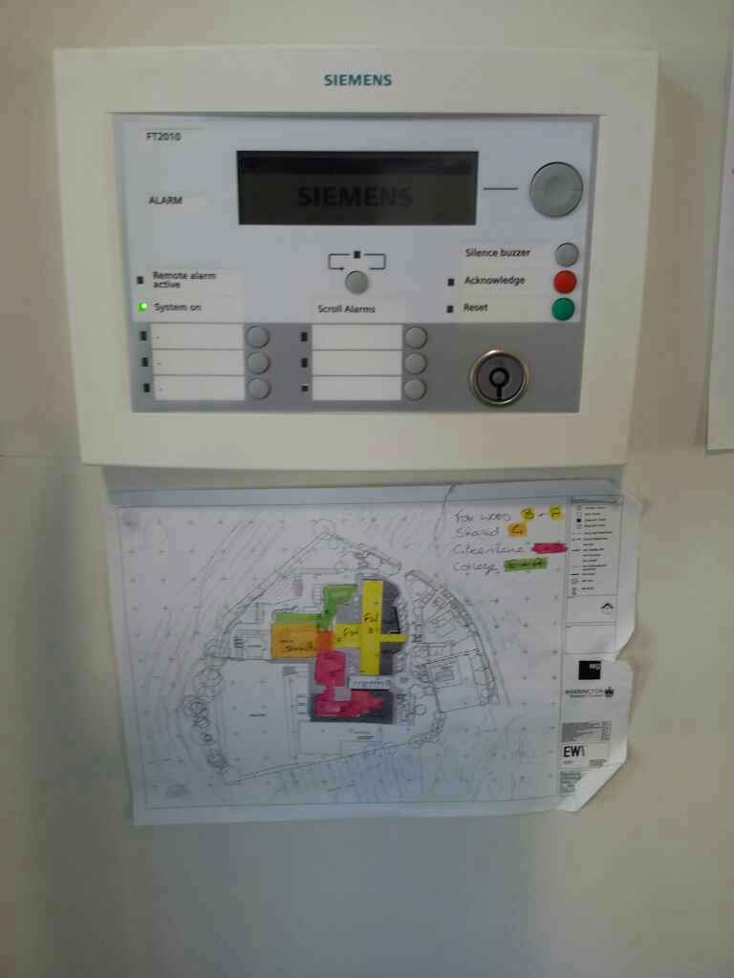  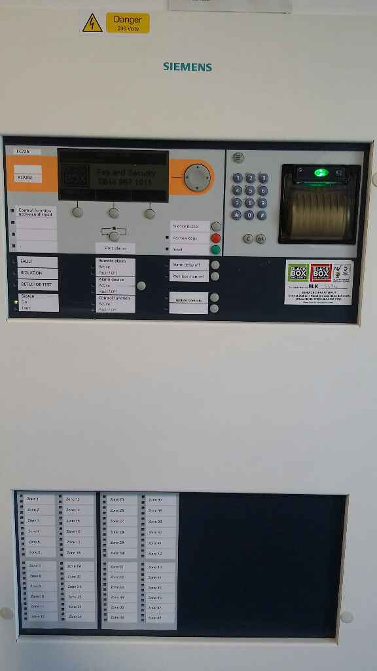  Figure 1 Green Lane Fire Panel  Figure 2 Green Lane Panel - Main panel
Is there a floor plan of the building next to the Fire Panel? | Yes
Photo of floor plan
Are automatic smoke detectors obstructed? | No
Maintenance checks:

Weekly tests - on fire alarm call points to ensure that the alarm sounder is working. Where provided, intermittent checks should be carried out to establish if the connection to the monitoring center is functioning correctly.

Are the call points tested on a weekly basis? | Yes, by the Site Managers. Every Wednesday Morning x 3 alarms each week.
Are records up to date to show which CP's have been tested? | All records are retained in the Fire Log Books – each school has their own fire log book.
Are Call points obstructed? | No, all clearly visible by final exit doors in classrooms, sports hall, offices and corridors.
What type of category is this system? | L1 – Automatic Fire Detection installed into all areas of the building.
Is the system suitable for the building? | Yes
If not, what improvements are required?
Are any further actions required to improve Fire Detection System? | Yes
2. Provide detail of further recommendations required to improve Fire Detection system. | 2.1 Contact Black Box and request an inventory of all smoke detectors across the whole site and ask for evidence that each detector, including void detectors in gym and the high level ones in sports hall, are tested on annual basis
Rating | 2 - Medium
Client Comments:

3. Emergency Lighting
Is there a floor plan showing location of emergency lights in place? | N/a. Most of the emergency lighting in school is non maintained emergency downlighting, with a five-year battery life. This is self-testing lighting.
Emergency escape lighting in accordance with BS 5266 is present on all escape routes in the form of illuminated bulkhead lighting and maintained emergency lighting units (regular lights that will convert to battery back up in the event of power failure). There is a mixture of maintained and non-maintained emergency lighting fixtures installed i.e. lighting that is designed to work in the event of a power failure or is illuminated all of the time. An external contractor carries out annual functionality and 3-hour discharge checks on emergency lighting.

Maintenance and checks: Emergency lighting should be checked on a monthly basis. Annual inspection to be carried out by a competent person to include 3 hour discharge test.

Frequency of Emergency Lighting inspection. | Blackbox carry out annual inspections for maintained lighting, such as the bulkhead lights and illuminated exit signs.
Percentage of Emergency lights tested during maintenance inspection. | Each day the non-maintained lights carry out a self-test. All batteries were changed in 2020 (5 yearly). On a monthly basis the lights perform a 3-hour test.  Monthly inspections are carried out for lights in accessibility toilet and
Date of last inspection. | August 2020 – next inspection due 16/04/20.
Were any faults identified on the last inspection. | No
If yes, provide further details of faults. | N/a
Are in-house visual inspection records up to date? | Yes. There is a fire log book in each area of the school.
Is there a visual strobe light in the Easy Accessibility Toilet? | Yes, Monthly inspections are carried out for lights in accessibility toilets.
Is this light visually inspected during regular CP tests? | Yes
Are any further actions required to improve Emergency Lighting? | No
3. Remedial action to improve Emergency Lighting | N/a
Risk Rating | 1 - Low
Client Comments:

4. Fire Fighting Equipment
What type of firefighting equipment is on site? | Mixture of Foam and Co2, plus fire blankets in suitable places across the school.
Date fire extinguishers were last inspected (Annual)? | 18/02/2021.
Is all the correct firefighting equipment in the correct places? | Yes
Further comments regarding the Fire Fighting equipment | Foxwood: One fire extinguisher needs to be replaced (due to exceeding 5 year service), as identified in the recent inspection. Replacement has been ordered.
Is there a Sprinkler system installed? | No
4. Provide detail of further recommendations required to improve Fire Fighting equipment | N/a
Risk Rating | 1 - Low
Client Comments:

Fire Fighting Hazards - 1
Multi Photo
Description of Hazard | Green Lane School: Fire extinguisher signs missing above fire extinguishers on 1st floor landing (2nd staircase).
Remedial Action required | Obtain the correct signage to be displayed above the fire extinguishers at top of 2nd staircase.
Date to be completed | 30/04/21
Risk Rating | 1 - Low
Client Comments:

5. Work Equipment
Best practice: Avoid an electrical fire

A failure or malfunction within the electrical components of equipment or machinery can cause electrical fires. Electrical fires originate in electric wires, cables, circuit breakers, and within electrical components. Fires start in electrical panels from overloaded circuits or age of the panel. The panel and circuits become overloaded when the distribution of electricity is inadequate. Occasionally, lighting equipment acts as a source of heat that is too close to easily combustible materials. Electrical systems pose an ongoing fire risk.

Maintenance checks:

Performing regular maintenance on electrical panels will reduce the risk of fire. Maintenance includes removing dirt and dust and inspecting and replacing faulty circuit breakers. Kinks in wiring cause electrical resistance within the wire, which creates heat and could cause an electrical fire.

A circuit breaker protects an electrical circuit from damage by automatically shutting off power to the circuit. Breakers trip because of overloaded circuits, power surges or spikes, a short circuit, and ground fault. If the circuit breaker fails, it can damage appliances or equipment on the circuit or lead to a fire. Keeping your electrical panel and circuit breakers up-to-date reduces the failure rate.

Date of Inspection: Kitchen Extractor | 06/10/21
Is the kitchen extractor linked to the fire alarm (automatic isolation)? | Yes
Date of Inspection: Kitchen Equipment | 20/08/20
Have any faults been identified with kitchen equipment? | Unknown
Provide detail of kitchen equipment faults. | TBC
Date of inspection: Convector heaters | N/a
Is a Lightening Rod installed? | Yes
Date of Inspection: Lightening Rod | 08/05/2020
Is there a Passenger or Platform Lift? | Yes
Date of TEAT: Passenger Lifts | 23/10/2020
Date of Service: Passenger Lifts | 18/01/2021
Is there a student kitchen? | Yes
Date of Equipment inspection | 15/02/2021
Comments - any other equipment | Yes, Underfloor heating pumps inspected 05/20/21
Is any further action required? | Yes
5. Provide details for further action | N/a
Risk Rating | 1 - Low
Client comments:

6. Sources of ignition allowing fire to start
Best practice: Fire Prevention

Sensible procedures that can assist to prevent a fire include,
- Not storing combustible materials near potential sources of ignition
- Good housekeeping – including safe disposal of waste, safe storage of equipment and materials and not creating risks through avoiding the use of excessive displays in classrooms, corridors and foyers
- Minimal use of electrical extension leads
- Prohibiting use of personal electrical equipment
- Carrying out visual inspections of equipment before use
- Correctly and safely using equipment

Date of Fixed Electrical 5-year periodic inspection. | 04/10/2019
Is the Fixed wiring in a Satisfactory condition? | Yes
Date of portable appliance testing. | Foxwood school & Sixth form appliances: 01/08/2019 Note: Gary does portable appliance testing; his equipment was calibrated 30/11/20.  Green Lane School appliances: July 2020
Have all portable appliances been tested? If not, refer to hazards. | Yes – all tested.
Are any Fixed Electrical items installed - Han dryers, wall heaters, high-level lighting? | Yes, at Green Lane School.  It isn’t clear if the equipment in the sixth form kitchen would be tested by Vennings or by your fixed appliance electrical contractor.
Date of Fixed Appliance Testing | Green Lane School appliances: 20/08/20
Are there any overloaded sockets or circuits? | No
What type of fuel heats the school? | 1. Gas
Date of Fuel Inspection - Heating system | 05/02/2021
What type of fuel is used in the kitchen? | Gas
Is the isolation of gas linked to fire alarm (automatic shut-off) in kitchen? | Yes
Date of Inspection for fuel supply to kitchen. | 04/09/2020
Are any ventilation ducts obstructed? | No
Suitable controls are in place to prevent arson attack? | Yes
Are any further actions required? | Yes
6. Detail further actions required. | 6.1 Sixth Form: Confirm how fixed appliances and portable appliances (frequency) are inspected in the Sixth form kitchen.
Risk Rating | 2 - Medium
Client Comments:

7. Sources of fuel that may assist fire growth
Best practice: Fire Precautions

The design of the schools with regard to fire walls, fire breaks and fire doors will determine the potential for fire spread. Displays are often located in corridors and in entrance foyers, and generally comprise of materials such as paper, cardboard and plastic which provide a means for the rapid spread of fire. The school should evaluate what material could ignite first and what would cause the fire to develop and spread, and assess how materials used in temporary or permanent displays would interact with surface linings and position them accordingly.

Are combustible materials segregated from heat or ignition source? | Yes. All classrooms have a storage cupboard which are well utilised to store art materials, work books etc. There were no flammable items within the store cupboards, lighting is on a sensor switch and each cupboard is fitted with a smoke detector.
Are flammable liquids stored in dedicated, well ventilated and secure storerooms. | There are several dedicated cleaner’s cupboards in the building which are kept locked through the day.
Are carpets in good condition? | Yes
Are there any full length curtains in the school i.e. stage curtains used in Main Hall, gym, dance studio. | No
Is there any internal wall cladding or polystyrene ceiling tiles. | No
Are Fire retardant / low flammability wall and ceiling linings used to limit fire spread. | Yes. The walls and ceilings are in an excellent decorative condition. There are a few wall displays in the circulation corridor, but these do not form large displays and unlikely to create excessive growth of fire or spread of smoke.
Have low flammability soft furnishings in corridors been treated with fire-retardant protection? | No.  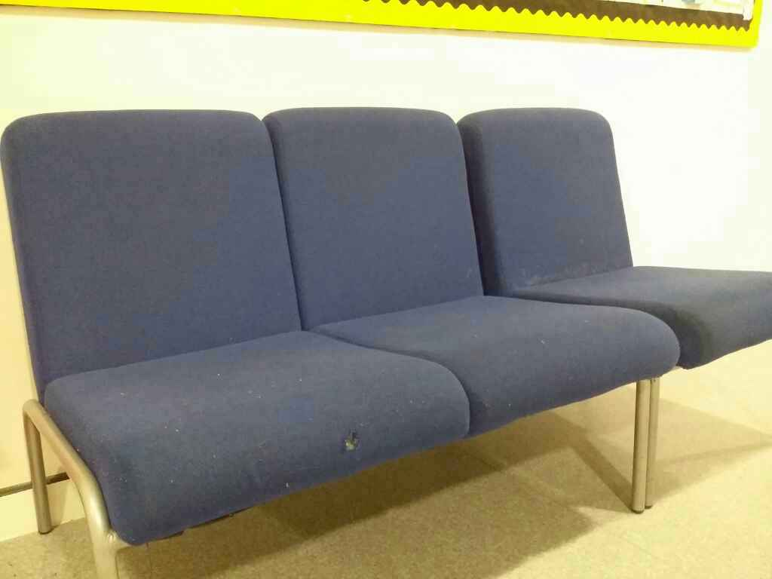  Green Lane: Corridor C27-damaged chair - no fire retardant labels attached.  Sixth Form: Chairs in the corridor outside school office do not have Fire Retardant labels attached.
Are further actions required? | Yes.
7. Provide detail of further recommendations required. | 7.1 Green Lane School: Remove the damaged chair in corridor C27, which is no longer fire retardant. Remaining chairs to be sprayed with fire retardant solution.  7.2 Sixth Form: Chairs in corridor outside school office to be sprayed with fire retardant solution.
Risk Rating | 2 - Medium
Client comments:

8. Rapid fire and smoke spread
Are there holes in any ceilings? | No
Is there adequate fire separation in access corridors and fire escape routes. | Yes. All fire doors segregating access corridors are either kept closed or on door retainers, which automatically close when alarm is activated.
Best practice:

It is important to ensure that, apart from where fire doors are on electro-magnetic release mechanisms, any designated internal fire doors remain closed. It is also recommended that checks are carried out to ensure there are no large gaps where double sets of fire doors should meet.

Are Fire doors being wedged open? | No.
Are Fire doors in good condition? | All doors are in good condition. The exception is the door leading into the sports Hall. The hinge at the top of the door has separated from the door itself and a contractor has fitted a second hinge to compensate. This has not resolved the issue as the door is split and it doesn’t close properly.  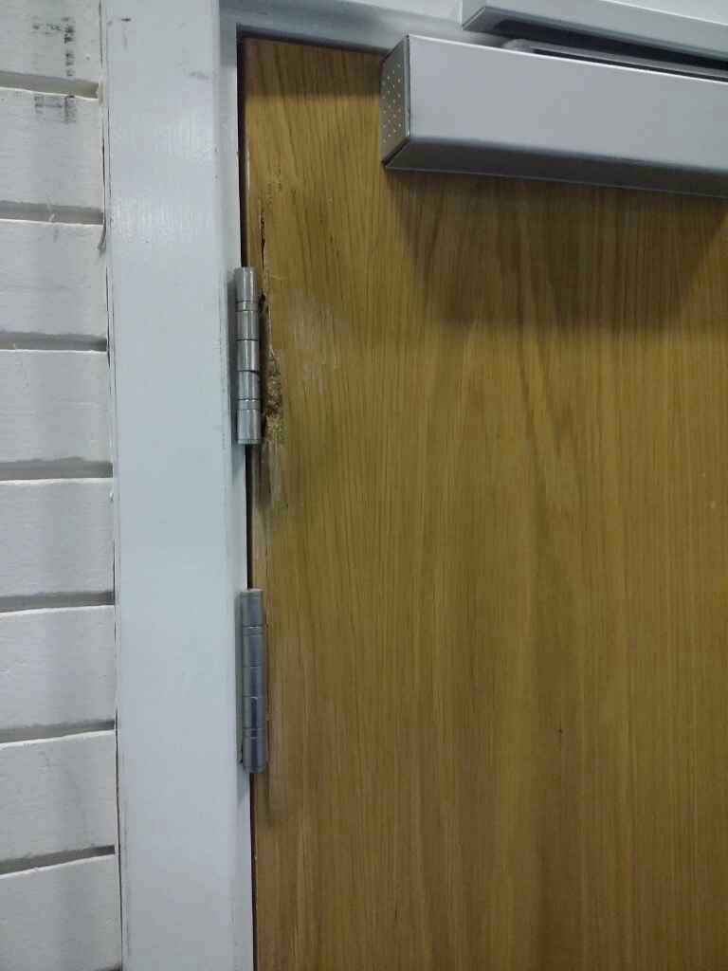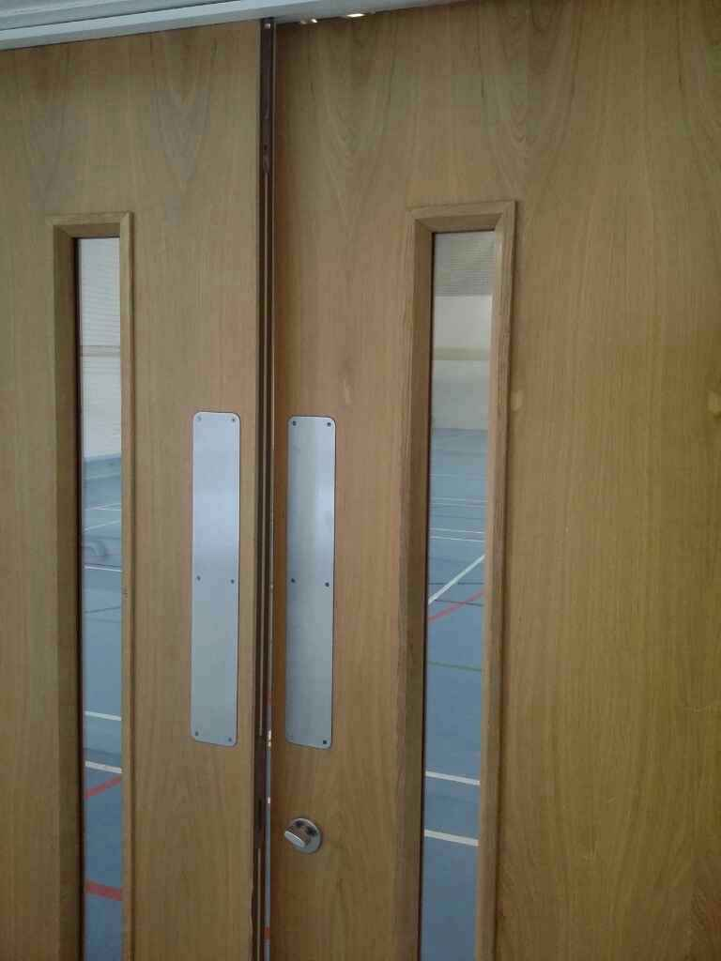
Weekly tests –of internal fire doors during the fire alarm tests to ensure that they are being released and close fully onto the door rebates and also on automatic final exit doors (where installed) to ensure that opening and ‘fail safe’ devices are operational.

Do fire doors have suitable self closers, where required? | Yes
Do fire doors close fully into the rebate of the frame? | All except for the sports hall door as shown in the photo above.
Do all sets of double fire doors close together with no excessive gaps? | Yes, Site Managers check the fire doors on a weekly basis and during the fire alarm activations tests.
Are all intumescent strips and cold smoke seals in place? | Yes
Are all storage and electrical meter / fuse cupboards of half hour fire-resisting construction and kept shut when not in use. | Yes
Are further actions required? | Yes
8. Provide detail of further recommendations required. | 8.1 Green Lane & Fox Wood: Replace the door leading in the Sports Hall (check that frame and hinges are suitable).
Risk Rating | 2 - Medium
Client comments:

9. People cannot safely evacuate in the event of a fire
Best practice: Fire escape.

In the event of a fire, automatic smoke/heat detectors will be activated and these are linked to the Fire Alarm, which will in turn activate the fire alarm, giving the signal to all staff to evacuate the building. It is important that staff are aware of two separate means of escape where they will be able to activate fire alarm call points. Where applicable, signage and emergency escape lighting should be used to help people find their quickest route out of the building in an emergency.

Is strobe lighting installed in disabled toilet to alert people with hearing difficulties that fire alarm is activated? | Yes
Are records kept to show that this equipment is visually checked when operational? | Yes
Are the size and number of the escape routes suitable to cope with the number of people in the workplace? | Yes. All corridors throughout the school are double width with plenty of space for movement.

Are escape routes clear of obstructions and free from slip and trip hazards? | Yes.
The number and location of existing exits is adequate. | All ground floor classrooms in Fox Wood, have direct access to external areas. The communal corridors in Green Lane and Sixth form lead to double width exit doors, with a maximum of 30 people attempting to exit from any exit door along the route.
Corridors more than 30m long are subdivided near the center with 30 minute fire doors. | Yes
Fire signs are provided in readily conspicuous positions. | Yes, clear signage around the building, predominantly illuminated directional signage.
Escape routes are capable of being illuminated on electrical supply failure. | Yes, emergency lighting is installed along all evacuation routes.
Doors on escape routes open in the direction of travel and are fitted with vision panels. | Yes. All fire doors along the evacuation corridors are fitted with vision panels.  Note: Green Lane School: both the double doors at the bottom of the 2nd staircase open inwards, not in the direction of travel. The exit route from stairs should lead through door no.2 (this was identified in last fire risk assessment report).
Where an inner room cannot be avoided, adequate fire safety controls are in place. | N/a there are no inner rooms in the buildings.
Existing fire exits and doors operate effectively.
Personal Emergency Evacuation Plans (PEEP’s)

People may not be able to use stairs, hear the fire alarm or move quickly which includes anyone with a temporary condition which might hinder their escape. Also, some people, e.g. children or people with learning difficulties, may not fully understand the rules for evacuation. They will require special arrangements to help them in emergencies which must be described and communicated to those involved in a Personal Emergency Evacuation Plan. At some stage there may be the need to leave the person in the “protected” place or refuge and it is essential that someone remains with them and there are effective communications.

Have PEEPS been written? | Yes – several GEEPS are in place in all schools to cover the multitude of individual needs for pupils across the building. Many pupils have one-to-one support and these pupils would never be on their own in the building.
Is there more than one floor in the school?
A suitable Emergency Refuge Point is positioned for people who cannot leave the building from lifts or stairs during an emergency without assistance. | Yes. At the top of the 2nd staircase in Green Lane there is a dedicated Refuge Point with alarm/caller equipment fitted and evacuation chair in place.
Is there an evac chair at the top of each stairwell in the building? | 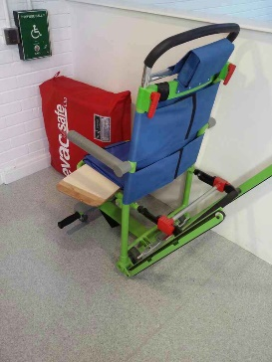  At the top of the 2nd staircase in Green Lane.
Who is trained to use evac chair and how is this practiced? | Several staff members are trained – in house training provided as required.
Provide detail of communication between the safe refuge area and Fire Wardens/Fire Marshall. | Walkie Talkies in use. The refuge call point is connected to a receiver in the reception area – Green Lane.
Is communication from Refuge Point to Fire Warden practiced during fire alarm drills? | The call point equipment is tested by Black Box – six monthly. It is also checked during a fire alarm drill.
External escape stairways are protected from the effects of fire. | N/a
Is there a basement in the building? | No
Are further actions required? | Yes
9. Provide detail of further recommendations required. | 9.1 Green Lane: Door no. 1 and Door no.2 should change direction leading to exit by the Head Teachers Office.
Risk Rating | 2 – medium
Client comments:

Safe Evacuation Hazards - 1
Multi Photo
Description of Hazard | The fire exit route from Green Lane (emergency exit by Head Teachers Office) passes over grass, where the pathway ends to the Sibcas building. The grass area is slippery and would be difficult for wheelchair users to use in order to reach the pathway leading to fire assembly point.
Remedial Action required | Green Lane: Extend the pathway used by pupils to reach the assembly point (either direction passed the Sibcas building).
Date to be completed | 30/04/21
Risk Rating | 2 - Medium
Client Comments:

10. Emergency planning
An adequate emergency plan is provided and has been effectively implemented. | Yes. All schools have produced a clear emergency plan, which is shared with staff and reviewed by SLT members each year (September 2020).
Emergency Plan | Stored in each school
Detail of improvements to emergency plan | N/a
What the law says: Training.

All employees will receive information, instruction and training in emergency fire procedures upon induction and annually thereafter. This should include the following:
- Fire risks in the premises
- Fire safety measures
- Details of the Fire Evacuation Plan
- An awareness of fire detection/prevention systems – how they operate and what action to take action to take in the event of a fire
- Location of call points, fire extinguishers, refuges and Assembly Point
- Method of operation of manual call points
- Means of summoning the Fire Service
- Action on hearing the fire alarm
- Means of escape including 2 alternative escape routes as they move around the building e.g. toilets, canteen, meeting rooms
- How to operate all doors fitted with an over-ride system (break glass green coloured boxes located at the side of door and/or fire alarm call point)
- Identity of fire marshals and persons who are trained to use fire extinguishers and evacuation chairs
- Roll call procedures

A sufficient number of trained fire wardens have been appointed. | Yes, but retraining is due for Sixth form due to staff changes.
Detail of training | Fox Wood: 5 x trained - Louise, Lucinda, Alison, Gary and Lianne  Lianne on 05/10/18.  Green Lane: All SLT’s and Site Manager trained – 05/010/18  Sixth Form: 2 x trained – Lynne and Vickie (Jackie also trained, but not one site fulltime).
How do Fire Wardens communicate between themselves? | 1. Walkie Talkie. Channel one is the fire warden channel, so that all schools can communicate and confirm to the Fire Marshal that everyone is accounted for. There is always at least one Site Manager on site through the day, who co-ordinates the sweeping of building and checking location of fire alarm activation.
How are staff, pupils and visitors accounted for? | 1. Digital records, 2. Paper records
The emergency evacuation arrangements have been shared with appropriate people. | During induction, all new staff will be provided with information about fire evacuation procedures. Cleaners and Catering staff are provided with verbal information on evacuation procedures.
Frequency of Fire Drill practice. | 2. Termly
Date of last fire drill practice | 27/11/2020 and 3/12/20 full school evacuation
Time of last fire drill practice. | 11:30 AM (0 GMT) for drill on 27/11/20
No’s of staff participating in drill | Full school
No’s of pupils participating in drill | Full School
Is evidence available to show that fire drill is reviewed after each practice. | Yes
Provide details | Each school provides a summary report for SLT’s to review following on from a fire alarm.
Is a suitable grab bag provided and available to pass to fire brigade? | Yes. Evidence provided by Sixth Form – evacuation kit contains space blankets, ponchos, first aid kit and spare key to mini bus.
Are any further actions required? | Yes
10. Provide detail of further recommendations required. | 10.1 – All schools to review Fire Warden refresher training in 2021. Additional staff needed in Sixth form and all SLT’s that have become FW’s since October 2018 will require training.
Risk Rating | 2 - Medium
Client comments:

11. Prioritising the fire safety recommendations

Your fire actions have been prioritized using the following system.

 | Priority | Comments
 | 1. | Ongoing (Requires some additional controls in due course)  Some additional fire safety controls are necessary.  Consideration may be given to a more cost-effective risk reducing solution. Regular monitoring of existing fire safety controls is essential.
 | 2. | Within 3 months (Requires remedial action Within 3 months)  Some additional fire safety controls are necessary. Consideration may be given to a more cost-effective risk reducing solution. Regular monitoring of existing fire safety controls is essential.
 | 3. | Immediate (Requires immediate remedial action)  The fire safety issue requires immediate action. If it is not possible to reduce the risk then work / access must be prohibited. If the work involves a work activity which is in progress it must be stopped and alternative means of carrying out the work identified.

12. Review, revise & monitor on a regular basis.
Your fire safety risk assessment is not a one-off procedure and should be reviewed regularly. If the findings of the assessment are considered to be no longer valid or there has been a significant change to the premises, or the organisation of the work undertaken has affected the fire risk or the fire safety measures, the assessment should be reviewed. Situations which might prompt a review include:
- A change in the number of people present or the characteristics of the occupants including the presence of people with some form of disability
- Changes to work procedures, including the introduction of new equipment alterations to the building, including the internal layout significant changes to furniture and fixings
- The introduction or increase in the storage of hazardous substances; or
- Becoming aware of shortcomings in fire safety measures or potential improvements.

Name of assessor: | Adele Partridge
Signature: | 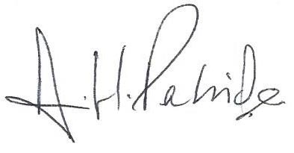
Date of Fire Risk Assessment: | 1st March 2021
Subsequent reviews

Reviewed by: | Date of review:
Comments:

Reviewed by: | Date of review:
Comments:

Reviewed by: | Date of review:
Comments:

