  Specialist School for  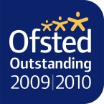  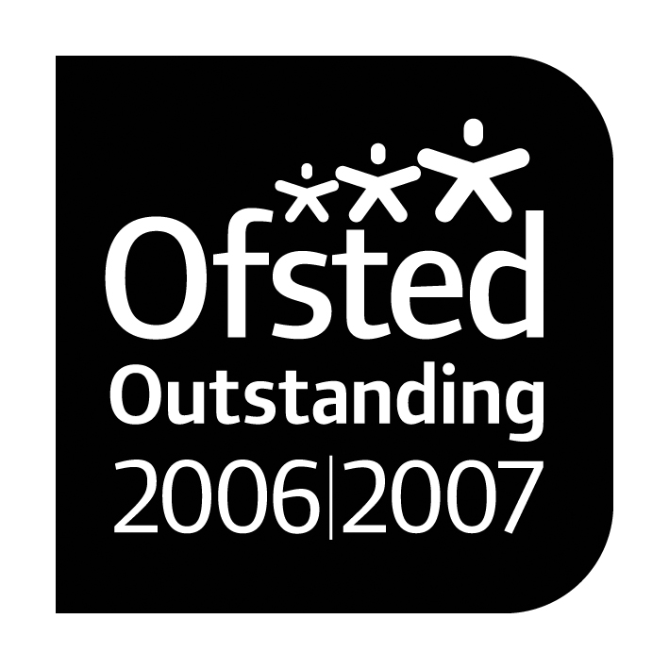      Cognition and Learning |  |   Paul King  Headteacher  Joanne Mullineux  Deputy Headteacher
Dear Parents and Carers,
Re: Home Learning

Due to the ongoing scenario of Covid- 19 we wanted to make you aware of the learning resources available online and through school links. We currently have no plans to close our school but are aware that this is a fast moving situation and that this could become necessary in the near future. In the event we do have to close we understand that the change of routine and lack of learning may be distressing to your child so we have put together some resources and websites that may be useful. These will help your child to carry on learning during a closure.

We have tried to make sure there are a variety of activities available and you will find resources for use on computer, Ipad and content that can be printed. Most of the websites provided contain fun games that your child can play while learning.
This is not an exhaustive list and more resources will become available if and when we are told to close. We will update through the website and class pages with news and other resources we feel would benefit you.

For official Government updates on Coronavirus:
https://www.gov.uk/coronavirus

Thank you for your continued support

Paul King
Headteacher
Website | Information | Password
Oak Academy | Oak Academy is a Government approved website made by teachers to support home learning. It contains full lessons covering a range of subjects. | https://www.thenational.academy/
Twinkl | Twinkl are offering free access for parents/carers to Twinkl resources (worksheets, visuals, games etc) | www.twinkl.co.uk/offer and enter the code UKTWINKLHELPS
Purple Mash | Purple Mash has fun activities and games to support learning throughout the curriculum with sections for English, Maths, Science, Computing, Art and Topics | www.purplemash.com  Your Child has their own individual login that will be sent home with them to enable access from home.
Education City | Education City provide engaging, educational resources and games for students | https://www.educationcity.com/  Your Child has their own individual login that will be sent home with them to enable access from home.
TTS | TTS have created work booklets that can be downloaded and printed. They are filled with different activities that cover various subjects. | https://www.tts-group.co.uk/home+learning+activities.html  You can download the booklet most appropriate for your child.
Helpkidzlearn | Filled with games for Ipads and laptops that support learning. | https://www.helpkidzlearn.com  click login  games and activities  play games  username: greenlane  password: learner1
Hamilton Trust | Hamilton will be providing free packs for English and maths for each year group | https://www.hamilton-trust.org.uk/blog/feel-free-share/  Click on the year group you feel best suits your child’s ability then browse through the units to pick one you feel would benefit your child.
Sensory stuck at home | Sensory ideas for home run by Occupational therapists. | https://www.facebook.com/groups/sensory stuckathome
OT Toolbox | Full of fun sensory ideas | www.OTToolbox
Whizz | Maths activities and games | www.whizz.com  Username: Greenlanesch  Password: Whizz123
Numeracy workout | Maths activities and games | www.numeracyworkout.co.uk  Username: Greenlane  Password: total57
Numeracy Warmup | Maths activities and games | www.numeracywarmup.co.uk  Username: Greenlane  Password: total57

