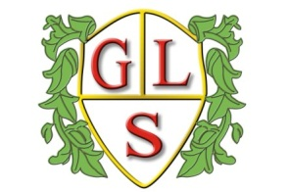
Class P3 Topics Spring 2022

Science
Lifecycles and reproduction
Energy

History
The Ancient Greeks and the Olympics

Geography
Famous Landmarks around the World

ICT
E-Safety
Data

Spanish
Colours and Flags
My House

RE
Sacred Texts
Places of worship

Art
Journeys
World of Animals

Design Technology
Textiles
Ways with Potatoes

PSHE
Relationships with others
Being safe in relationships

PE
Handball
Gymnastics

