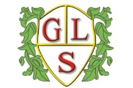
Green Learning Environments
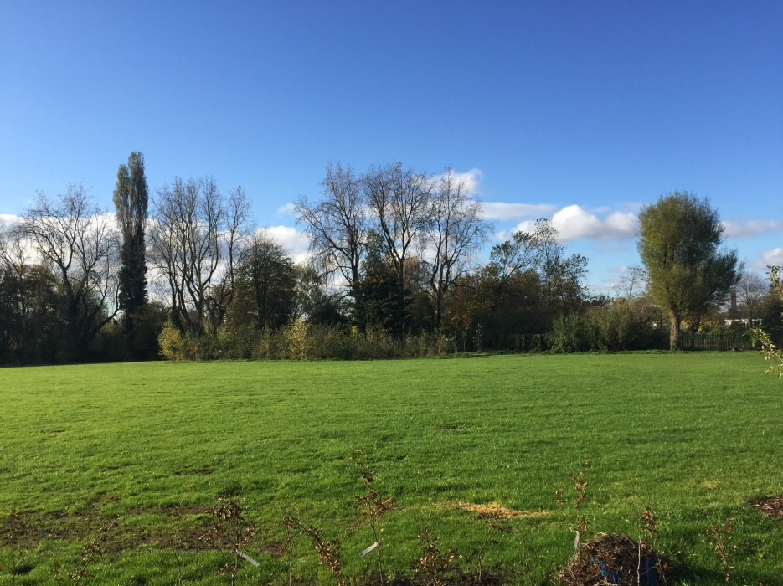
Green Lane Community Special School is working with environmental partners and schools for children with special needs across the UK, Belgium and Slovenia as part of Erasmus+, a European funded project.
We know from research that children learn better in a natural environment, and this is especially so for children with learning difficulties. However to our best knowledge, there is no educational material on nature-based skill development across these three countries. The aim of this project is to utilise welcoming, eco-friendly outdoor settings for children with learning disabilities. Through an exchange of practices we aim to develop innovative methods for outdoor learning.
Partner schools include the Mersey Forest and Bluebell Park School, Kirkby. The team will also be working alongside other partners including: The Institute for Forest Pedagogy, GOZDIZ - Department of Forest Ecology, Ljubo Sercer Elementary School and Os Jela Kanezica in Slovenia and MPI Heemschool, Brussles and The Royal Orthopedagogisch Centre in Belgium.
The Mersey Forest Team will support us in delivering Forest Schools, help to develop and test a Green Learning Toolbox and monitor its impact helping to identify best practice.
The Green Learning Environment project will last from September 2016 until December 2018.
