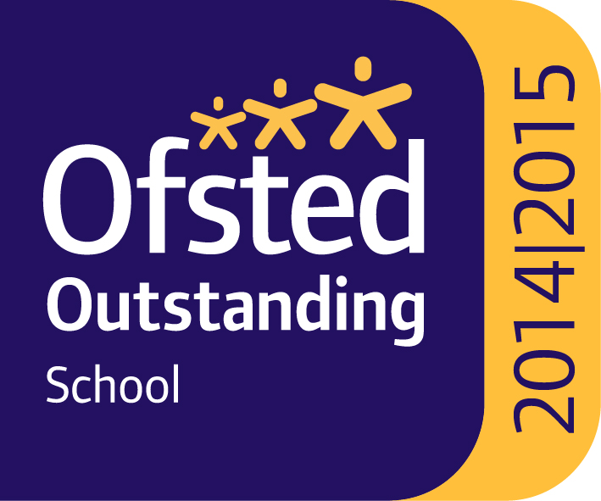  Specialist School for    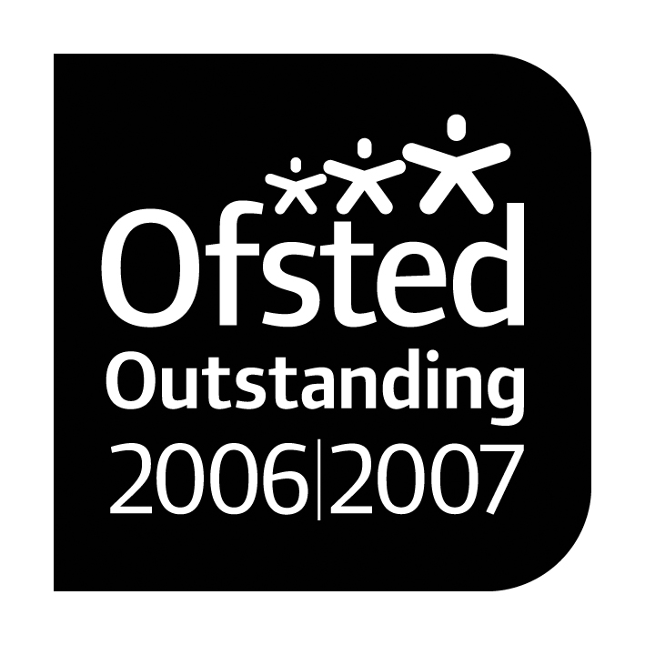      Cognition and Learning |  |   Paul King  Headteacher  Joanne Mullineux  Deputy Headteacher
Dear Parents/ Carers

As you may be aware, as a school we have been using a new digital based evidence system. This system will allow us to share evidence of our learning, through videos and pictures, throughout the year and will replace our existing ROA model.

To ensure we can send you the best evidence we are asking for your permission to allow your child to be in the photos and videos sent to other parents/ carers. This will allow us to send evidence that includes group work and class based discussions. This evidence will only be sent to parents within your child’s class and will not be shared further.

Can you also please sign the slip below to say you agree not to share any information, videos or pictures of the children on any social media sites.

Thank you,
Danielle Taylor
P3 Class Teacher/ Computing Lead
__________________________________________________________
I give/ don’t give permission for my child to be featured in evidence sent to other parents/carers

Signed __________________________________
__________________________________________________________
I agree not to share evidence of other children on social media

Signed_________________________

Parent / carer of ________________________

