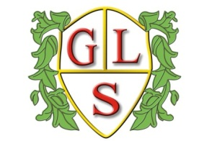

Rabbit Class Topics Spring Term 2025

Maths

Multiplication and Division/ Measures- including time

English

Class Novel- 2 Weeks with the Queen

Science

Everyday Materials/ Animals Including Humans

History

Victorian Britain

Geography

Different time zones/ Study of York

Computing

Data and Multimedia

Design and Food Technology

To Be Confirmed…

Art

Journeys/ World of Animals

PSHE

Relationships with others/Being safe in relationships

RE

Islam and Christianity

PE

Handball/Outdoor Adventurous Activities

Music

Film Music