**Badger class staff.**

Ms K.White

Ms J.Forrest

Mrs K.Dickson

Badger Class Spring Term 2025

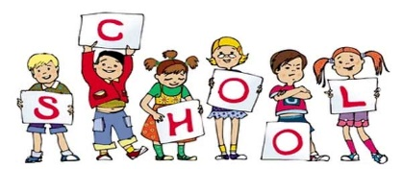

**Topics**

**Spring 1**

Class Novel - Matlida

**Spring 2**

Class Novel – Matilda

Ongoing - Spelling and Phonics, Guided Reading, Guided Writing, Handwriting. Speech and language work.

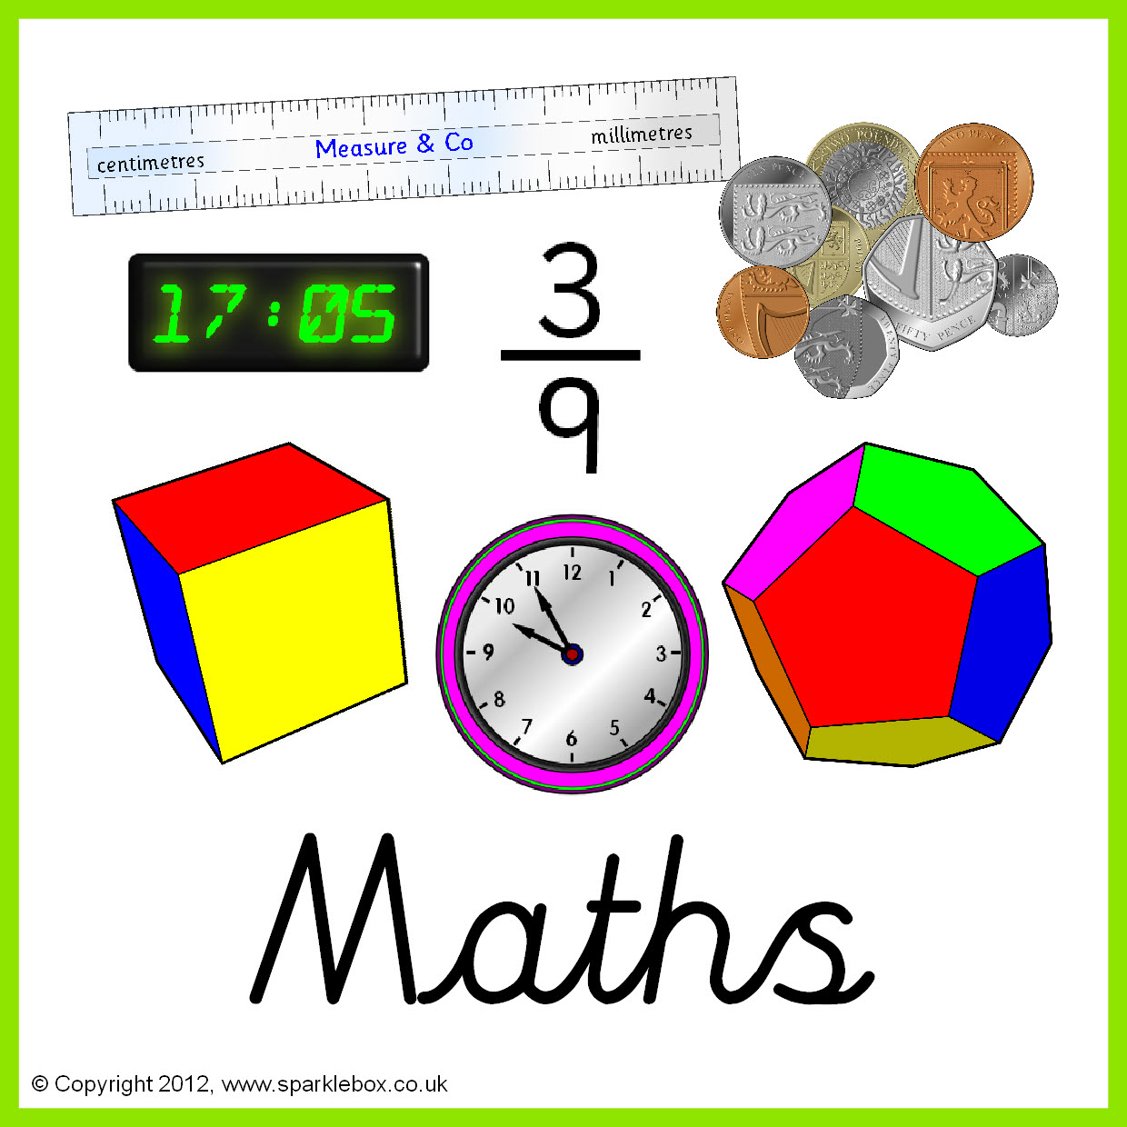

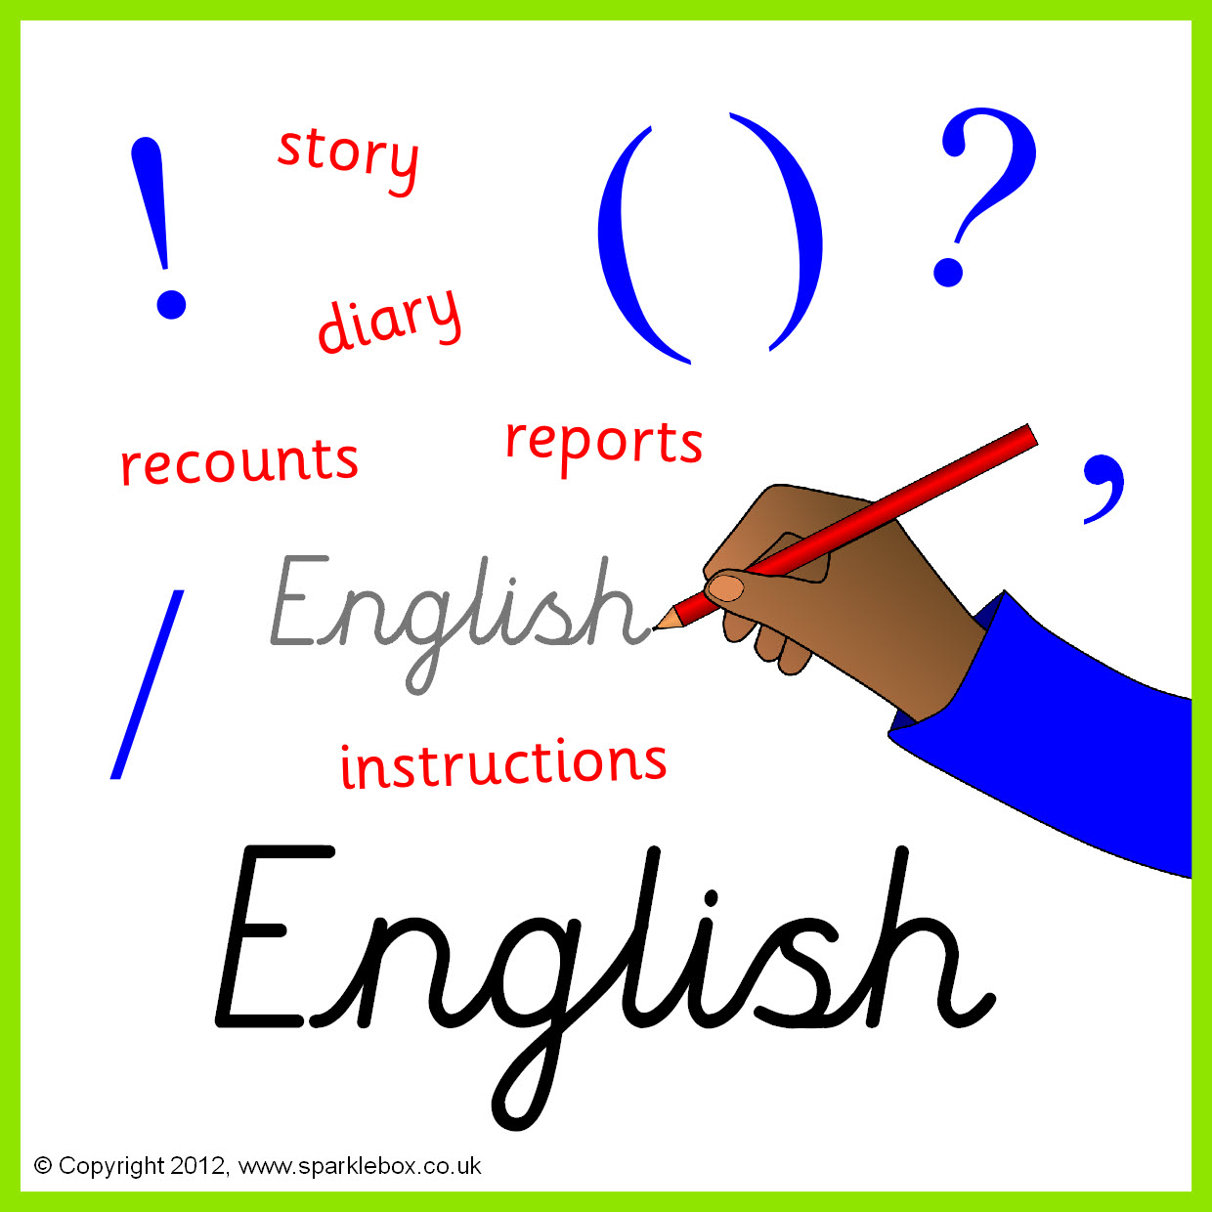

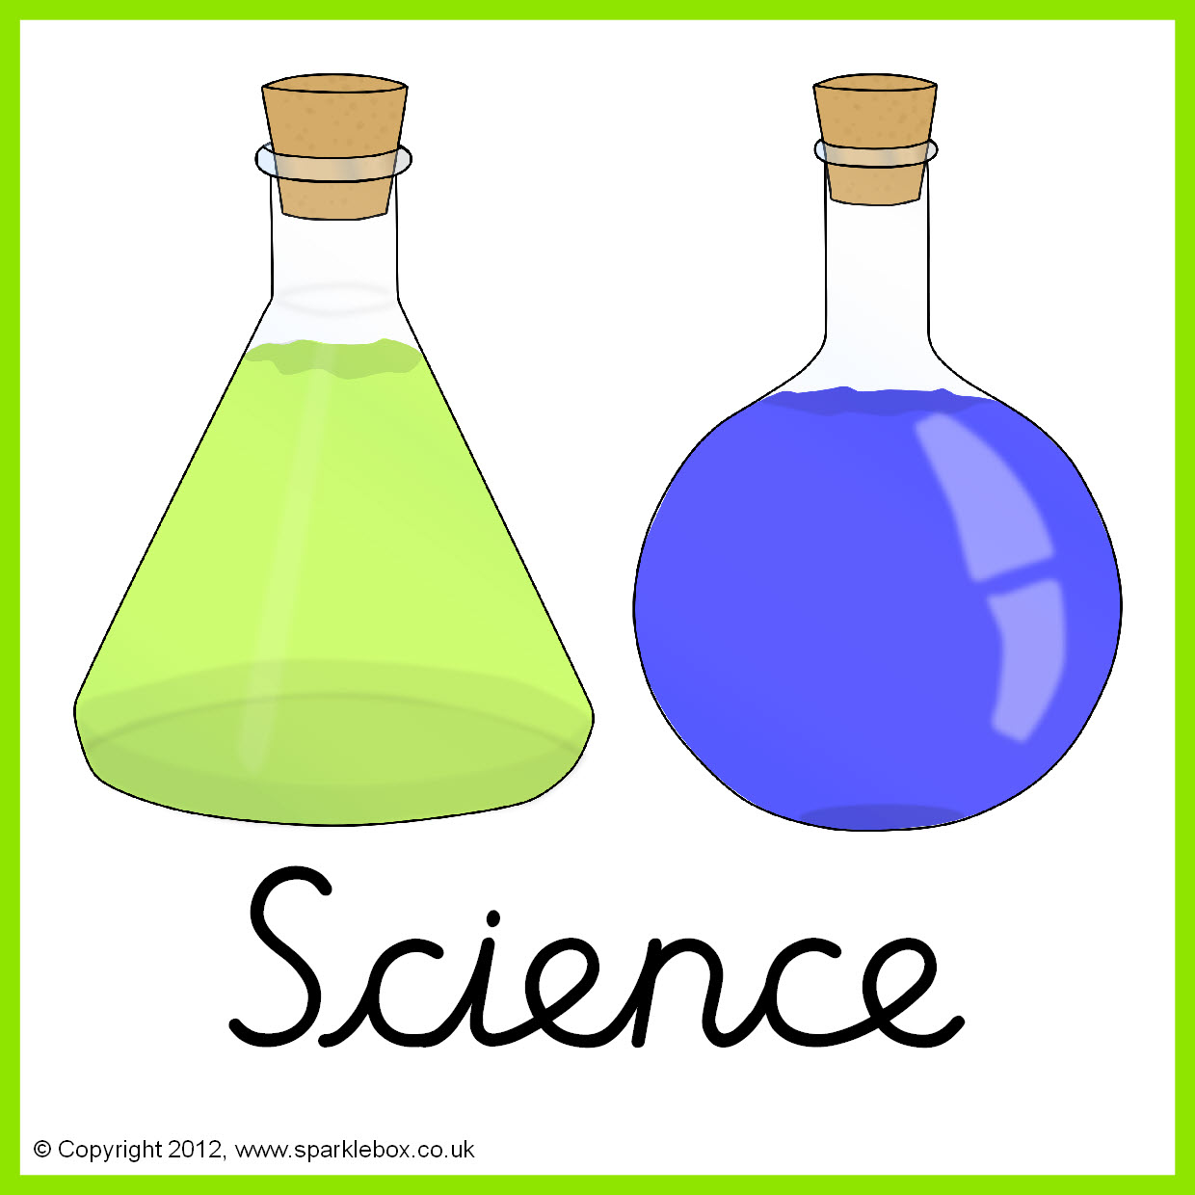





**Topics**

**Spring 1** – Everyday materials.

**Spring 2** – Animals including humans.

**Topics**

**Spring 1** – Data.

**Spring 2** **-** Multimedia.

**Topic**

Dream Space

**Topics**

**Spring 1** - Journeys.

**Spring 2** – World of Animals.







**Topics –**

Investigating Seas .

**Topic**

Film Music



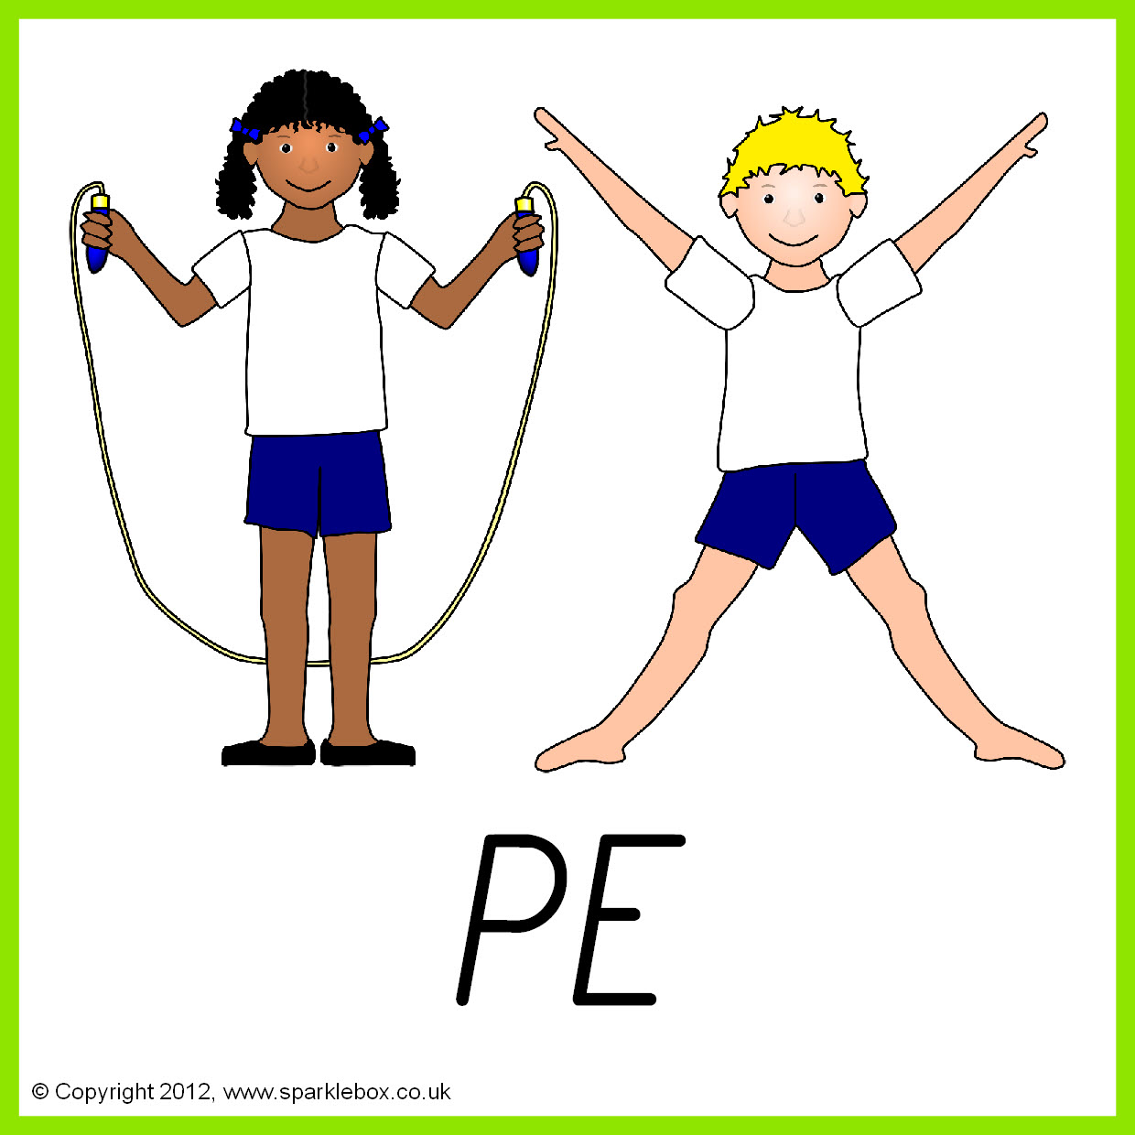

**Topics**

**Spring 1** – Handball.

**Spring 2** – Outdoor Adventurous Activities.

**Topics**

**Spring 1** – Creation.

Should we be Ecologists?

**Spring 2** – Christianity/Islam.

The Easter story and places of worship.





**Topics**

**Spring 1 –** Changing adolescent body**.**

**Spring 2 –** Relationships with others.



Topics

**Spring 1** - Textiles: How things fasten.

**Spring 2** – Ways with potatoes.