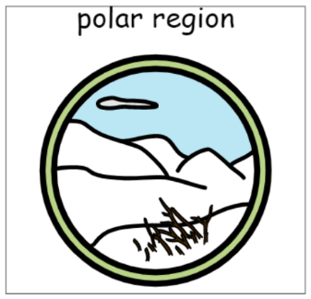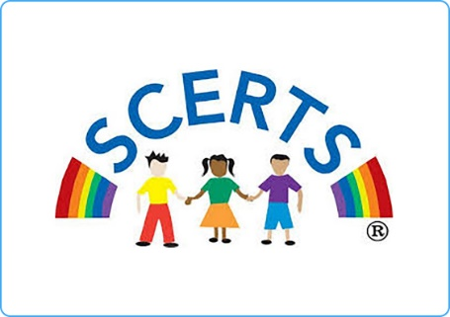

**Topics**

Numbers to 10 and beyond

Missing numbers

Adding

Money and coins

Capacity

Length

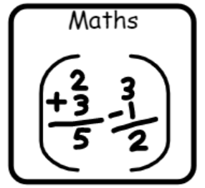

**Topics**

Themed stories

Explanation texts – how do we keep warm?

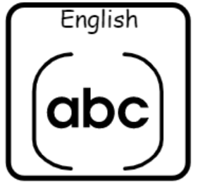

**Topics**

**Floating and sinking**

**Melting, freezing and gases**

**Topics**

E-safety

Multimedia - art

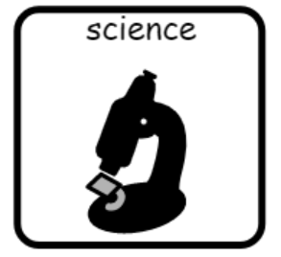

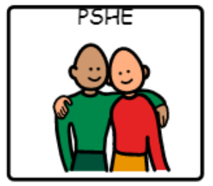

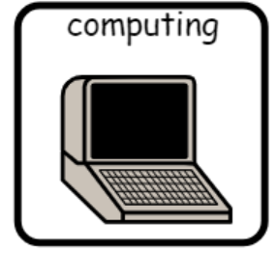

**Topic**

The world we live in

**Topic**

Collage

**Topic**

The arctic and the UK

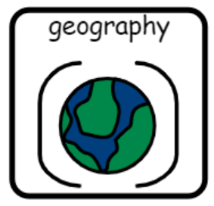

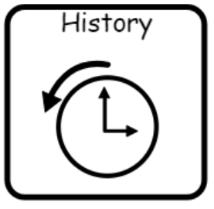

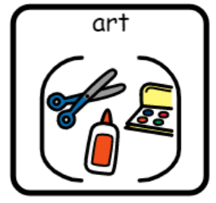

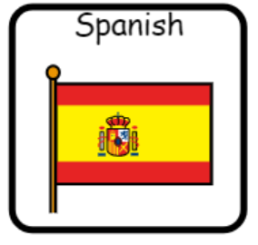

**Topics** –

European languages day – food

Spanish Christmas

**Topic**

The Titanic

**Topics**

Judaism

Christmas/winter festivals

**Topics**

OAA

Athletics – striking/fielding

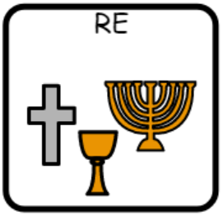



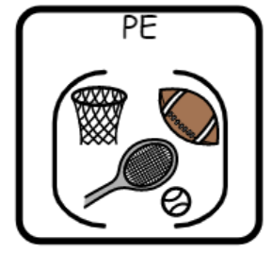

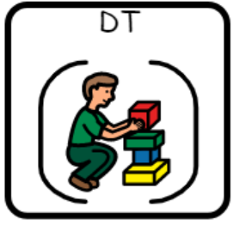

**Topic**

Hot and cold foods

**Topic**

Structures – Igloos