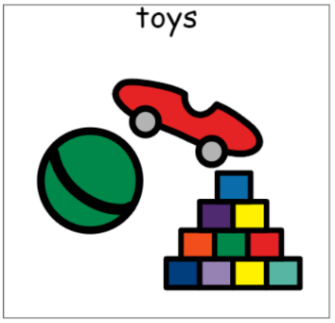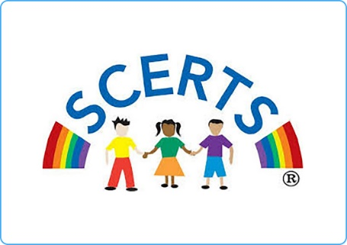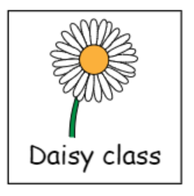

**Topics**

Addition and subtraction

Mass

Time

2D shapes

Patterns

Positions

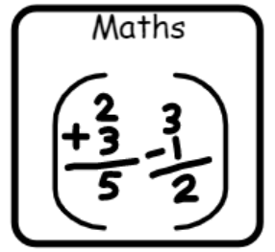

**Topics**

Instructions

Toy stories - characters

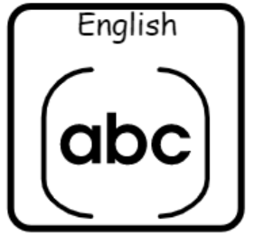

**Topics**

Magnets

What materials are toys made of?

**Topics**

Multimedia – sound and music

Programming and algorithms

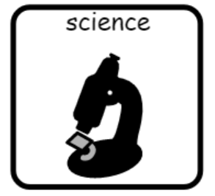

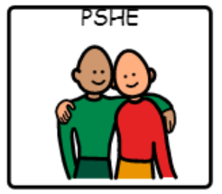

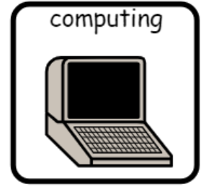

**Topic**

Changing and growing

**Topic**

Sculpture

**Topic**

London

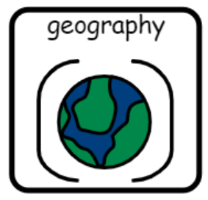

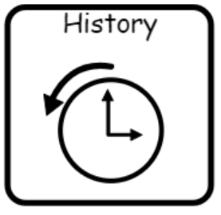

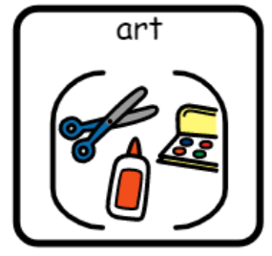

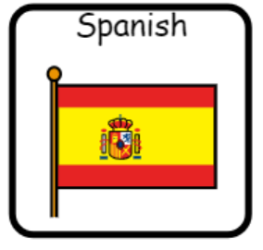

**Topic**

What toys did my grandparents play with?

**Topics** –

Spanish native animals

Spanish traditions

**Topics**

Special things and special places

Easter and Spring festivals

**Topics**

Gymnastics

Invasion games

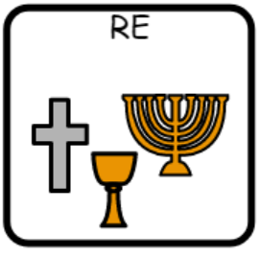

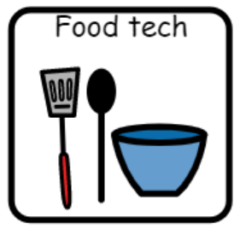

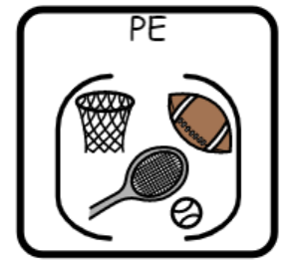

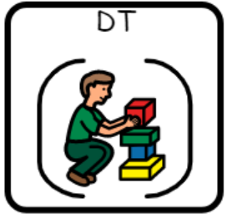

**Topic**

Treat boxes

**Topic**

Textiles – making toys