Badger class staff.

Ms K.White

Ms J.Forrest

Mrs K.Dickson

{@]

[-@

Badger Class Autumn Term 2024



**Topics**

**Autumn 1 -**

**Number**

Place value of a digit in a number. Counting in steps.

Solve practical problems involving place value.

**Autumn 2 –** 2D and 3D shapes and Statistics.

**Topics**

**Autumn 1**

Instructions.

**Autumn 2**

Magazine/Newspaper articles.

**Ongoing** - Spelling and Phonics, Guided Reading, Guided Writing, Handwriting.

Speech and language work.

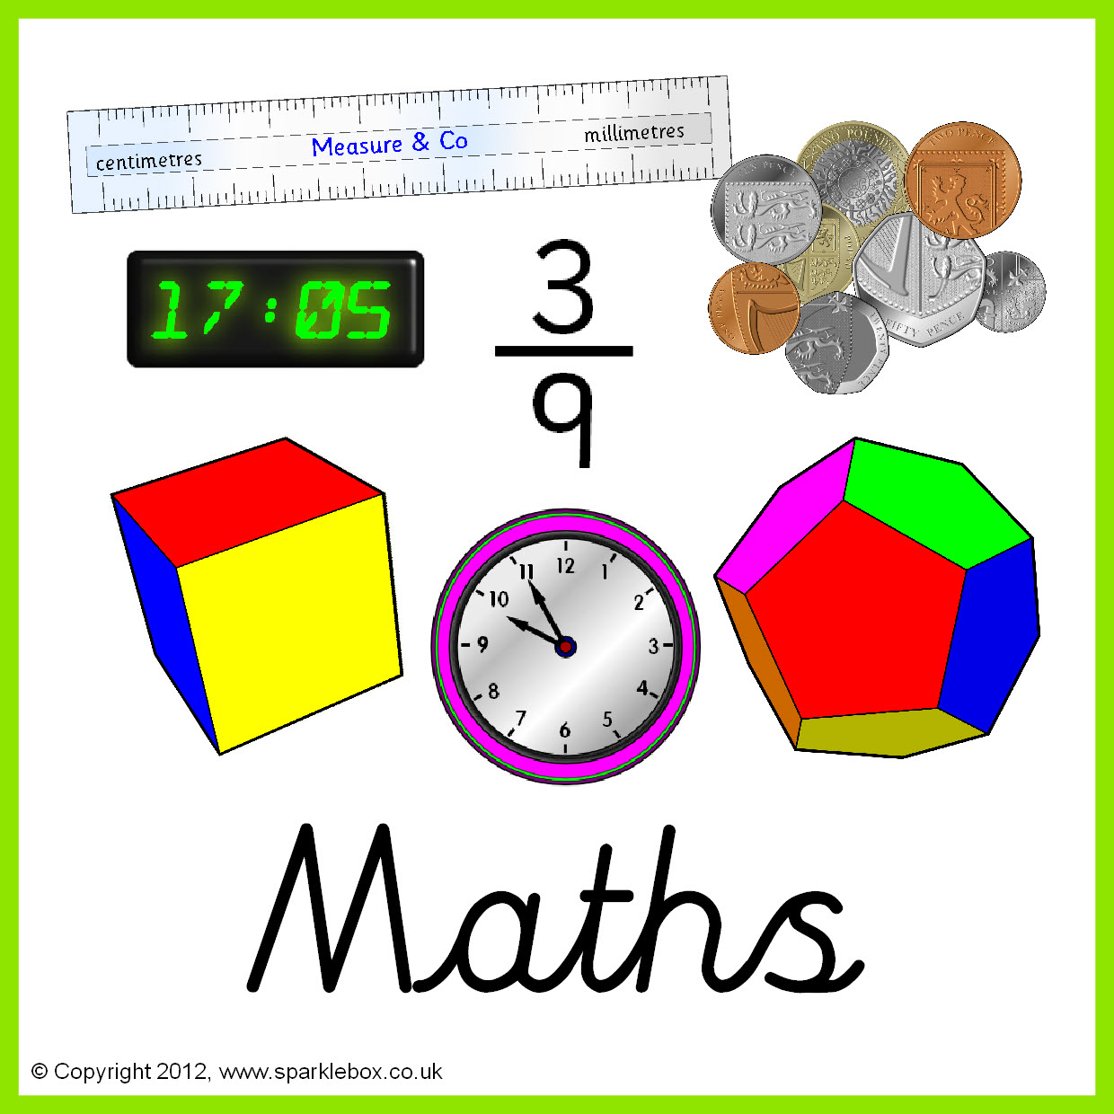



**Topics**

**Autumn 1 –** Parts of Plants.

**Autumn 2 –** Seasonal Changes.

**Topics**

**Autumn 1** – Key skills – typing, copy and paste etc.

**Autumn 2** - E-safety.





**Topics** –

Capital cities in the U.K.





**Topics –**

**Autumn 1** - Introduction to formal elements of art. Drawing.

**Autumn 2** – Spanish Tiles.

**Topic** -

The Stone Age to the Iron Age.

(What changed?)



**Topics –**

**Autumn 1** – Dance.

**Autumn 2** – Gymnastics.

**Topics**

**Autumn 1** – Various Religions- What makes a community?

**Autumn 2** – Christianity and celebrations.

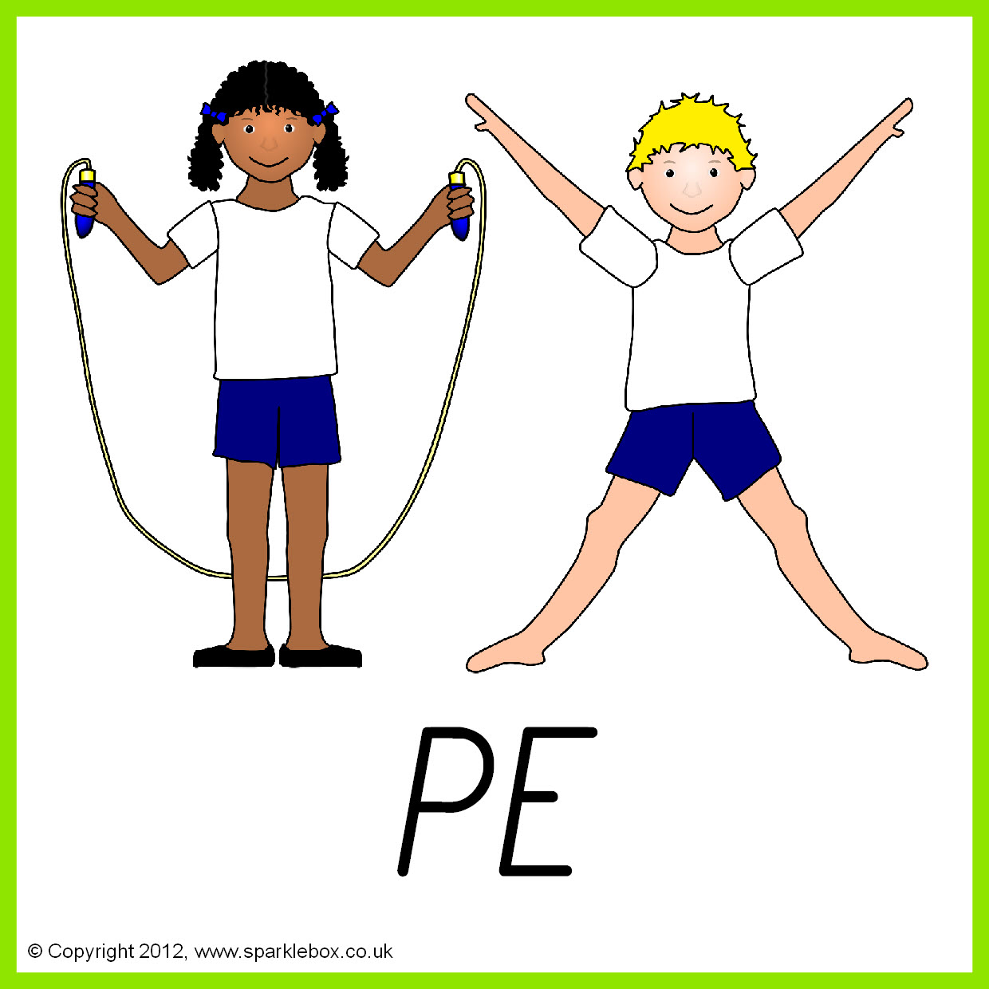





**Topics**

**Autumn 1 –** Families.

**Autumn 2** – Health – Keeping fit.

**Topics -**

**Autumn 1 –** Structures. Design and make a mobile.

**Autumn 2 –** Winter warmers – Soups.

**Autumn 2 – Basic food hygiene – Winter warmers.**

