**Topics**

**Summer 1 -**

Number - Fractions

Measures – Length and Perimeter.

**Summer 2 –**

Number – Addition and Subtraction.

Measures – Mass and Capacity.

**Badger class staff.**

Ms K.White

Ms J.Forrest

Miss K.Bhalla

Badger Class Summer Term 2025

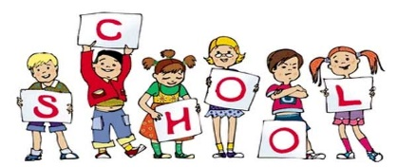

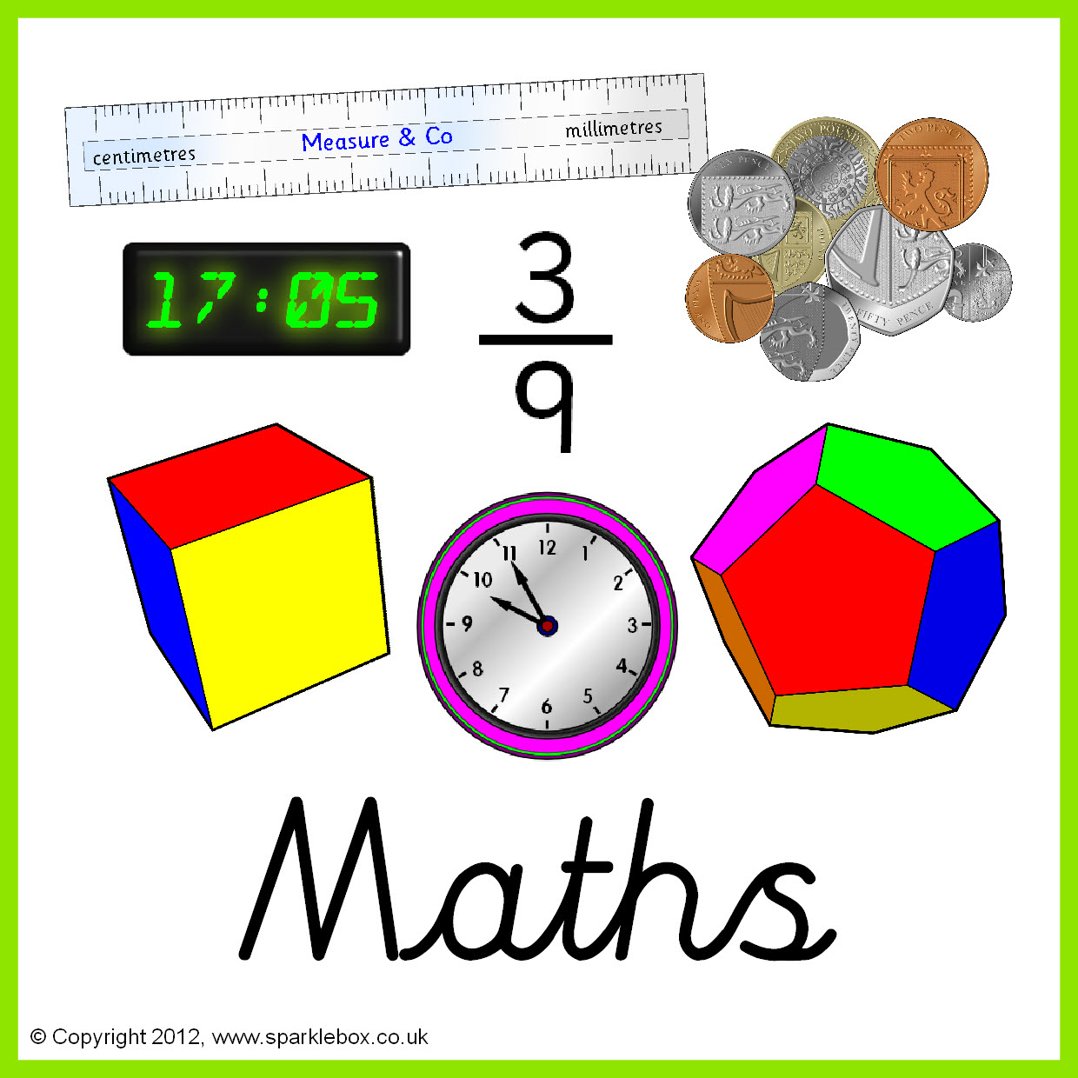

**Topics**

**Summer 1 -**

Poetry – Performance and Riddles.

**Summer 2 -**

Adventure Stories.

Ongoing - Spelling and Phonics, Guided Reading, Guided Writing, Handwriting. Speech and language work.

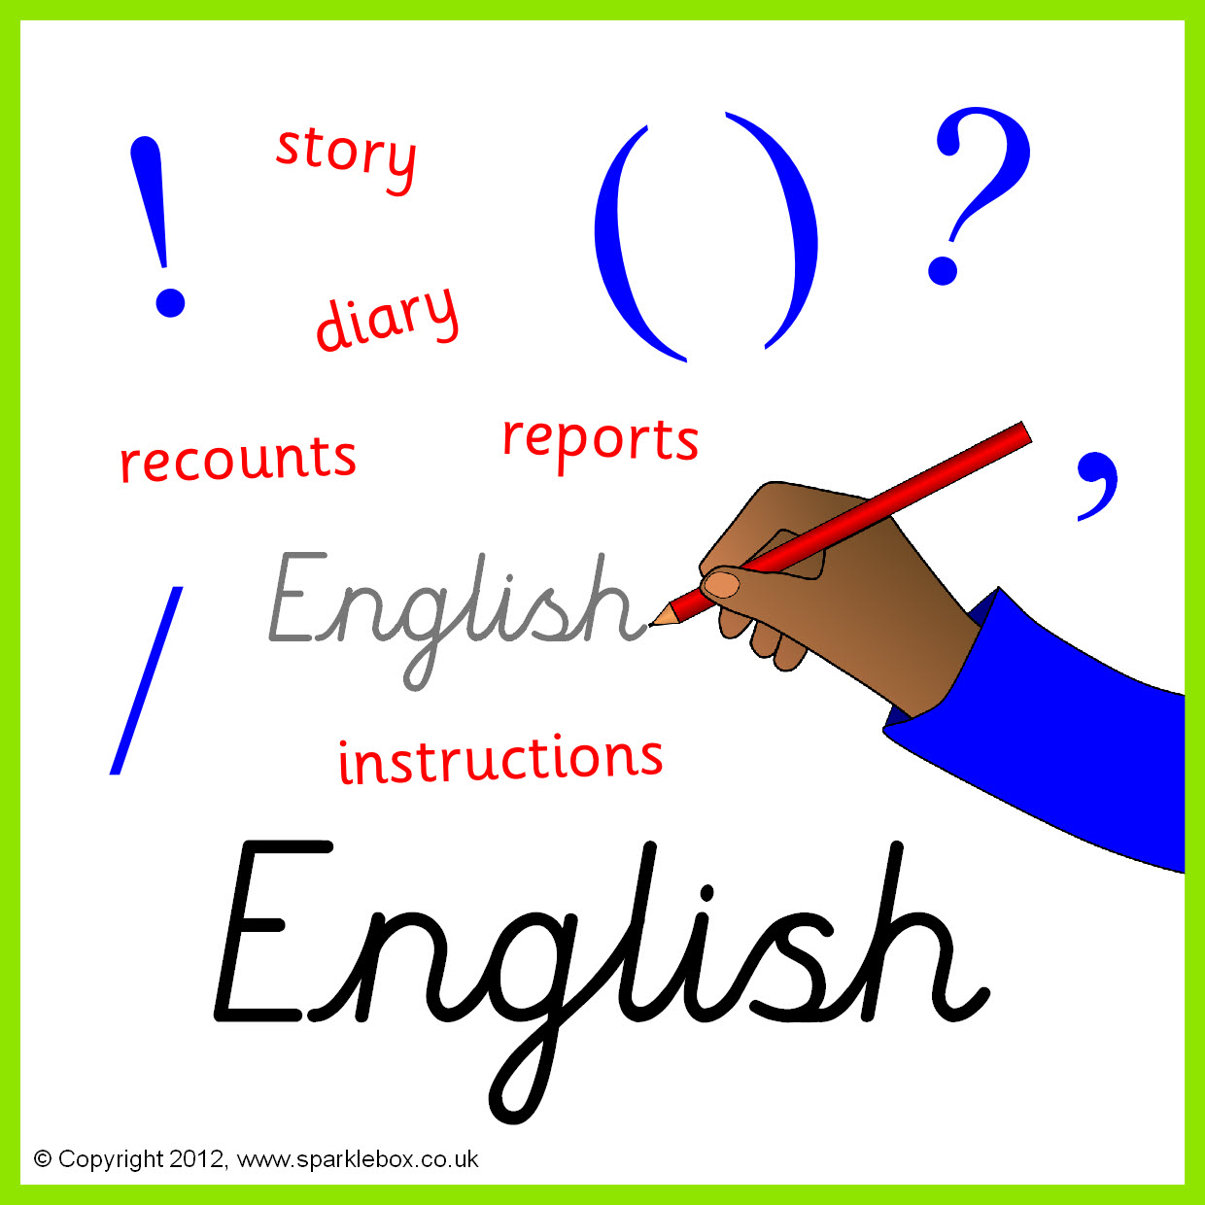







**Topics**

**Summer 1** – Rocks and Fossils.

**Summer 2** – Light and Colour.

**Topics**

**Summer 1** – E-safety.

**Summer 2** **-** Multimedia: Art; Working with text.

**Topic**

Design/Trades

**Topics**

**Summer 1** – Day of the Dead.

**Summer 2** – View through a Door.







**Topics –**

Local Study.

**Topic -**

Changes within living memory – Local History.

**Topic**

Reggae



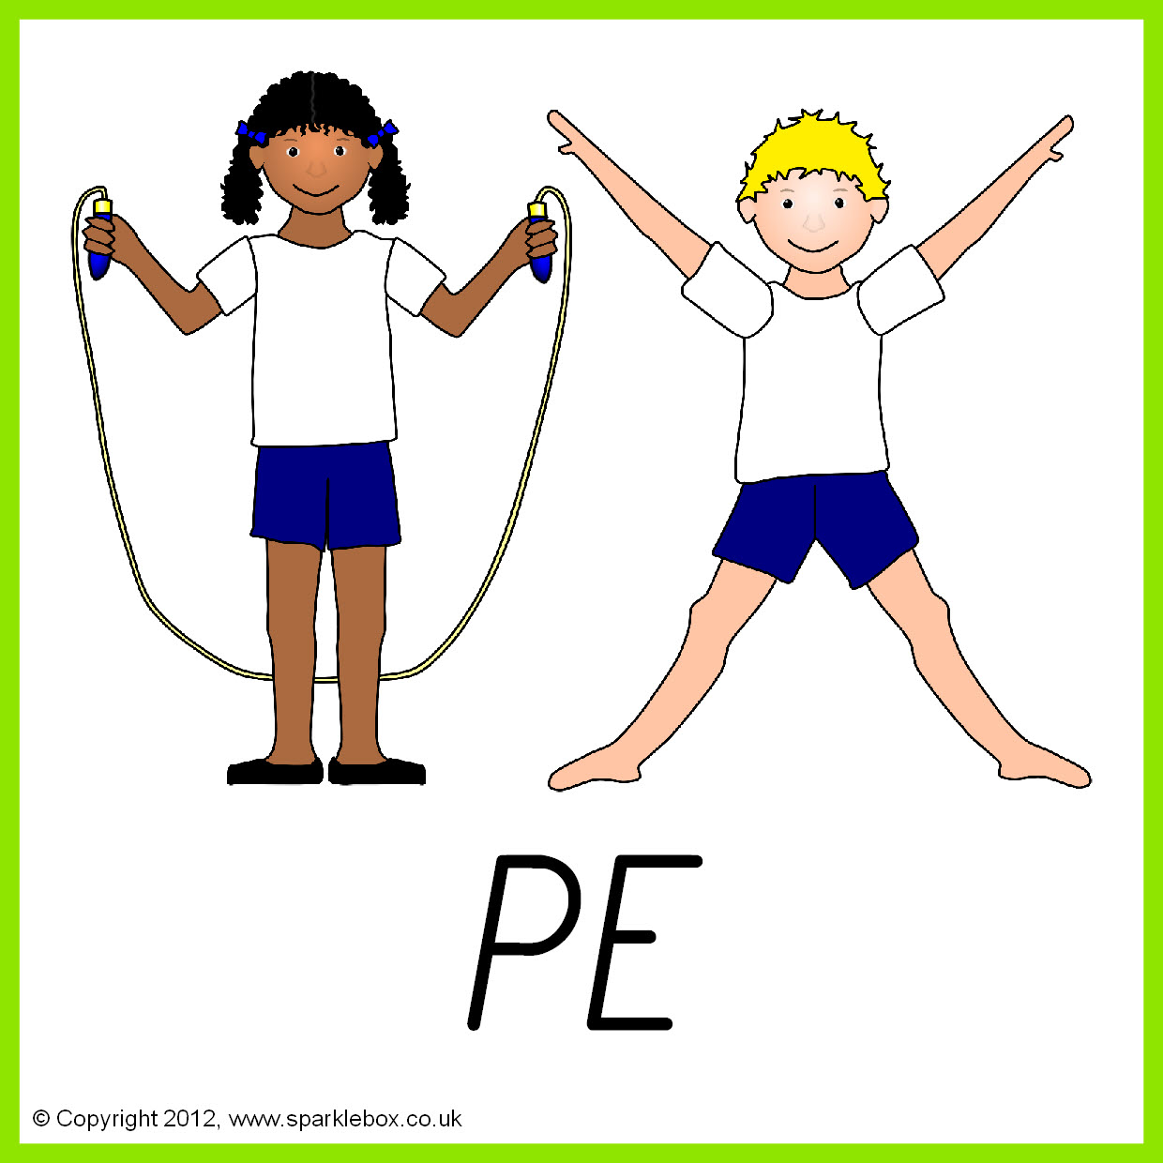

**Topics**

**Summer 1** – Tennis

**Summer 2** – Athletics

**Topics**

**Summer 1** – What is the Bible?

**Summer 2** – Islamic Rites of Passage – The Hajj





**Topics**

**Summer 1 –** British values.

**Summer 2 –** Environment.



Topics

**Summer 1** – Designing and making Jewellery.

**Summer 2** – Making a Snack.