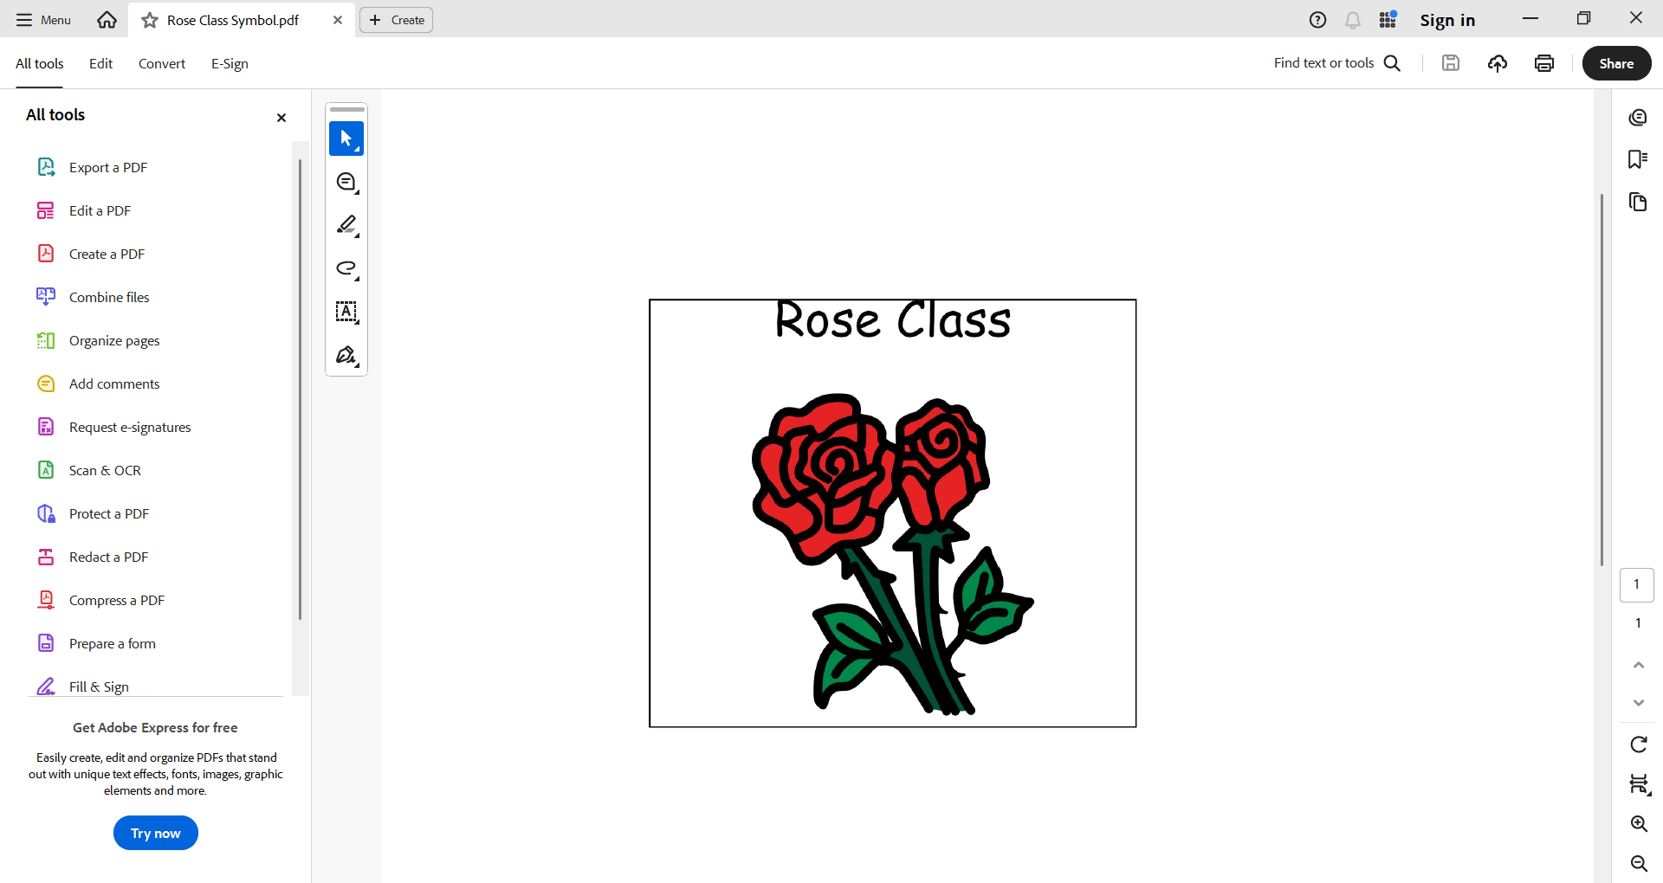

Rose Class

2025/26

**Our Topics**

Autumn: My Class & My Pets

Spring: People Who Help Us & Things That Grow

Summer: Under the Sea & Farm Animals

Sensory

Regulating my emotions.

Identifying and using sensory tools.

Using sensory for engagement.

Accessing the sensory room.

Finding tools that help me calm.

Understanding my senses.

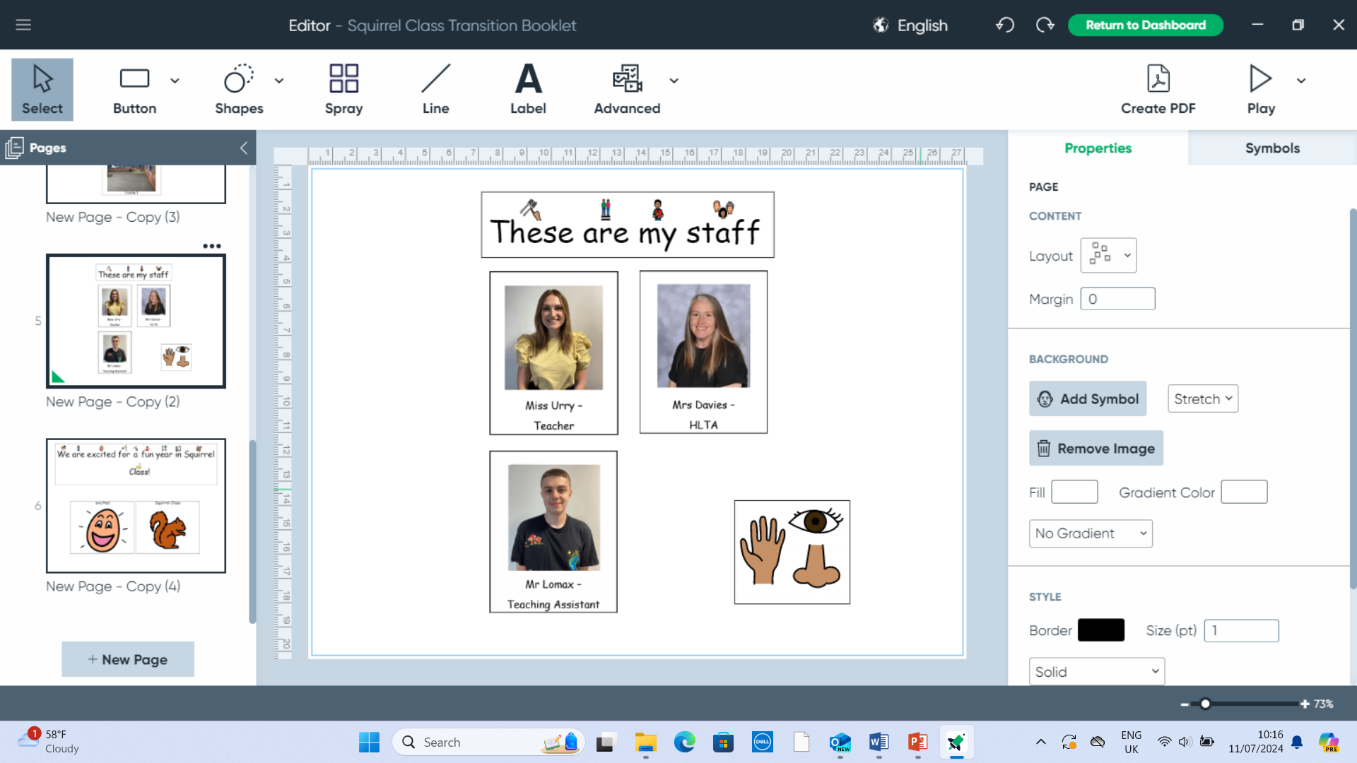

Communication

Intensive interaction, total communication, phonics, ELS, reading skills, PECS, Makaton, objects for reference, go talk devices, sounds in our environment.

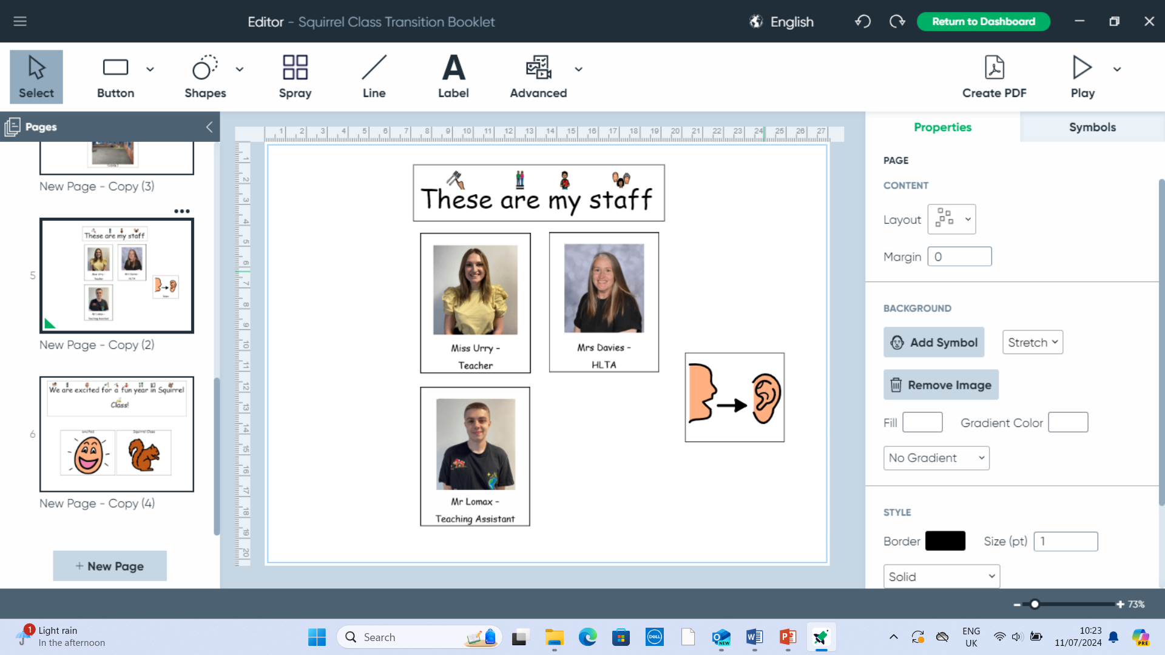

Self and Emotions

Zones of regulation

Good morning routine

Independence skills

What makes me happy?

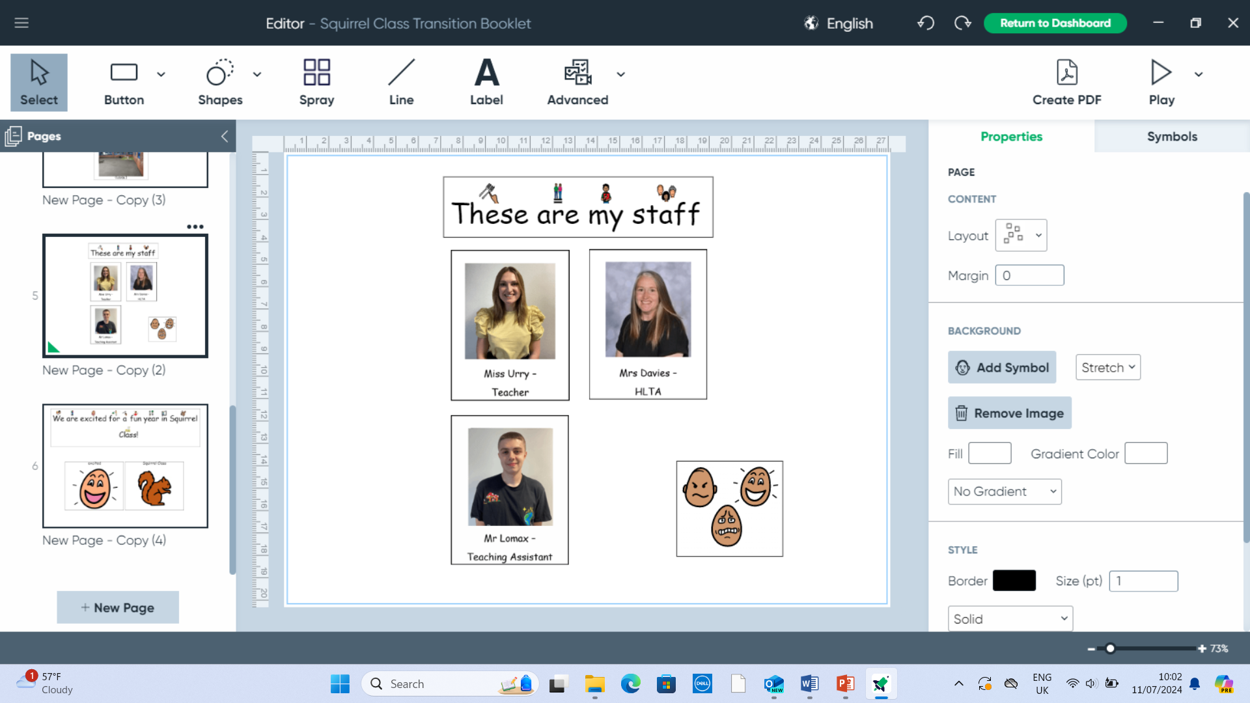

Functional Movement

Developing fine motor skills. Developing gross motor skills.

Using the O.T. equipment to regulate.

Using the sensory room.

Looking after myself.

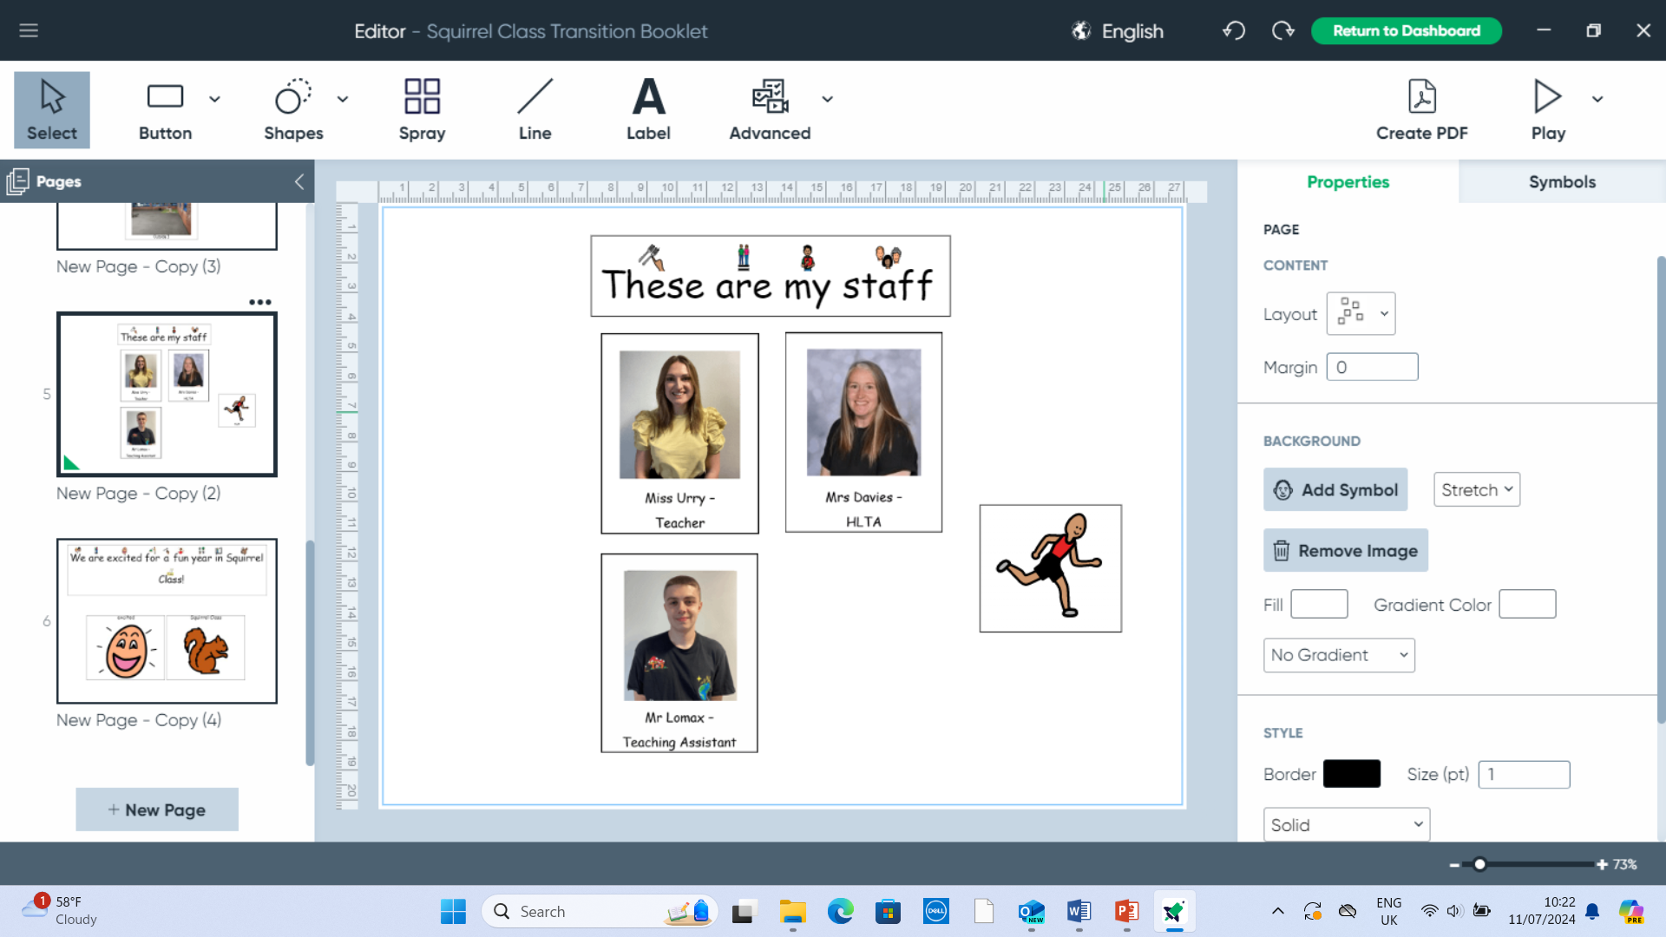

Making Connections.

Making choices.

Learning to cooperate.

Learning to communicate

Learning to interact with others.

Greeting others.

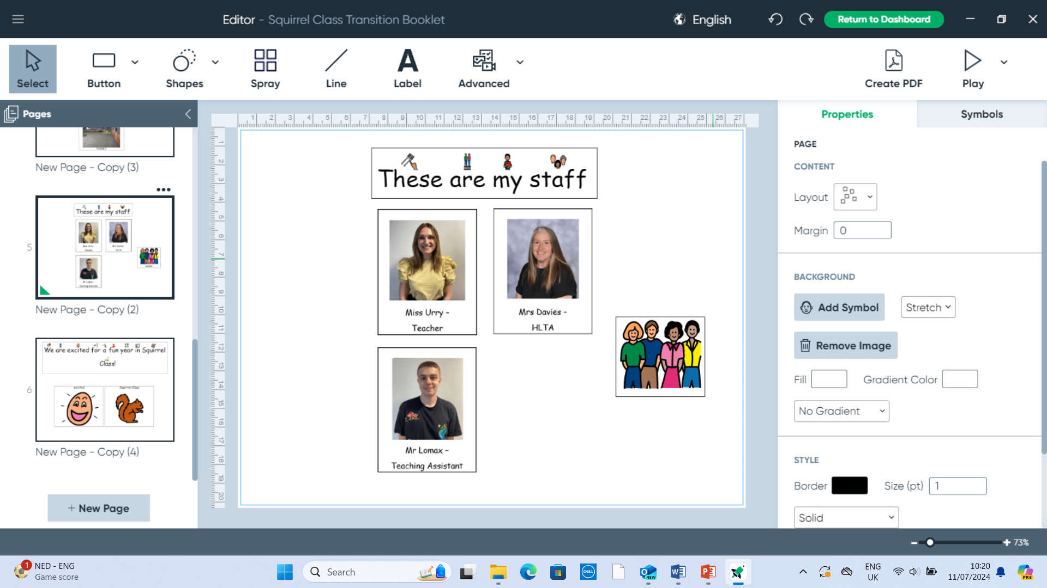

Mathematics

Number

Shape

Coins

Days of the week

Months of the year

Positional language

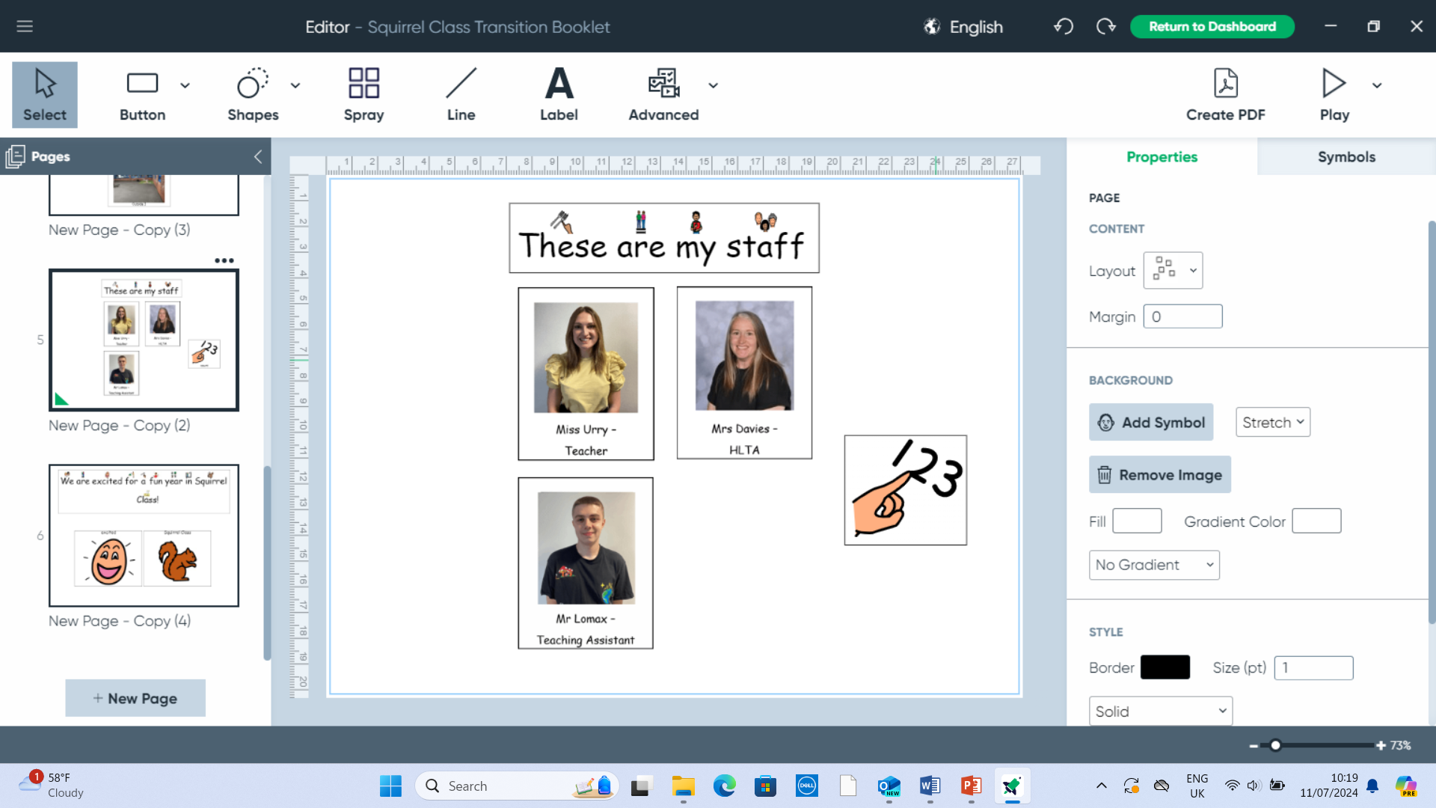

SCERTS: targets are set and reviewed termly based on joint attention, symbol use, and mutual regulation and self-regulation goals. Our SCERTS work focusses on Social Communication, Emotional Regulation and Transactional Supports. We plan our activities around pupil’s SCERTS targets and support our pupil’s in becoming confident and competent social communicators and active learners.