|  |  |  |  |  |  |  |  |  |  |  |  |
| --- | --- | --- | --- | --- | --- | --- | --- | --- | --- | --- | --- |
| **Rose Class** | **Lesson 1** | **Lesson 2** | **Break** | **Lesson 3** | **Dinner** | **Lesson 4** | | **Lesson 5** | | **Lesson 6** |  |
| **Monday** | Greetings/Music (MH) | Computing (ED) | Break time | Attention Autism (ED) | Dinner |  | Story Massage (ED) | PE (Wolves) | | | Home |
| **Tuesday** | Greetings | English | Break time | Topic (Science) | Dinner |  | DT/Art (ED)  Handwriting  Phonics//  Handwriting | | | | Home |
| **Wednesday** | Greetings | Maths | Break time | Topic (RE) | Dinner |  | Food Technology    TA TEACCH baskets | | | | Home |
| **Thursday** | Greetings | English | Break time | Attention Autism | Dinner |  | Science    TA TEACCH baskets | | | | Home |
| **Friday** | Greetings | Maths | Break time | Assembly | Dinner |  | Topic (History/Geography) | | Phonics/Handwriting    TA TEACCH baskets | | Home |

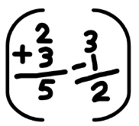

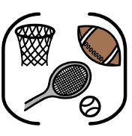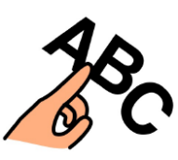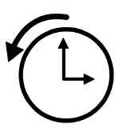 

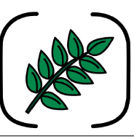 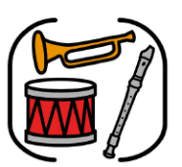

 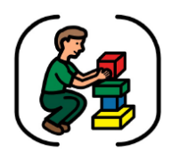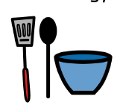

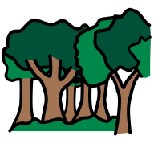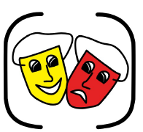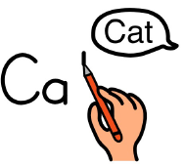

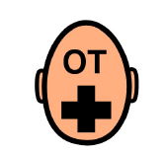 

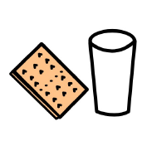

 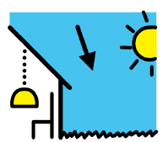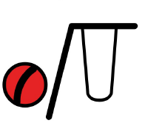

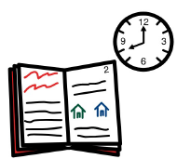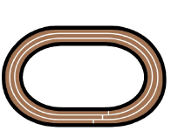

 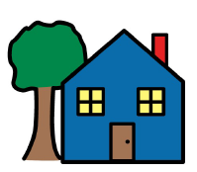

|  |  |  |  |  |  |  |  |  |  |
| --- | --- | --- | --- | --- | --- | --- | --- | --- | --- |
| **Dormouse** | **Reg** | **Lesson 1** | **Lesson 2** | **Break** | **Lesson 3** | **Dinner** | **Lesson 4** | **Lesson 5/6** |  |
| **Monday** |  | English / Handwriting | Music | Break time | Maths | Dinner | Topic - SCERTS | | Home |
| **Tuesday** |  | English - Topic | | Break time | Maths | Dinner | Science Topic | | Home |
| **Wednesday** |  | English (R&S) | Big Sing | Break time | Maths | Dinner | Shopping / PE / Topic (Rotated) | | Home |
| **Thursday** |  | Topic - SCERTS | English - Phonics | Break time | English - Phonics | Dinner | Topic – SCERTS – Food Tech / DT | | Home |
| **Friday** |  | Assembly | Maths | Break time | Topic – SCERTS | Dinner | Topic - SCERTS | PE - Wolves | Home |