**Primrose Class**

*Autumn term*

People All Around Me / Animal Magic

Making choices.

Learning to cooperate.

Learning to communicate.

Learning to mutually regulate.

Learning to self-regulate. Following instructions.

Sharing with others.

Communication and language.

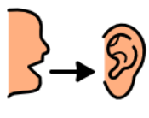

Lots of opportunities to communicate needs.

Use of PECS to make requests.

Listening opportunities

Initiating communications.

Extending communications.

Attention Autism

Personal, Social and emotional development.





English

Phonics phases 1, 2 and 3.

Recognising and writing sounds and words.

Nursery rhymes, songs, actions songs, stories, non-fiction books animals, family and people around us

Mark making skills.

Enjoying books.

Mixing and using colours.

Using different tools and media.

sculptures

Music & movement.

Singing.

Using my senses.

Using malleable materials.

Art/D.T.



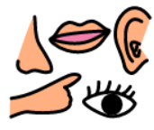

Science/Computing/History/Geography

Life cycles

Animal habitats

Family tree, Changes within living memory

Simple maps

Creating information and internet safety

Mathematics

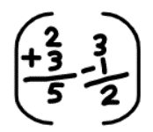

Number - Place Value, counting, addition and subtraction

Geometry - Shape

P.E.

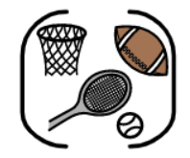

Developing fine motor skills. Developing gross motor skills.

Using the O.T. equipment to regulate.

Using the sensory room.

P.E (Warrington Wolves)