2025-2026 MENU – WEEK 3
OPTION | MONDAY |  | TUESDAY |  |  | WEDNESDAY |  |  | THURSDAY |  |  | FRIDAY
1 | Homemade Tomato and mascarpone pasta bake, served with vegetables |  |  | 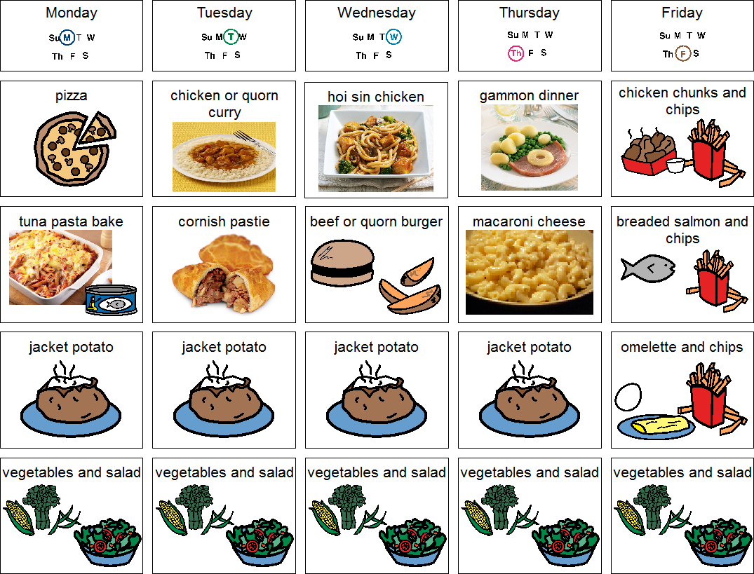 |  | Pepperoni or cheese pizza with jacket wedges & salad |  |  | Pork meatballs in tomato & basil sauce with pasta & garden peas | 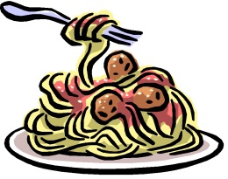 |  | Chicken poppers served with chips & peas or beans | 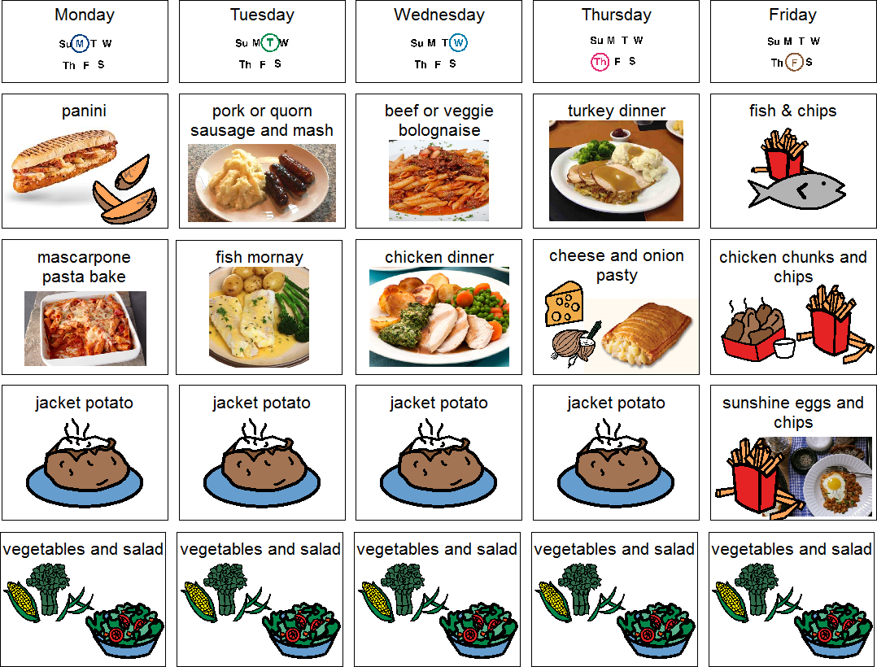
  Chicken Katsu curry served with rice
2 | Omelette with herby diced potatoes & beans |  | Cheese or cheese & ham panini served with sweetcorn & salad |  |  | Sweet & sour chicken or quorn served with rice or noodles | 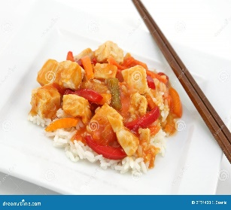 |  |  |  |  | Fish stars served with chips & peas or beans
JP | Jacket Potato |  | Jacket Potato |  |  | Jacket Potato |  |  | Jacket Potato |  |  | Jacket Potato
DESSERTS
 | Fresh fruit segments or yoghurt |  | Chocolate ice cream roll |  | Apple crumble and custard |  |  | Jelly and fruit |  |  | Homemade cookie or biscuit
Available daily as an alternative:- Fruit yoghurt, a selection seasonal fresh fruit, soreen and cheese & biscuits
Unlimited fresh salad and unlimited wholemeal bread
LUNCH WILL BE SERVED WITH FRESH MILK OR WATER
Menu Cycle Week 3: 15th Sep, 6th Oct, 27th Oct, 17th Nov, 8th Dec, 29th Dec, 19th Jan, 9th Feb, 2nd Mar, 23rd Mar, 13th Apr, 4th May, 25th May, 15th Jun, 6th Jul

