2025-2026 MENU – WEEK 2
OPTION | MONDAY |  | TUESDAY |  |  | WEDNESDAY |  |  | THURSDAY |  |  | FRIDAY
1 | Margarita pizza served with baked jacket wedges & sweetcorn |  |  |  |  | Spaghetti Bolognese served with garden peas | 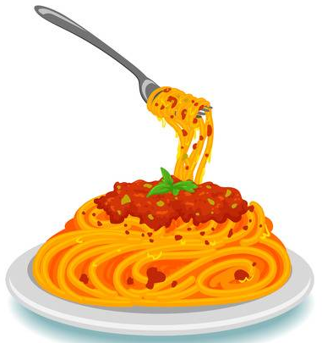 |  | Brunch lunch – sausage, beans, hash brown & omelette | 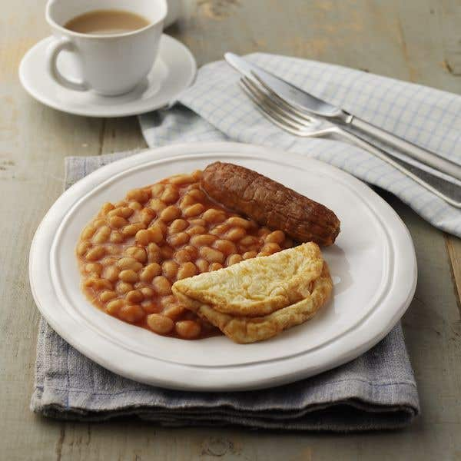 |  | Crumb coated chicken served with chips & peas or beans | 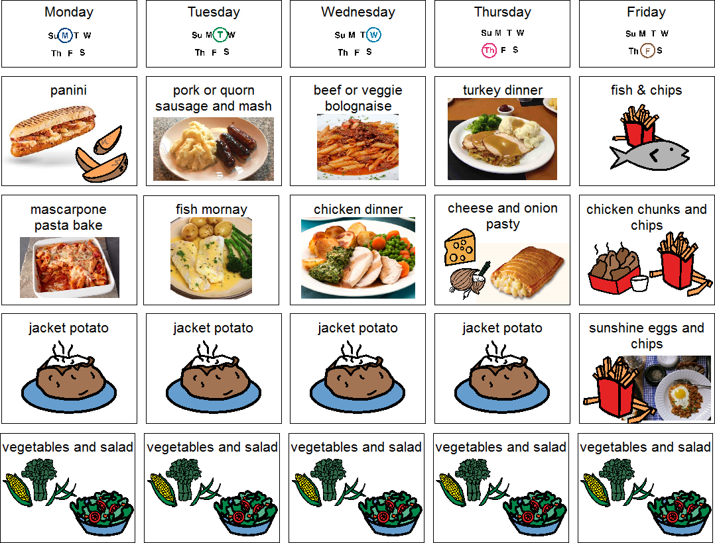
  Pasta bake
2 |  | 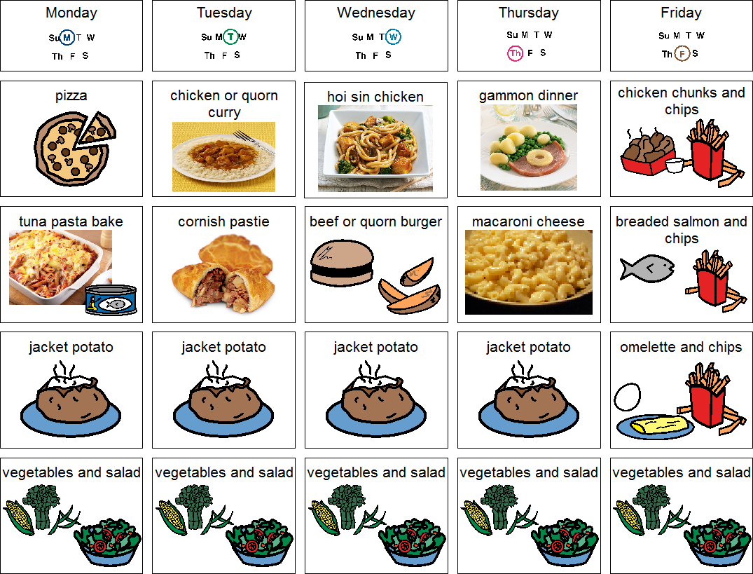 |  |  |  | Garlic & herb chicken pitta with vegetable rice & broccoli | 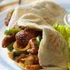 |  |  |  |  | Oven baked battered salmon served with chips & peas or beans
  Vegetarian curry served with rice
JP | Jacket Potato |  | Jacket Potato |  |  | Jacket Potato |  |  | Jacket Potato |  |  | Jacket Potato
DESSERTS
 | Fresh fruit salad or yoghurt |  | Raspberry ripple ice cream roll |  | Jelly and fruit |  |  | Cook’s choice homemade carrot cake or banana and oat cake |  |  | Homemade cook’s choice biscuit
Available daily as an alternative:- Fruit yoghurt, a selection seasonal fresh fruit, soreen and cheese & biscuits
Unlimited fresh salad and unlimited wholemeal bread
LUNCH WILL BE SERVED WITH FRESH MILK OR WATER
Menu Cycle Week 2: 8th Sep, 29th Sep, 20th Oct, 10th Nov, 1st Dec, 22nd Dec, 12th Jan, 2nd Feb, 23rd Feb, 16th Mar, 6th Apr, 27th Apr, 18th May, 8th Jun, 29th Jun, 20th Jul

