2025-2026 MENU – WEEK 1
OPTION | MONDAY |  | TUESDAY |  |  | WEDNESDAY |  |  | THURSDAY |  |  | FRIDAY
1 |  |  |  | 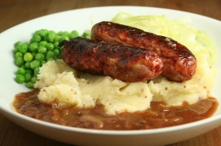 |  | Beef or veggie burger in a bun, herby diced potatoes & fresh salad |  |  | Homemade beef chilli, served with rice | 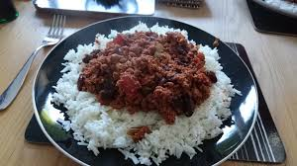 |  | Crumb coated chicken served with chips & peas or baked beans | 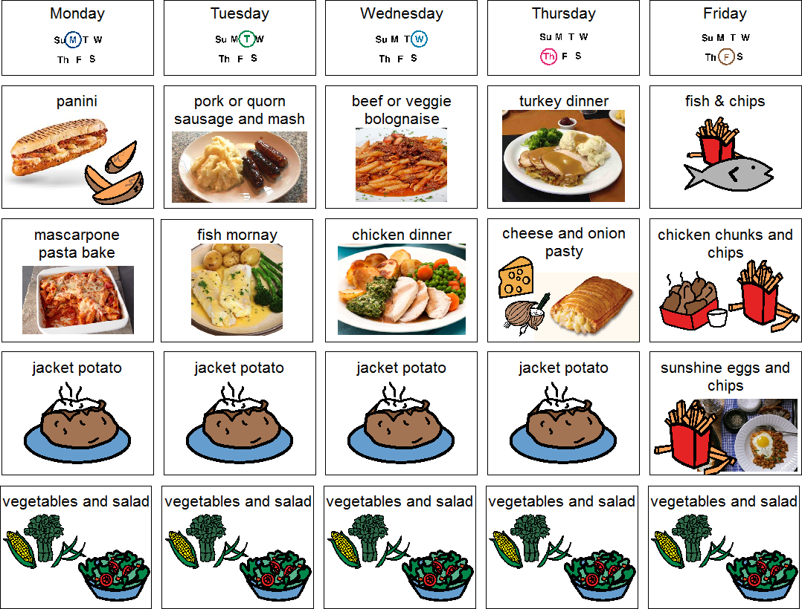
  Vegetarian sausage roll, herby diced potatoes & beans
  Pork sausage & Yorkshire pudding, mash, carrots and peas
2 |  |  |  |  |  |  |  |  | BBQ Chicken or Quorn, with baked wedged potatoes & sweetcorn | 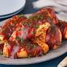 |  | Fish fingers served with chips & garden peas or baked beans | 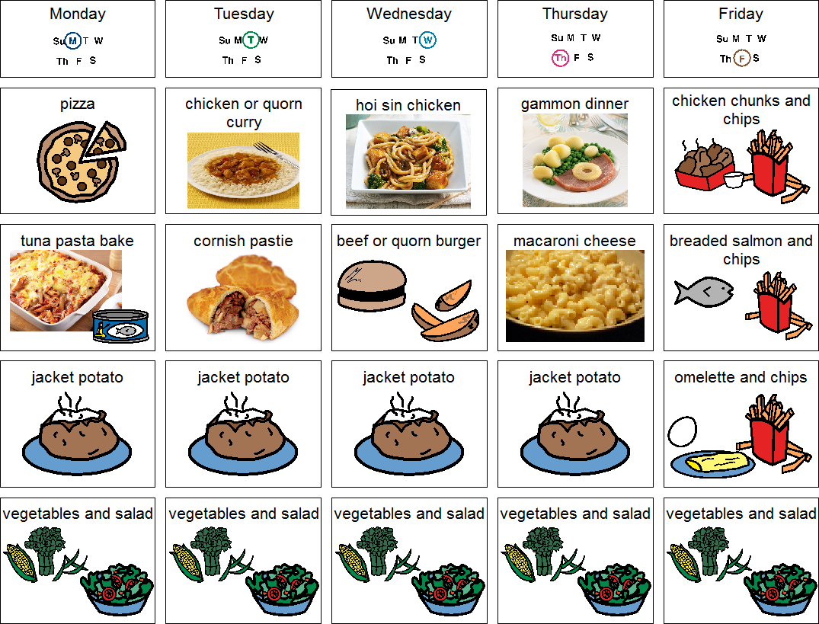
  Homemade Macaroni cheese
JP | Jacket Potato |  | Jacket Potato |  |  | Jacket Potato |  |  | Jacket Potato |  |  | Jacket Potato
DESSERTS
 | Fresh fruit segments or yoghurt |  | Strawberry ripple ice cream roll |  | Homemade blueberry cake |  |  | Jelly and fruit |  |  | Homemade shortbread biscuit
Available daily as an alternative:- Fruit yoghurt, a selection of seasonal fresh fruit, soreen and cheese & biscuits
Unlimited fresh salad and unlimited wholemeal bread
LUNCH WILL BE SERVED WITH FRESH MILK OR WATER
Menu Cycle Week 1: 1st Sep, 22nd Sep, 2nd Sep, 13th Oct, 3rd Nov, 24th Nov, 15th Dec, 5th Jan, 26th Jan, 16th Feb, 9th Mar, 30th Mar, 20th Apr, 11th May, 1st Jun, 22nd Jun, 13th July

