Pupil premium strategy statement
This statement details our school’s use of pupil premium (for the 2024 to 2025 academic year) funding to help improve the attainment of our disadvantaged pupils. It outlines our pupil premium strategy, how we intend to spend the funding in this academic year and the effect that last year’s spending of pupil premium had within our school.

School overview
Detail | Data
School name | Green Lane Community Special School
Number of pupils in school | 208 GLS and 26 College = total of 234 pupils
Proportion (%) of pupil premium eligible pupils | 47.4% inc post 16
Academic year/years that our current pupil premium strategy plan covers (3 year plans are recommended) | 2022-2025
Date this statement was published (3 year plan) | December 2023
Date on which it will be reviewed | July 2025
Statement authorised by | Joanne Mullineux
Pupil premium lead | Sarah Irwin
Governor lead | Andrea Machin
Funding overview
Detail | Amount
Pupil premium funding allocation this academic year | £125,408
Recovery premium funding allocation this academic year | £0
Pupil premium funding carried forward from previous years (enter £0 if not applicable) | £0
Total budget for this academic year  If your school is an academy in a trust that pools this funding, state the amount available to your school this academic year | £125, 408

Part A: Pupil premium strategy plan

Statement of intent
Our aim is to use pupil premium funding to help us achieve and sustain positive outcomes for our disadvantaged pupils, as well as supporting all pupils to become responsible citizens who can make a positive contribution to society. We recognise that disadvantaged children can face a wide range of barriers which may impact on their learning, particularly in terms of:
- Academic attainment
- Progression to further learning and employment
- Social opportunities
- Independent living
- Understanding how to lead a healthy life
At the heart of our approach is high-quality teaching focussed on areas that disadvantaged pupils require it most, targeted support based on robust analysis of pupil progress data, and helping pupils to access a broad and balanced curriculum.
Although our strategy is focused on the needs of disadvantaged pupils, it will benefit all pupils in our school where funding is spent on whole-school approaches, such as high-quality teaching. Implicit in the intended outcomes detailed below, is the intention that outcomes for non-disadvantaged pupils will be improved alongside progress for their disadvantaged peers.
Our objectives are to:
- Remove barriers to learning created by poverty, family circumstance and background, disability or additional need
- Close the gap in attainment with peers internally and externally to Green Lane
- Enable pupils to communicate effectively in a wide range of contexts
- Enable pupils to look after their social and emotional wellbeing and to develop resilience
- Ensure that those pupils who have social, emotional and mental health needs will access high quality provision from appropriately trained adults.
- Allow pupils to access a wide range of opportunities to develop their knowledge and understanding of the world
- Develop independent living skills in preparation for adulthood
Our strategy will be driven by the needs and strengths of each young person, based on formal and informal assessments. This will help us to ensure that we offer them the relevant skills and experience they require to be prepared for adulthood.

Challenges

This details the key challenges to achievement that we have identified among our disadvantaged pupils.
Challenge number | Detail of challenge
1 | Attainment gap between pupils and their peers in Reading, writing, maths and phonics.
2 | Delayed speech and language development including social communication.
3 | Behaviour, Sensory Processing, Emotional and Mental Health.
4 | There are a number of pupils eligible for PP whose attendance is below the school target.
5 | Families needing support in a range of areas that impact on the child, including the cost-of-living crisis.
6 | Low self-esteem, poor self-awareness and social skills and vulnerabilities.
7 | Regression or lost skills in social communication and interaction skills, independence and life skills.
8 | Concerns around pupil mental health, wellbeing and resilience.

Intended outcomes
This explains the outcomes we are aiming for by the end of our current strategy plan, and how we will measure whether they have been achieved.
Intended outcome | Success criteria
Improve reading progress and skills and phonics knowledge, supported by quality reading materials at home and school. | By the end of the academic year (continued) our data will show that at least 85% of PP pupils met or exceeded their personal targets in Reading.  Pupils have a love of reading and read at home and at school.
Continue to improve the speech, language and communication skills of PP pupils. | By the end of the academic year (continued) our data will show that at least 85% of PP pupils met or exceeded their personal targets in Spoken Language. Those pupils accessing NHS SALT, will be making good progress against their personal targets.
Catch up and increase progress for pupils identified as talented mathematicians. | By the end of the academic year (continued) our data will show that at least 85% of PP pupils exceeded their personal targets in Maths.
Deliver a structured programme for teaching and measuring social skills. | Pupils have strong self-awareness, self-esteem, conversation and friendship skills.
Develop pupils’ play skills, social communication, resilience, imagination, investigation and common unity through a bespoke programme. | Increased opportunities to promote positive social, emotional and mental health through outdoor and play based experiences and activities. Focus on continuous provision in EYFS, independent activities and play at social times.
Increase attendance rates for pupils eligible for PP. | PP pupils absence has improved and in the last academic year the gap has narrowed between PP and non PP pupils to 2.74% below non PP pupils. Overall PP attendance to improve to 95% in line with other non PP pupils.
Support families with issues relating to: mental health, behaviour support, family support and finance. | Pupils thrive at school and at home, with parents working in partnership with school and external agencies to access any support needed.  A training calendar including workshops for families is planned throughout the year. These are based on parental feedback.
Provide appropriate resources for PP pupils to access the opportunities offered at school including specific resources, appropriate clothing purchased, educational visit paid for etc. | All pupils fully access school and its opportunities.
Provide therapies for those pupils needing additional support with their mental health and wellbeing. | Pupils that need therapeutic support are referred by staff and access a range of therapeutic interventions (e.g. art, play and horticulture), improving mental health and wellbeing.  Internal training has taken place (ELSA) and is being rolled out across school to further support individual pupils and families.
Support pupils with travel skills and safely accessing the local community. | Pupils are familiar with and feel part of their local community. Pupils at all levels are given opportunities to develop their independent travel skills, ranging from those pupils who are fully supported to those who are capable of travelling to school and back independently.  The offer has been revised to further support pupils who parents had previously not given permission for. An additional Independent Travel plan has been shared which will teach basic road safety to larger groups meaning that more pupils will benefit from this.

Activity in this academic year
This details how we intend to spend our pupil premium this academic year to address the challenges listed above.

Teaching (for example, CPD, recruitment and retention)
Budgeted cost: £34,206.60

Activity | Evidence that supports this approach | Challenge number(s) addressed
To continue to offer and develop quality first teaching through the whole school CPD programme. | - EEF: What happens in the classroom makes the biggest difference: improving teaching quality generally leads to greater improvements.  - The Quality of Education has been judged outstanding by Ofsted.  - Pupils make outstanding progress at Green Lane School (as judged by Ofsted – Latest report - Feb 2025).  - Continuous review and development of the curriculum and outcomes through Pupil Progress Meetings, lesson monitoring and work scrutinies. | 1,2,3,7
Improve phonics knowledge and access to quality reading materials at home and school by subscribing to ELS, Reading Eggs and updating school reading resources both online and offline. | - EEF: Developing reading and comprehension strategies can improve progress by 6+months. Developing and increasing pupil vocabulary allows greater understanding of text and examination materials.  - EEF: Children will need a range of wider language and literacy experiences to develop their understanding of written texts in all their forms. This should include active engagement with different media and genres of texts and a wide range of content topics.  - EEF: Digital technology can improve pupil progress by 4+ months.  - EEF: Diagnostic assessment can be used to inform professional judgement about the best next steps; it also makes teaching more efficient by ensuring that effort is not wasted on rehearsing skills or content that a pupil already knows well.  - Reading eggs has engaged pupils at school and at home. Parents report that ebook subscriptions have engaged hard to reach children. | 1,2,7
Train staff and purchase resources to deliver the Talkabout programme, which teaches and measures progress in social skills. | - EEF: Interventions which target social and emotional learning seek to improve pupils’ interaction with others and self-management of emotions can have +4 months impact on progress.  - EEF: Small group tuition can increase progress by 4+months when targeted effectively.  - Talkabout has been recommended to us by the NHS SALT team.  - Staff delivering the programme report positive feedback and progress. | 1,2,3,6,7
Work with a play therapist to create and resource a bespoke programme that will develop social Interaction, communication, imagination, investigative skills and confidence. | - EEF: Personalised packages of support tailored to suit individuals can improve pupil progress by 3+months. | 2,3,6,7
Training Year 9-11 pupils about road safety awareness.  Training Year 9–11 pupils to use public transport.  This will involve CPD and release time for two staff members. | Independent Travel Training is likely to enhance pupils’ social and employment opportunities:  - Department for Education (publishing.service.gov.uk)  In offering Road Safety Awareness prior to travel training within the community, more pupils will access this. It will also enable public travel to begin much quicker. | 2,6,7
Provide IT resources focussed on supporting high quality teaching and learning | - EEF: Technology can be used to improve the quality of explanations and modelling  - EEF: Technology offers ways to improve the impact of pupil practice  - EEF: Technology can play a role in improving assessment and feedback | 1,2,6,7
Warrington Wolves | - Primary PE Sports Premium supports the delivery of exceptional PE delivery through WW coaches. https://www.gov.uk/guidance/pe-and-sport-premium-for-primary-schools  - CPD opportunity for staff to work alongside coaches.  - Improved teaching and learning within PE and outcomes in KS4. | 3, 6, 7, 8
LiveMusicNow! | - Significant benefits to live music within schools including enriching learning, building confidence, developing skills, teaching teamwork, promoting engagement.  - The Power of Music to Change Lives - https://assets.publishing.service.gov.uk/media/62bc1242d3bf7f292040d364/The_Power_of_Music_to_Change_Lives.pdf | 2, 3, 6, 7, 8

Targeted academic support (for example, tutoring, one-to-one support structured interventions)
Budgeted cost: £29,246

Activity | Evidence that supports this approach | Challenge number(s) addressed
ELSA | - CPD training for 2x staff to complete School based Emotional Literacy Support to support the emotional well-being of pupils.  - Staffing costs for therapeutic intervention delivery.  - Purchase a bank of resources that can be developed over time to support with ELSA. | 3, 6, 8
Improve Speech and Language skills across the school by employing an additional full time Level 3 TA to deliver speech and language programmes under the guidance of NHS Therapists. | - EEF: Targeted timely intervention can improve academic progress and social and emotional resilience by +3 months.  - EEF: Small group tuition can increase progress by 4+months when targeted effectively.  - EEF: One to one tuition can increase progress by 5+ months when targeted effectively.  - EEF: Developing reading and comprehension strategies can improve progress by 6+months. Developing and increasing pupil vocabulary allows greater understanding of text and examination materials.  - The Communication Trust worked with the Better Communication Research Programme to develop the What Works database of evidenced interventions to support children’s speech, language and communication.  What works database (ican.org.uk)  - This has been endorsed by the Royal College of Speech and Language Therapists.  - We have invested in L3 and HLTA staff to deliver SALT in recent years. This has proven to be successful, and we want to ensure that this continues.  - The impact has been very positive and as a result most pupils eligible for PP have met or exceeded their personal targets across the school. | 1,2,6,7
To support pupils in accessing lessons within mainstream education, as appropriate. | - Pupil has been entered for GCSE examinations.  - Pupil confidence and self-esteem has significantly improved.  - Stronger links with mainstream colleagues to improve support networks from SEND-Mainstream and vice-versa. | 1,7

Wider strategies (for example, related to attendance, behaviour, wellbeing)
Budgeted cost: £74,590.01

Activity | Evidence that supports this approach | Challenge number(s) addressed
Continue to support pupils and their families to improve life chances.  Continue to Fund a Level 4 TA to provide a Family Support Worker role and have a key Safeguarding role.  Improve the attendance rate for all pupils to 95% for the school year. | - EFF: Parental engagement can have a positive impact on pupil progress by 3+ months impact on progress as stated by the EEF  - NFER: Poor attendance is one of the biggest barriers to learning. addressing attendance is a key priority  - We have invested in 2x Family Support Workers and 1x Safeguarding Manager. They attend a variety of child and family centred meetings e.g. child in need, (CiN) or child in care (CiC). The impact has been very positive and as a result many families have been able to access services from a range of other agencies.  - Increasing numbers of families accessing support for issues relating to: mental health, behaviour support, family support, finance.  - Positive parental engagement can support pupil progress and attendance | 3,4,5,6,7
PP used to pay for a play therapist to deliver sessions to specific pupils.  PP used to pay for an art therapist to deliver sessions to specific pupils.  To support disadvantaged families with the costs involved in trips and visits. | - EEF: Personalised packages of support tailored to suit individuals can improve pupil progress by 3+months.  - EEF: Interventions which target social and emotional learning seek to improve pupils’ interaction with others and self-management of emotions can have +4 months impact on progress.  - EEF: Arts participation can increase progress by 2 months  - EEF: There is some evidence that enrichment activities, such as sports participation, may lead to improvements in attendance. There is evidence that outdoor adventure learning can have a positive impact on attainment.  - Children from disadvantaged families may not be able to attend school trips, events or access resources which will disadvantage their access to a broad and balanced curriculum. | 3,4,6,7
Fund two Forest School Leaders (one day a week each) to deliver sessions to classes on a rolling programme. | - EEF: Interventions which target social and emotional learning seek to improve pupils’ interaction with others and self-management of emotions can have +4 months impact on progress. | 1,2,3,6,7,8

Total budgeted cost: £ 138, 052.61
*Overspend of £12, 634.61 due to ongoing commitments to support PP pupils – This is included in the school budget.

Part B: Review of outcomes in the previous academic year

Pupil premium strategy outcomes
This details the impact that our pupil premium activity had on pupils in the 2024 to 2025 academic year.
- Pupil Premium Data Continues to be strong and shows that pupils in receipt of this premium generally perform as well as their peers, and better in many cases.
- Pupil’s in receipt of pupil premium funding have had opportunities to experience curriculum enhancements such as a theatrical production, sensory visits, external visitor workshops within school and live music sessions, which have further developed their social skills and love of learning outside of the classroom.
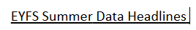
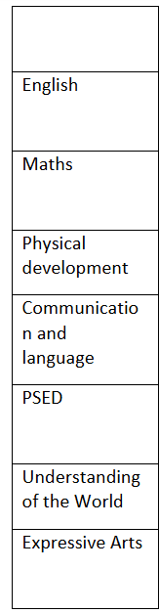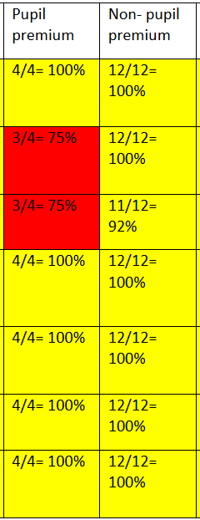
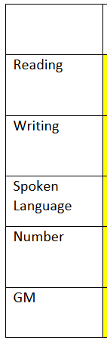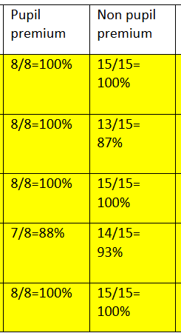
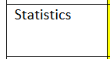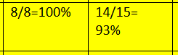
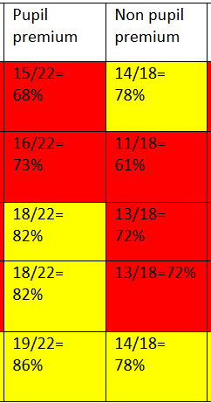
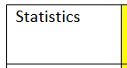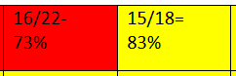
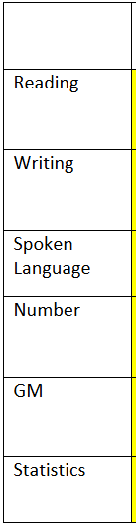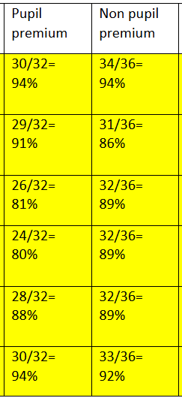
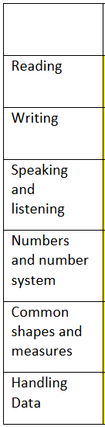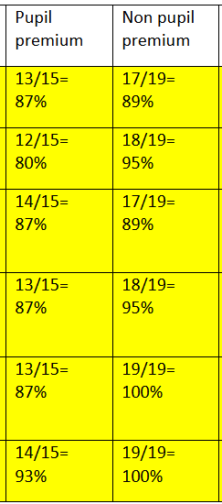
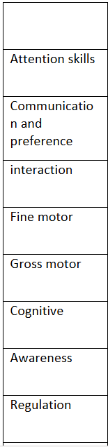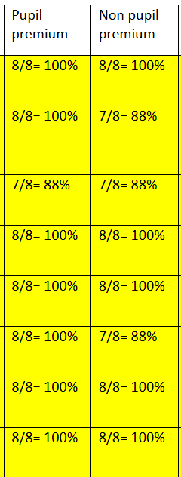
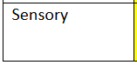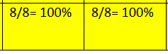

- 2x new staff have completed ELSA training, 1x staff member is currently completing training. This has ensured that pupil premium pupils have opportunities to additional weekly therapies within school. ELSA therapists support pupils with loss and bereavement, Emotional Literacy, Self-esteem, Social Skills, Friendship issues, Relationships, Managing strong feelings, Anxieties and worries, Bullying, Conflict, Emotional Regulation, Growth Mindset, Social and therapeutic stories and Problem solving.
- Attendance rates were 93.10% in the year 2024 – 2025. Pupil Premium children exceeded this with an attendance figure of 94.03%. 2 LAC pupils achieved 100% attendance.
- At Green Lane we offer Independent Travel Training to children and young people who have special educational needs. We train them on a set of essential skills to enable them to travel independently to and from school or college. Travel Training has further developed this year with a new programme in which pupils who are not ready to travel independently have accessed road safety sessions in preparation for this next week to travel independently. We have had a lot of success and development from individual pupils. Increased confidence has been seen when out in the community, by having more knowledge and recognition of the local area and being able to ask questions that help with their problem-solving skills. Some pupils that have found it hard to speak in public but have made progress by being able to use their manners when getting on and off the bus, which is a great achievement for them. Social skills have increased when travelling with other pupils that they may not have been familiar with. They talk and create conversations between themselves and members of staff. Children have now expressed an interest in wanting to travel independently or with friends in their local area.
- Our Forest School offer continues to be strong and all pupils have access to it on a yearly cycle. A new member of staff has completed training to become a Forest School Leader so that more pupils can access Forest School. Pupils develop soft skills such as collaboration, teamwork, problem solving and social communication. The sessions also promote wellbeing and good mental health, life skills such as personal safety and physical exercise. Focussed Forest School sessions run as a mental health and wellbeing intervention and supports individual pupils who need a bespoke offer.
- We are in the process of developing a new pastoral role. This person will work alongside the safeguarding team to further support pupils across school and their families.
- Parental feedback is positive and parents have shared that they like the new, ‘you said we did’ information that follows, following data collation.
- 70% of pupils have an autism diagnosis. Pupils are assessed by a trained OT and a personalised programme is created for them. The programme requires a variety of resources and the nature of the programmes lead to ongoing wear and tear of resources. Behaviour data supports the impact of these programmes as there would be more instances of dysregulation if sensory diets and snacks were not being accessed.

Externally provided programmes
Please include the names of any non-DfE programmes that you purchased in the previous academic year. This will help the Department for Education identify which ones are popular in England
Programme | Provider
Reading Eggs | Reading Eggs
Essential Letters and Sounds | Essential Letters and Sounds

Service pupil premium funding (optional)
For schools that receive this funding, you may wish to provide the following information:
Measure | Details
How did you spend your service pupil premium allocation last academic year?
What was the impact of that spending on service pupil premium eligible pupils?

