Primrose Class
Autumn term
People All Around Me / Animal Magic

Making choices.
Learning to cooperate.
Learning to communicate.
Learning to mutually regulate.
Learning to self-regulate. Following instructions.
Sharing with others.

Communication and language.

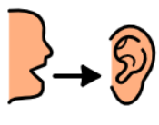
Lots of opportunities to communicate needs.
Use of PECS to make requests.
Listening opportunities
Initiating communications.
Extending communications.
Attention Autism

Personal, Social and emotional development.




English

Phonics phases 1, 2 and 3.
Recognising and writing sounds and words.
Nursery rhymes, songs, actions songs, stories, non-fiction books animals, family and people around us
Mark making skills.
Enjoying books.

Mixing and using colours.
Using different tools and media.
sculptures
Music & movement.
Singing.
Using my senses.
Using malleable materials.

Art/D.T.


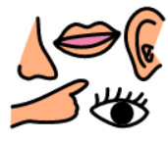
Science/Computing/History/Geography

Life cycles
Animal habitats
Family tree, Changes within living memory
Simple maps
Creating information and internet safety
Mathematics

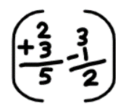
Number - Place Value, counting, addition and subtraction

Geometry - Shape

P.E.

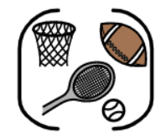
Developing fine motor skills. Developing gross motor skills.
Using the O.T. equipment to regulate.
Using the sensory room.
P.E (Warrington Wolves)

