Primrose Class
Spring term
Fire! Fire! / Around the World

Making choices.
Learning to cooperate.
Learning to communicate.
Learning to mutually regulate.
Learning to self-regulate. Following instructions.
Sharing with others.

Lots of opportunities to communicate needs.
Use of PECS to make requests.
Listening opportunities
Initiating communications.
Extending communications.
Attention Autism

Personal, Social and emotional development.


Communication and language.

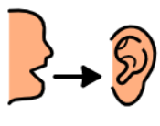

English


Phonics phases 1, 2 and 3.
Recognising and writing sounds and words.
Nursery rhymes, songs, actions songs, stories, non-fiction books about materials, fantasy stories, different countries and cultures.
Mark making skills.
Enjoying books.

Mixing and using colours.
Using different tools and media.
Collage
Music & movement.
Singing.
Using my senses.
Using malleable materials.

Art/D.T.



Mathematics

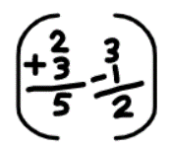
Number – Multiplication and division, Place Value
Geometry – Position and direction
Measurement –
Money

Science/Computing/History/Geography

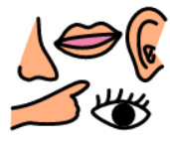
Materials and volcanoes.
The Great fire of London.
Countries around the world.
Multimedia art and exploring stories through technology.
P.E.


Developing fine motor skills. Developing gross motor skills.
Using the O.T. equipment to regulate.
Using the sensory room.
P.E (Warrington Wolves)

