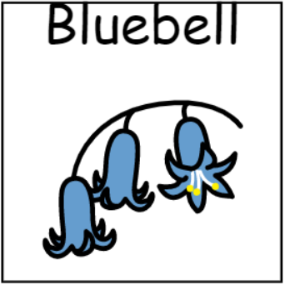
Bluebell Class
2025/26

Our Topics

Autumn 1: People all around us
Autumn 2: Animal Magic
Spring 1: Fire! Fire!
Spring 2: All Around the World
Summer 1: Holidays
Summer 2: Town and Country

Design Technology

Autumn 1: Photo Frames
Autumn 2: Moving Pictures - Animals
Spring 1: Emergency Vehicles
Summer 1: Aeroplanes
Summer 2: Structures: Buildings
Art

Autumn 1: Portraits
Autumn 2: Animal Prints
Spring 1: Collage
Spring 2: Indian Art
Summer 1: Travel inspired art
Summer 2: Town and Country Sculpture and Modelling
History

Autumn: My Family History
Spring: The Great Fire of London
Summer: Seaside Holidays: Then and Now
Geography

Autumn: Simple Maps
Spring: Countries Around the World
Summer: My Town and My Country
Science

Autumn 1: Life Cycles
Autumn 2: Animals and Habitats
Spring 1: Materials
Spring 2: Volcanoes
Summer 1: Investigating and experimenting
Summer 2: How does it light up?
English

Autumn 1: People Who Help Us – Information Texts
Autumn 2: Shape Poems/Acrostic Poems/Animal Rhymes
Spring 1: Stories about Dragons – Fantasy Stories
Spring 2: Multicultural stories
Summer 1: Leaflets – Holidays/Transport
Summer 2: Fables – The Town Mouse and the Country Mouse
Maths

Autumn: Place Value, Counting, Addition, Subtraction, Shape, Pattern, Time
Spring: Sorting, Counting, Addition, Subtraction, Length and Height, Mass and Volume
Summer: Number Recognition, Sequencing, Multiplication and Division, Fractions, Position and Direction, Money, Time

Music

Autumn 1: Recognising different sounds
Autumn 2: Glockenspiel Stage 1
Spring 1: Exploring Improvisation
Spring 2: 3 Little Birds
Summer 1: Our Big Concert
Summer 2: Reflect, Rewind, Replay
PE

Autumn 1: Gymnastics
Autumn 2: Athletics
Spring 1: Dance
Spring 2: Tennis
Summer 1: Basketball
Summer 2: Cricket
Modern Foreign Languages

Autumn 1: European Languages Day
Autumn 2: Spanish Christmas Market
Spring 1: Spanish Traditions – Carnival
Spring 2: Spanish Holiday – Journey to Spain
Summer 1: Spanish Festivals – Córdoba
Summer 2: Spanish Music – Flamenco
PSHE

Autumn 1: People who look after me
Autumn 2: Caring for Animals
Spring 1: Keeping safe and knowing who to ask for help (999)
Spring 2: Identifying how people are the same and different
Summer 1: Exploring my feelings
Summer 2: Comparing different jobs
Computing

Autumn 1: Creating Information
Autumn 2: Internet Safety
Spring 1: Multimedia Art
Spring 2: Exploring stories through technology
Summer 1: Programmable Toys
Summer 2: Sorting and Classifying
Food Technology

Autumn 1: Family Cooking
Autumn 2: Biscuits
Spring 1: Hot and Cold Foods
Spring 2: Foods of the World
Summer 1: Foods to take on a road trip
Summer 2: Gingerbread Houses
RE

Autumn 1: Our Wonderful World – Plants
Autumn 2: Christianity – The Wise Men and gifts for baby Jesus
Spring 1: What do Hindus celebrate? – Raksha Bandhan
Spring 2: What do Sikhs believe? – Working hard and honesty
Summer 1: Special Places in our town – Visits to places of worship
Summer 2: Special Places in our town – Visits to places of worship

