My Bendrigg Residential Adventure

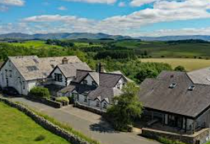

This story is about my residential trip from Green Lane School to Bendrigg Trust.

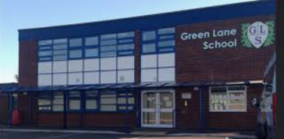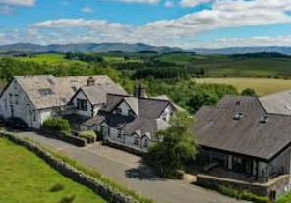


The adults leading our residential are:
 
Mrs Irwin Mrs VanRooy
Other staff that are coming on residential with us are:

Mr Gaskell Miss Urry Mrs Sweeney
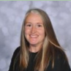
Mrs Fitzpatrick Ms White Mrs Davies

Miss Taylor Mrs Chapman Miss McElroy

Miss Wright Mrs Green Mrs Dumican

Mrs Gorman Mrs Taylor Mrs Lothrop
They will help to keep me safe and happy.

Getting Ready to Go
I am going on residential to Bendrigg Trust on Wednesday 25th February.
On this day, I will bring my belongings to school with me.
My teachers will help me make sure I have everything I need.
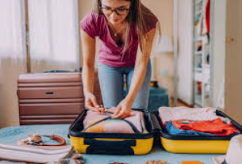

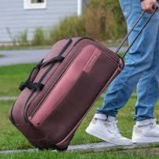
Travelling to Bendrigg
We will travel to Bendrigg in the school minibuses.
I will travel with my friends and teachers.
If I feel worried, I can talk to an adult.


Arriving at Bendrigg
When we arrive, we will be shown to our rooms.
An adult will help me make my bed.
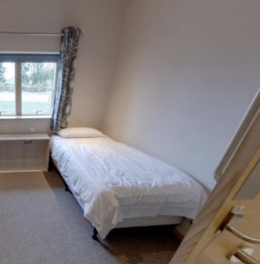

My Bedroom
My teacher will tell me before we go which friends I am sharing a bedroom with.
I might share with friends or I might have my own room.
Both are okay.
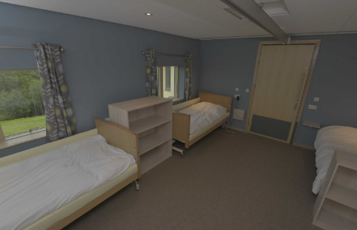


The Adults Helping Me
My teachers will be with me during the day and night.
They are there to help me with anything I need.
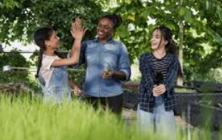
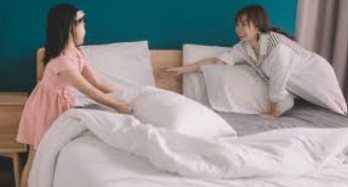

Activities at Bendrigg
I will have the chance to try lots of fun activities like:
Archery, bikes, sensory swing, tube slide, climbing, canoeing, sports, indoor cave, sensory room and orienteering.
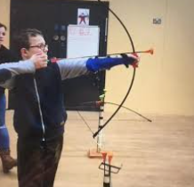 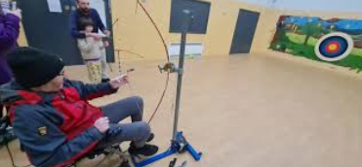
archery
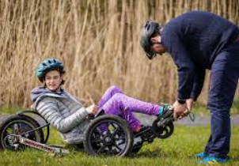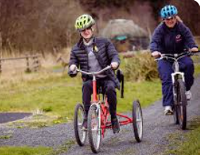
bikes

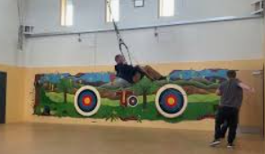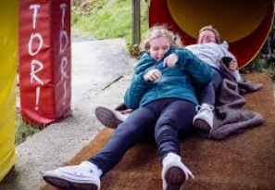
sensory swing tube slide
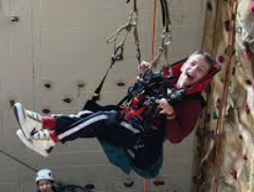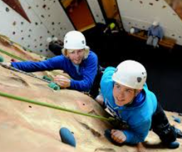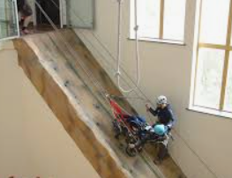
climbing wall
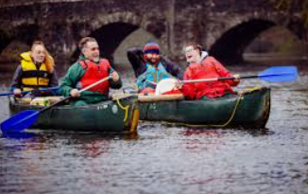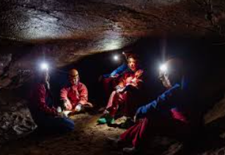
canoeing indoor cave
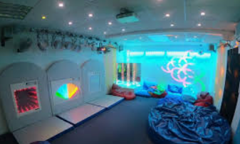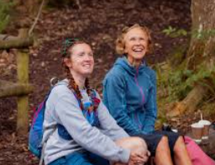
sensory room orienteering

Mealtimes
I will eat breakfast, lunch and tea at Bendrigg with my friends.
Mealtimes are a nice time to relax and talk.


How I Might Feel
I might feel excited, nervous or happy.
All feelings are okay.
If I feel worried, I can ask an adult for help.
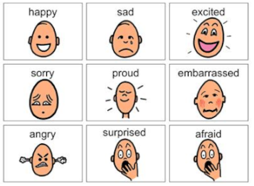

A Wonderful Experience
Going on residential is going to be a wonderful experience.
I will have fun, make memories and try new things.
