   |  |   Joanne Mullineux  Headteacher  Sarah Irwin  Deputy Headteacher
16th December 2025

Dear Parents and Carers,

It feels like a lifetime ago since we first met to talk about the Key Stage 3 Residential to Bendrigg. However, we are now only 2 months away! Below is all of the key information that you will need to prepare for your child’s visit to Bendrigg.

On Monday 26th January there will be a parents/carers meeting with myself and Mrs VanRooy to talk through the information in this letter and answer any questions that you may have. The staff who will be accompanying the visit will also be in attendance. I am sure that you will have met the majority of staff before, but it is always good to be able to put names to faces for anyone unfamiliar. The meeting will take place in the school hall from 3:30pm – 4:30pm. If you are collecting your child from school that day, they are more than welcome to join us.

Payments
Thank you to all of you who have now paid in full. For those paying in instalments, the final payment is due via parentpay in January 2026. If you are experiencing any problems relating to payments, please contact the school office.

Dates and times
We will be leaving school on Wednesday 25th February at 10:30am and returning to school on Friday 27th February 2026 by 12:00.

Luggage can be dropped off at the office, at one of the following times:
Tuesday 24th February – Drop off between 1-3
Wednesday 25th February – Drop off either at school drop off or alternatively between 9:15 – 9:45 once the car park has cleared.

Alternatively, if your child comes to school on transport and you would like to send their luggage with them, please check with transport in advance that they have the space to store this on the bus.

Please ensure that all clothing and luggage is clearly labelled with your child’s name or initials.

On Friday 27th February the children are likely to be tired after a full 2 days of activities. You are welcome to collect your child from school at 12:00. Alternatively, pupils staying in school will have the opportunity to have a quieter afternoon and finish at the usual time of 3:20pm.

Please note that you will need to contact transport directly if your child travels by Warrington Borough Council transport, to let them know that your child will not require transport for the duration of the visit.

Staffing
There is a large team of Green Lane staff who know your children well and will be accompanying the residential visit. Mrs Irwin and Mrs VanRooy are the lead staff for the residential and are available to answer any questions in advance. In addition to the Green Lane team, a number of Bendrigg staff will also be supporting pupils with activities during the day. Bendrigg staff are all fully trained and DBS checked. Allocated staff will be on night duty and will remain with pupils identified as needing support throughout the night. There will be at minimum 1 member of SLT available during the day and another at night.

Mobile phones and iPad/tablets
For safeguarding reasons pupils are not permitted to bring mobile phones. Mrs Irwin will inform school when we arrive at Bendrigg and a parentmail will be sent to let you all know that we have arrived safely.

Please ensure that you are set up on Evidence for Learning as photographs will be shared throughout the visit. If you require any support prior to the visit, please contact your child’s class teacher who will let Miss Taylor know.

Mrs Irwin will then inform school on the day of departure when we are leaving and a parentmail will be sent to let you know that we are on our way.

Mrs Irwin and Mrs VanRooy will have mobile phones and emergency contact details for all pupils. Please be assured that in the event of an emergency we would contact you directly however, due to the number of pupils attending are unable to make individual calls beyond this.

Ideally, iPad/tablets will not accompany pupils on the residential. However, we understand that some pupils will want to watch their iPad/tablets in bed or at social times and that this is part of their routine. In this instance pupils are allowed to bring iPad/tablets with them, however, they will need to be clearly labelled and be in a protective case with a screen protector. Whilst school will do our very best to ensure that iPad are handled with care, parents who choose to send one accept that school are not liable for any damage to them.

Facilities onsite
Laundry facilities are available for emergency use only. Bendrigg also have a wide range of accessible aids available on a first come first serve basis, this includes shower chairs & commodes, door alarms, night lights & audio-visual monitors. Please state below if your child will require any of the accessible aids so that we can request them in advance.

Medication
If your child requires medication whilst on residential this will need to be signed over to staff on the morning of Wednesday 25th February. Mrs Chadwick will be available from 8:30 – 9:45 to receive any medication. Please note that all medication will need to be prescribed by your child’s GP and have a clear label showing the date issued, expiry date and dosage. Medication that has not been prescribed by the GP cannot be accepted.

Attached is a blank medication form. Please can this be completed in advance and handed FAO Mrs Chadwick by Friday 6th February. This will allow Mrs Chadwick time to review all of the medication and storage requirements in advance. If your child is prescribed any new medications after this date that they will need to take on residential, please complete a new medication form and send into school as soon as possible.

Mrs Chadwick will then be available upon our return to sign out any medication and hand this back to you. If your child will be remaining in school, then transport will be made aware so that they can ensure it reaches you safely.

Bendrigg require all parents and carers to complete an online form in which you will be asked for any medical or/and dietary requirements. You can access the form here – https://bendrigg.jotform.com/team/bookings-team/green-lane-community-special-school Please ensure that this is completed by Friday 16th January 2026.

Kit list
A lot of the time will be spent outdoors, so I advise you to pack comfortable, loose-fitting and warm clothes for activities. All specialised clothing (e.g. waterproofs and wellies) and safety equipment (e.g. helmets and harnesses) will be provided by Bendrigg.

4-8 sets of comfortable loose fitting clothing for activities
Trainers or comfortable appropriate shoes
Warm coat
Hat and gloves
Water bottle (for drinking)
Towel
Toiletries
Medication
Sleepwear
Slippers or indoor shoes
Soft toy or comforter
Money for a souvenir from the gift shop (no more than £10)

Activities
Bendrigg have confirmed our activities for the visit and it looks amazing! Pupils will be split into 4 groups, each group will have two group leaders – One from Bendrigg who will lead the activities and one from school. Additional Bendrigg staff and Green Lane staff will support each group. Throughout the course of the visit all pupils will have the opportunity to experience:
- Archery
- Bikes
- Sensory Swing
- Tube slide
- Orienteering
- Sports Hall
- Sensory Room
- Indoor Cave
- Climbing Wall
- Canoeing

Pupils will also have the opportunity, with staff support, to explore the grounds and relax in the lounge.

Meals and snacks
Breakfast, lunch and tea, along with snacks throughout the day and evening are all provided. Food is all homemade and from experience, I can say that it is delicious! Bendrigg will cater for all dietary requirements, please ensure that you share these on the online form (link above.) Please do not send your child with food, unless agreed with Mrs Irwin, via email in advance.

We are all really looking forward to the visit and know that it will be an unforgettable experience for all!

If you have any questions or concerns please contact me at school or on the ks3residential@greenlaneschool.co.uk email address.

Yours sincerely,

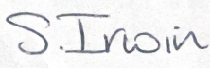

Mrs Sarah Irwin
Deputy Headteacher

Bendrigg – Key Stage 3 Residential

Please answer all questions below and return to school FAO Mrs Irwin by Friday 16th January 2026.

Pupil name:
Class group:
Emergency Contact information
Contact 1
Name | Relationship to pupil | Address | Email address | Telephone number
Contact 2
Name | Relationship to pupil | Address | Email address | Telephone number

My child will / will not require medication whilst on residential.

If yes, I understand that any medication will need to be prescribed, as described above and agree to sign over this medication on the morning of 25th February between the agreed times.

Medication list

Name of medication | How often it is taken | Time it is taken | Dosage | How it is taken, e.g. swallow with a drink | Any issues taking it?

My child will / will not require any accessible aids.

If yes, please select the aids that your child will require:

Tick if needed
 | Mobile hoist | 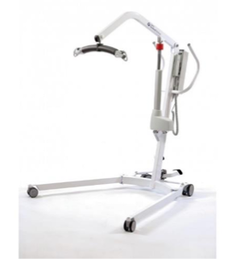
 | Sling (please send your child’s own sling with them. Slings are available in case they get wet or damaged) | 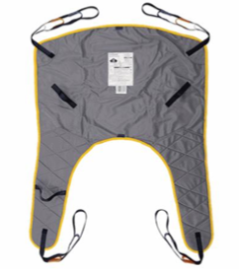
 | Shower/toilet chair | 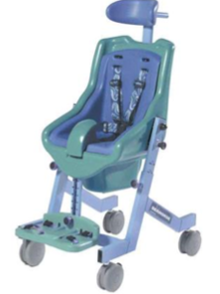
 | Shower chair | 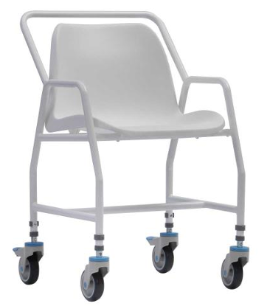
 | Shower commode chair | 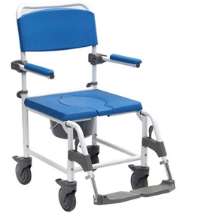
 | Commode | 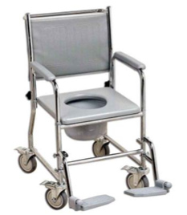
 | Commode – Self propelling | 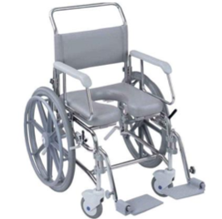
 | Hydraulic shower trolley | 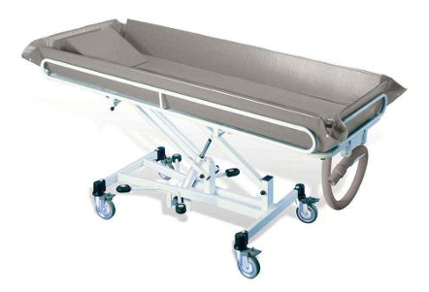
 | Padded bedside protectors | 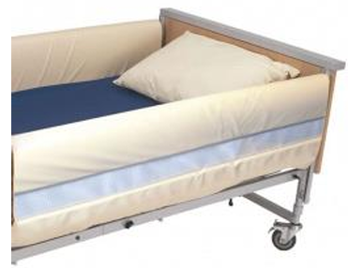
 | Electric fan | 
 | Door alarm | 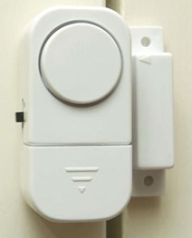
 | Night light | 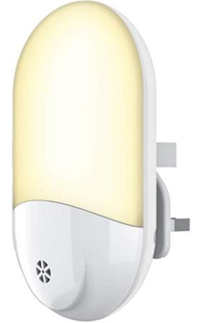
 | Audi-visual monitor | 
 | Toilet seat topper | 
 | Posture wedge | 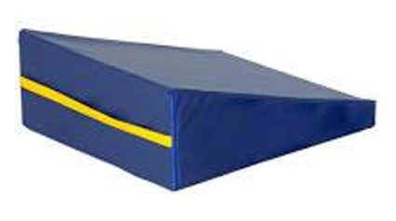
 | Standing and raising aid | 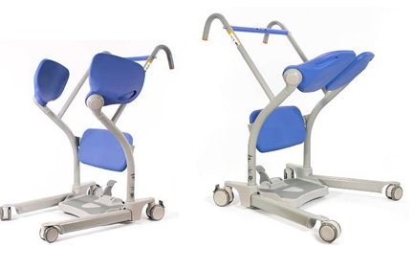

On Friday 27th February I will:

Collect my child from school at 12:00 (please note that parents/carers are responsible for informing transport.)
My child will remain in school and return home at the end of the school day.

Signed: ___________________________________________ Parent/Carer

Name: ____________________________________________ Parent/Carer

