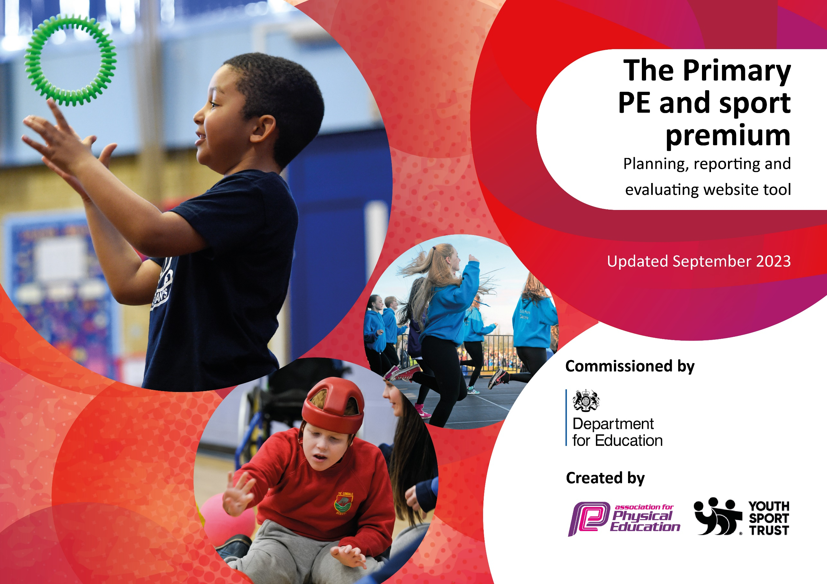

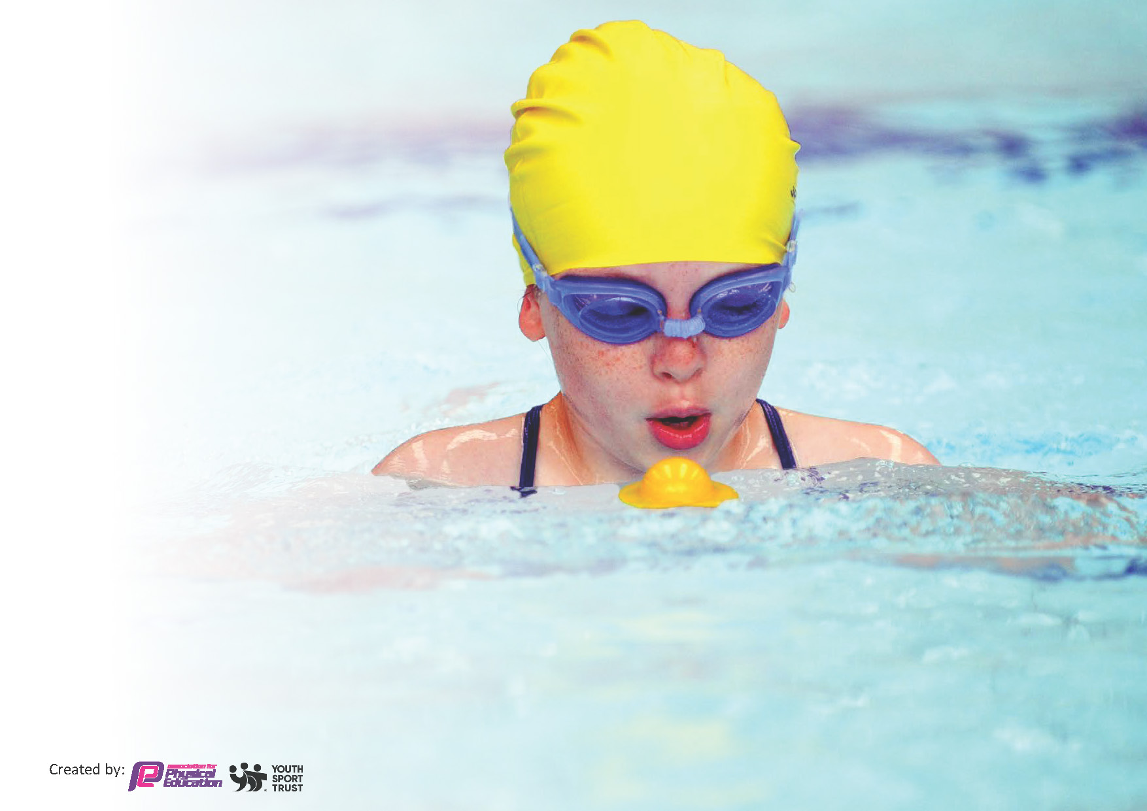
This template can be used for multiple purposes:
by:
- It enables schools to effectively plan their use of the Primary PE and sport premium
- It helps schools to meet the requirements (as set out in guidance) to publish information on their Primary PE and sport premium
- It will be an effective document to support Ofsted inspections enabling schools to evidence progress in Physical Education (PE) and evidence swimming attainment, which forms part of the PE National Curriculum. We would recommend schools consider
the Intent, Implementation and Impact of any spend, as examined within the Education Inspection Framework.

It is important that your grant is used effectively and based on school need.

Schools must use the funding to make additional and sustainable
improvements to the quality of the PE, School Sport and Physical Activity (PESSPA)
they offer. This means that you should use the Primary PE and sport premium to:

- Build capacity and capability within the school to ensure that improvements made now will benefit pupils joining the school in future years
- Develop or add to the PESSPA activities that your school already offers.

The Primary PE and sport premium should not be used to fund capital spend projects; the school’s core budget should fund these. Further detail on capital expenditure can be found in the updated Primary PE and sport premium guidance.

The Primary PE and sport premium guidance, outlines 5 key priorities that funding should be used towards. It is not

necessary that spending has to meet all the key priorities, you should select the priorities that you aim to use any funding towards.

Although completing this template is not a requirement for schools, schools are required to publish details of how they spend this funding. Schools must also outline what the impact this funding has had on pupils’ PE and sport participation and attainment and how any spending will be sustainable in the future. All funding must be spent by 31st July 2024.

The Department for Education has worked closely with the Association for Physical Education (afPE) and the Youth Sport Trust (YST) to develop this template and encourages schools to use it. This template is an effective way of meeting the reporting requirements of the Primary PE and sport premium.
Review of last year’s spend and key achievements (2022/2023)

We recommend you start by reflecting on the impact of current provision and reviewing your previous spend.

Activity/Action | Impact | Comments

Key priorities and Planning
This planning template will allow schools to accurately plan their spending.

Action – what are you planning to do | Who does this action impact? | Key indicator to meet | Impacts and how sustainability will be achieved? | Cost linked to the action
Our focus is to enable all pupils to become more physically active at play times. By becoming more physically active, we endeavor to develop confidence and independence in our pupils. This increase in the opportunity to be physically active can nurture and develop positive attitudes towards sport and physical activity using structured and unstructured play, modelled and supported by trained staff.  - Development of outdoor equipment  - Training of staff to support play activities  - Upkeep/maintenance of the ‘track’ throughout the year | Students  Staff | Key indicator 1: The engagement of all pupils in regular physical activity – Chief Medical Officers guidelines recommend that primary school pupils undertake at least 30 minutes of physical activity a day in school  Key indicator 2: The profile of PESSPA being raised across the school as a tool for whole school improvement | More students achieving the 30 active minutes in school.  Development of a love of sport and physical activity.  Visibly healthier students.  Development of student play skills for identified groups.  Increase in staff knowledge, understanding and confidence.  Sustainability:  The development of outdoor equipment and provision areas will benefit current and future students. The skills that students learn at younger ages will enhance their sporting skills as they progress through school. Furthermore, as well as allowing them to foster a positive relationship with sport and physical activity at a younger age, which can remain with them into adulthood.  The development of staff knowledge, understanding and confidence can impact new staff in the future as staff will be able to model their knowledge and skills, as well as supporting new staff directly. | £1000 - staff training  £7000 - outdoor provision/equipment
Our focus is to further develop the opportunities for our pupils to be physically active and to be involved in a variety of sports and activities. The development of opportunities to be physically active and experience a broad range of activities can raise the profile of PE and sport across the whole school. By broadening the sports and activities delivered to pupils in PE, we want our pupils to foster and develop a love of PE, sport and physical activity. We want them to experience a variety of sports and activities that may lead them to further develop skills and/or seek to take up sports and activities out of school.  - External coaches to deliver sport and physical activity in PE lessons  - Enhancement of the relationship with Wolves and the enhancement of their provision in our school  - Advertisement of external clubs both within school and on the school’s social media  - Review and revamp of the PE curriculum as and when it is needed  - Enhancement of the sport equipment used to support sport and physical activity  - Attendance at external competitions and events  - Appropriate sports day provision that caters for all needs | Students  Staff | Key indicator 1: The engagement of all pupils in regular physical activity – Chief Medical Officers guidelines recommend that primary school pupils undertake at least 30 minutes of physical activity a day in school  Key indicator 2: The profile of PESSPA being raised across the school as a tool for whole school improvement  Key indicator 3: Increased confidence, knowledge and skills of all staff in teaching PE and sport  Key indicator 4: Broader experience of a range of sports and activities offered to all pupils  Key indicator 5: Increased participation in competitive sport | Provision of a wider range of sport and physical activity, such as karate, table cricket etc.  Inspiration of students through the use of external coaches. This can lead to students taking up new sports outside of school.  Student development of positive relationships with sport and physical activity.  Student experiencing competitive sport – this can build confidence, develop sporting skills, make new friends, experience different/new sports, and develop other skills (such as waiting, turn taking etc.) Furthermore, the opportunity to access the community is greatly beneficial to our students.  Enhancement of PE lessons through the upkeep and improvement of equipment used. The purchase of specialist equipment ensures we can continue to support all students, such as the purchase of the LuSu tennis equipment.  Development of staff knowledge, understanding and confidence when delivering and/or supporting PE through working with external coaches, particularly the Wolves.  Sustainability:  Fostering positive relationships with sport and physical activity that can last a lifetime.  Improved health and fitness, as well as development of physical skills (fine and gross motor skills as well as sport specific skills)  Development of confidence and a growth mindset (through the use of competition)  Development of staff knowledge, understanding and confidence when delivering and/or supporting PE and sport.  Investment into PE equipment will support current and future students, enabling teachers to cater for all needs.  Connections made/maintained with external coaches that can benefit the school in the future. For example, the newly formed relationship with a karate coach may support the school’s arts festival in the future.` | £6000 - Wolves  £3000 - External coaches and external opportunities  £3000 - PE equipment  £2500 - WSSP membership (including swimming)

Key achievements 2023-2024
This template will be completed at the end of the academic year and will showcase the key achievements schools have made with their Primary PE and sport premium spending.

Activity/Action | Impact | Comments
Development of outdoor playing areas through the development of lower school outdoor provision, enhancement of the play skills clubs and the upkeep of the ‘track’ used for daily exercise. Alongside this, the development of play time provision lead by adults.  This has been achieved through:  - Audit of lower school outdoor provision  - Purchase of outdoor equipment for our lower school provision to enhance physical activity both for the curriculum and for break times  - Purchase of equipment for the ‘play skills’ clubs that take place at lunch time, focusing on the development of play skills and the increase in physical activity for identified students  - MDA/TA play time training to develop the adult provision at lunch time  Delivery of a broad range of sports and activities throughout the curriculum and beyond.  This has been achieved through:  - External cricket coach providing sessions for 4 classes throughout the year  - External karate coach providing sessions for 8 classes over 1 term  - External dance classes attended by several classes throughout the year  - Review of the curriculum to ensure it provides a broad range of sports and activities  Development of relationship with Wolves coaches to further enhance their provision in the school.  This has been achieved through:  - Meetings with the Wolves coaches to discuss provision and its development  - Increase in coaching provision to widen student opportunity to receive high quality PE and to enhance the development of staff CPD  - Provision of opportunities for Wolves volunteers to come into school to support PE lessons and develop their coaching skills  - Training of Wolves staff (Team Teach, OT, safeguarding etc.) to ensure they are able to fully support our staff and students and so that they feel fully supported within our setting  - Action planning for the future – introduction of sport leaders and an assessment system for primary students to demonstrate the impact of the Wolves provision  - Introduction of 2 lunch time sports clubs for our students  Provision of competitive sport both within and outside of school.  This has been achieved through:  - Continuation of membership for Warrington School Sports Partnership – this provides external sport opportunities/competitions, development of PE subject lead knowledge and relationships with other schools, and subject specific support (such as support to develop curriculum or with sports day organisation)  - Successful sports days that catered for all needs. The attendance of parents/carers/siblings made this a great showcase of sport and physical activity at Green Lane. | - Increase in student physical activity at play times  - Increase in confidence of adults leading play time activities  - Enhancement of play times through the development of outdoor provision and equipment  - Development of student play skills for identified students  - Students have experienced a broader range of sport and physical activity  - Staff have benefitted from observing external coaches (CPD)  - Students have begun to attend karate lessons outside of school  - Provide students with an understanding of the wide scale of sports, both team and individual  - Opportunities for students to be involved with Wolves outside of school (PC in particular – see published short film), both at sports clubs and other opportunities (match mascots etc.)  - Continuation of staff knowledge and confidence when delivering and/or supporting sport and physical activity  - Development of Wolves coaches' knowledge of how to support students beyond their physical ability (such as behaviour management, sensory input etc.) This has positively impacted our students but will also benefit all students/schools that the Wolves coaches support in  - Students have had the opportunity to learn from external adults that represent their local sports team, which many of our students support  - Provision of lunch time sports clubs to develop the play time provision of sport and physical activity  - Students have attended external and internal sporting provision  - Continuation of the ‘ability days’ held on school grounds to offer sport and physical activity for a larger selection of students  - Positive experiences of sport and physical activity  - Student sense of achievement  - Development of confidence and sporting skill | This will continue moving forward to further enhance the development of active play and learning times.  This will continue moving forward to continue to provide a broad range of sport and physical activity experiences for our students.  This will continue moving forward to continue to build the offer that we receive from the Wolves to ensure the highest quality provision for our students.  This will continue moving forward as the provision of competitive sporting opportunities is important for our students.

Swimming Data
Meeting National Curriculum requirements for swimming and water safety.
Priority should always be given to ensuring that pupils can perform safe self-rescue even if they do not fully meet the first two requirements of the National Curriculum programme of study

Question | Stats: | Further context  Relative to local challenges
What percentage of your current Year 6 cohort can swim competently, confidently and proficiently over a distance of at least 25 metres? | 0% | Due to the needs and abilities of our students the percentage of students swimming confidently, competently and proficiently over 25m is 0%. Our students have been developing water confidence and water safety, as well as swimming ability.
What percentage of your current Year 6 cohort can use a range of strokes effectively [for example, front crawl, backstroke, and breaststroke]? | 0% | Due to the needs and abilities of our students the percentage of students using a range of strokes effectively is 0%. Our students have been developing water confidence and water safety, as well as swimming ability.

What percentage of your current Year 6 cohort are able to perform safe self-rescue in different water-based situations? | 0% | Due to the needs and abilities of our students the percentage of students being able to perform safe self-rescue in different water-based situations is 0%. Our students have been developing water confidence and water safety, as well as swimming ability.
If your schools swimming data is below national expectation, you can choose to use the Primary PE and sport premium to provide additional top-up sessions for those pupils that did not meet National Curriculum  requirements after the completion of core lessons. Have you done this? | Yes/No | Due to the needs and abilities of our students, we use swimming lessons to develop water confidence and water safety, as well as swimming ability. We endeavor to allow as many of our students to access swimming as possible.
Have you provided CPD to improve the knowledge and confidence of staff to be able to teach swimming and water safety? | Yes/No | Staff receive CPD through actively taking part in swimming lessons to support our students. Due to the needs of our students, a high level of staff are needed both in the water and on the side of the pool. All staff are involved in the supporting of students.

Signed off by:

Head Teacher: | Mrs Joanna Mullineux
Subject Leader or the individual responsible for the Primary PE and sport premium: | Victoria Rodgers  Class teacher and PE subject lead
Governor: | Andrea Machin - Chair
Date: | 24th July 2024

