

Green Lane School

Pupil Safeguarding Policy

How to Stay Safe

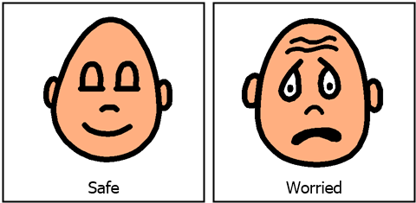

What is a Safeguarding?

To help you decide what could be a problem and where to get help and support. It is important that you know who to talk to and also understand why you might need to talk to someone.

All the adults around you look after your health, safety and welfare.

At Green Lane School, we respect all children and adults, and help to protect your rights.

What is a safeguarding policy for?

At Green Lane School we have a **Safeguarding Team**.

* **We will listen to you.**
* **We know it takes courage to speak to us.**
* **We know the problems that young people face.**
* **We won’t judge you.**
* **We aren’t easily shocked.**
* **We will let you take your time.**

Who can help?

How does school keep you safe?

At Green Lane School we provide a safe environment for you to learn.

Staff at school know how to keep you and your friends safe.

It is important for you to know where to get help, if you are worried or unhappy about something.

We teach you how to keep yourself and others safe, and recognise risks in different situations. Lessons include e-safety, road safety, anti-bullying.

At Green Lane School, we have security measures for visitors.

ALL visitors sign into the school at the front office.

ALL adult visitors wear a badge that is given to them by the office staff when they enter the building.

Visitors are asked for their Enhanced DBS, which is a certificate to say that the visitor has been checked by the law, that they have no criminal records and are safe to work with or around children and young people.

If an adult does not have a DBS certificate, they will have an adult who works at school with them at all times.

Has someone touched you in a place that makes you feel uncomfortable?

Has someone hit, punched, smacked or hurt you in any way?

**Giving you something they shouldn’t**

Has someone asked you if you want a tablet, cigarette, a drink of alcohol or something that you are unsure of? **Please tell us.**

**Giving you something they shouldn’t**

Has someone asked you if you want a tablet, cigarette, a drink of alcohol or something that you are unsure of? **Please tell us.**

Has someone said something strange to you, or have you heard something that you do not like?

Has someone asked you if you want a tablet, cigarette, alcohol or something that you are unsure of?

**Giving you something they shouldn’t**

Has someone asked you if you want a tablet, cigarette, a drink of alcohol or something that you are unsure of? **Please tell us.**

Have you seen something worrying on a phone, tablet or computer?

Is someone bullying you by hurting you, threatening you, leaving you out or calling you names regularly?

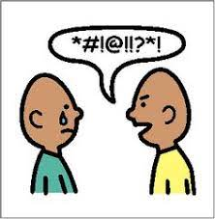

What else do you need to understand about safeguarding?

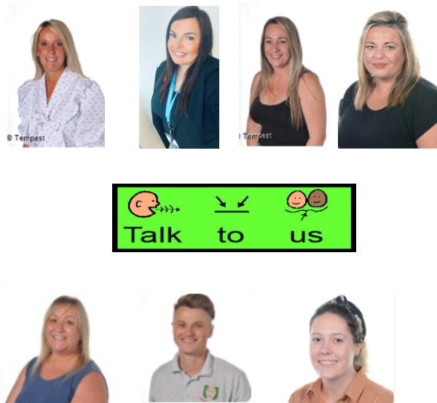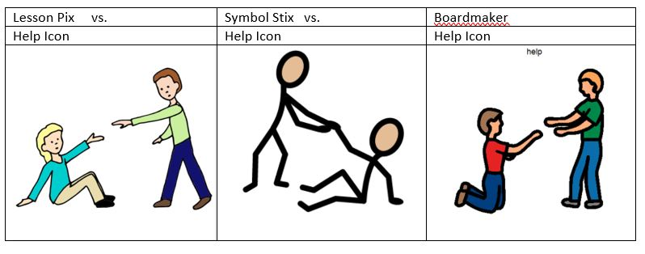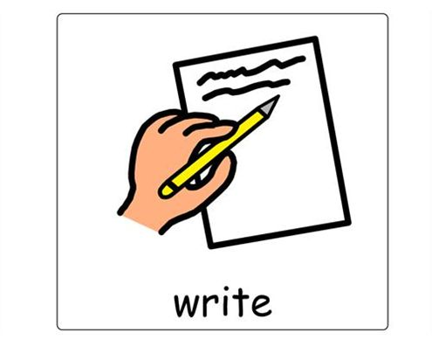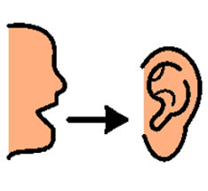

* All adults will listen to what you have to say.
* Adults won’t ask lots of questions.
* Adults might make notes to make sure all concerns are recorded.
* Adults will not promise to keep secrets. They will explain they have to share your worries with someone else.
* All adults will immediately tell the Safeguarding team, so they can help.