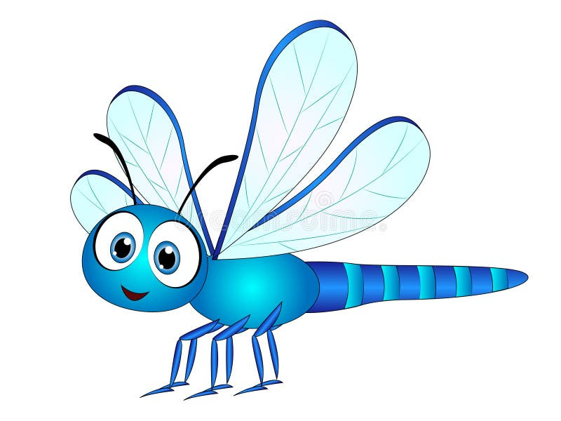
Literacy:
Phonics
Traditional tales
Topic related stories and non-fiction information
Songs and rhymes link to topic
Sequencing stories and information
Expressive Arts and Design:
Musical instruments – keeping a beat, creating own musical patterns.
Develop role play – retelling familiar stories.
Adding meaning to the marks we make.
Using different tools and techniques.

Understanding the world:
Festivals
Using senses to explore natural materials.
Explore how things work.
Plant seeds and care for growing things.
Understand features of life cycles – caterpillar,
Develop positive attitudes about the differences in People.

Physical Development:
Increasingly become independent in dressing and undressing,
Increasing independent in brushing teeth.
Choose the right resources to carry out their own plan.
Developing balancing skills.
Mathematics:
Order by size – long, longer. Longest, short, shorter, shortest, tall, taller, tallest. Big, medium and small. Full and empty.
Counting to 10/20, number recognition, subsidising to 3 and beyond.
Personal, Social and Emotional development:
Developing empathy
Identifying feeling
Sharing and turn taking
Caring for plant and out environment.
Communication and Language:
Use a growing vocabulary / speech sounds
Listen to longer stories.
Understand simple questions,
Start to stay how they are feeling use either words or actions.
Add to the number of songs and rhymes they know.
A Unique + Positive + Enabling = Learning and
child relationships environments development

Dragonfly class staff:
Mrs Smith
Mrs Gorman
Mrs Bass/ Mrs Crowther Brown
Spring term 2026:
Spring A- Traditional Tales
Spring B- In the Garden
Our curriculum is based on the EYFS strategy. We encourage the children to explore and learn through play.

