Number – Multiplication and Division
How can we split/share objects?

Geometry – Position and Direction
How can we change and describe the position of different objects?
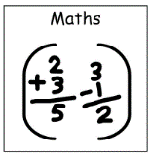
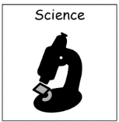

Does it Melt?
What happens when something ‘melts?’
Can we sort objects that melt and objects that don’t?
What makes an object melt?

Key texts –
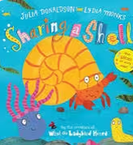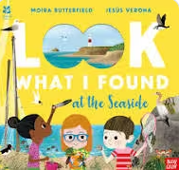
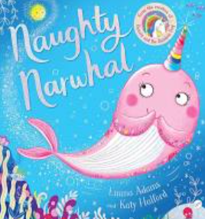
Sensory Stories / Postcards
Can we engage with a range of sensory stories linked to our topic theme?
Can we create our own postcards to give to somebody special?

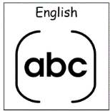

How Can We Stay Safe in the Sun?
What do we need to do when the weather is hot so we can stay healthy and safe?
What should we wear when the weather is hot?
What can we do outside with friends?
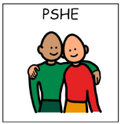

Sun, Sea and Sand-Spring 2
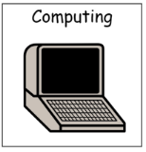
Seaside Holidays – Then and Now
What do we do at the seaside?
How have seaside holidays changed over the years?

Data – Counting and Sorting
How can we use technology to count and sort?
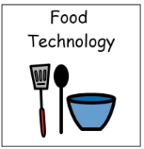
Picnic Foods / Picnic Baskets
Can we make some picnic foods and create our own picnic baskets?

Landscapes – The Seaside
How can we create our own seaside landscapes using a range of media?
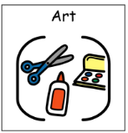
What do Hindu’s Celebrate?
What is Hinduism?
What and how do Hindu’s celebrate?
What is important to the Hindu religion?

