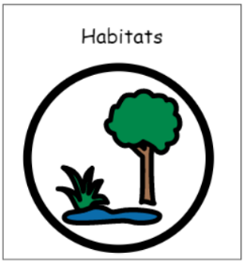
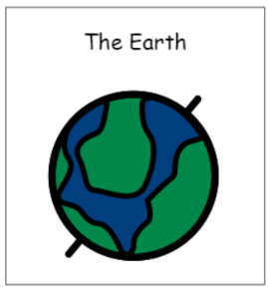
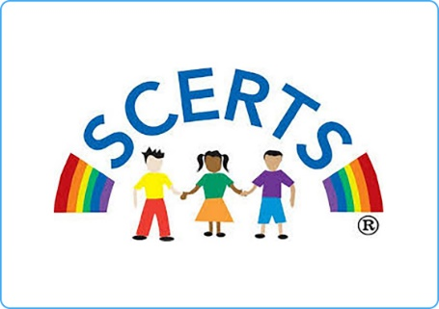


Topics

Number – Multiplication and division

Number - Fractions

Geometry – Position and direction
Number – Place Value

Measurement – Money

Measurement – Time

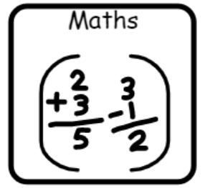

Topics

Poems on the theme of weather

Stories around a theme – bear hunt


Topics
Earth and space
What lives in soil?
Topics

The internet

Multimedia art

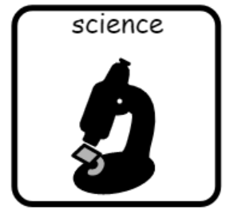
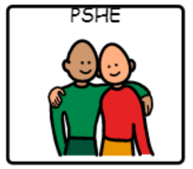

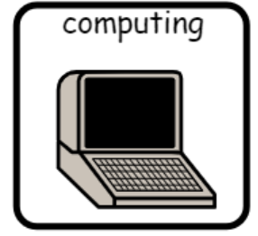

Topic
Keeping healthy – exercise

Topic
Collage – natural art

Topic
Hot and cold climates
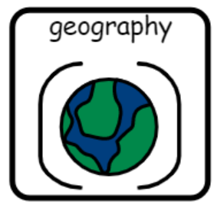

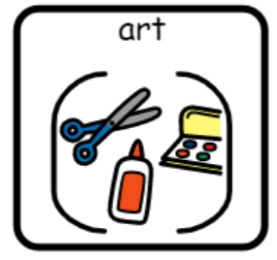


Topics –
Festivals – cordoba
Music - flamenco

Topic
Our Earth long ago

Topics
What do Hindus celebrate?
What do Sikhs believe?

Topics
Tennis
OAA
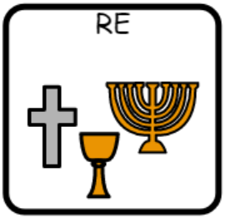


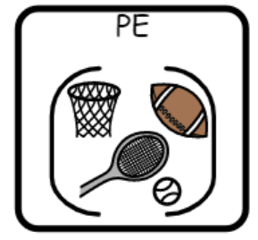
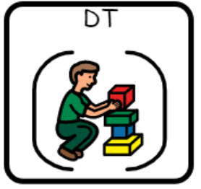
Topic
Food that we grow
Topic
Moving pictures

