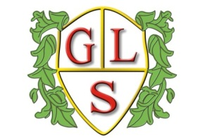
Class Daffodil Topics Spring 2026

Science
Comparing Habitats
Comparing UK to Greece

History
Ancient Greece:
Life a long time ago

Geography
Weather: Weather around the world

Computing
Effective Searching
Data: Spreadsheets

MFL: Spanish
Spanish carnival
Spanish holiday: Journey to Spain

RE
Hinduism: Basic beliefs and celebrations
Buddhist Festivals

Art
Ancient Greece: Greek Pottery
Weather: Vincent Van Gogh – Starry Night

Design Technology
Exploring Greek Foods
Buildings and Structures: Ancient Greek Buildings

PSHE
Friendships
Managing my Emotions

PE
Wolves Foundation – Basketball/Dance

