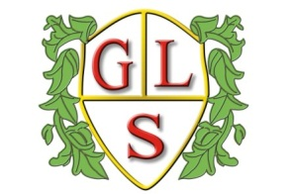
Class Daffodil Topics Summer 2026

Science
Animals and Humans
Magic and Mixing

History
Changes in our Local Area

Geography
Compass Directions to Describe Locations

Computing
Programming & Algorithms
Creating eBooks

MFL: Spanish
Spanish festivals - Los Patios, Cordoba
Spanish Music- Flamenco Dancing.

RE
Sikhism and Equality
Special places – Visiting places of Worship

Art
Natural art: Andy Goldsworthy
Masks: Masquerade Balls

Design Technology
Inventions
Castles and Palaces

PSHE
Hygiene
Looking After the Environment

PE
Wolves Foundation – Tennis/Outdoor Adventurous Activities

