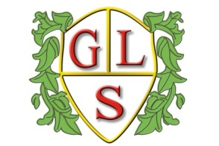
Rabbit Class Topics Summer Term 2026

Maths
Fractions, money, time, mass and capacity

English
‘Classic Fiction’ and ‘Stories with real life issues’

Science
‘Everyday Materials’ and ‘Electricity’

History
‘Crime and Punishment’

Geography
‘Local Field Work’

ICT
‘Sound and Music Presentations’ and ‘Algorithms and Programming’

Design Technology

‘Cogs and Locks’ and ‘Summer Salads’

Spanish
‘All about School’ and ‘Tell me When’

Art
‘Pop Art’ and ‘Scraffito’

PSHE
‘British Values’ and ‘Environmental issues’

PE
Athletics and Cricket

RE
‘Tudor Christianity’ and ‘Hindu Homes and Mandir’

