Badger Class – Summer 2026
Badger class staff.
Ms K.White
Ms J.Forrest
Ms. E Bourque

Topics
Number - Fractions
Measurement – Shape, Money, Time.
Statistics
.

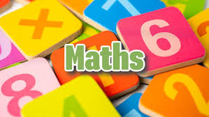
Topics

Summer 1 – Classic Fiction.

Summer 2 – Real Life Issues.

Ongoing - Spelling and Phonics, Guided Reading, Guided Writing, Handwriting.
Speech and language work.


Topics
Summer 1 – Multimedia – Sound & Music.
Summer 2 – E-Safety. Alorithms and Programming

Topics
Summer 1 – Uses of Materials.
Summer 2 – Electricity.




Topics –
Summer 1 – Pop Art.
Summer 2 – Sgraffito.

Topics – Fieldwork



Topic – Crime and Punishment.
Topics
Summer 1 – British Values.
Summer 2 – Environment.



Topics
Folk Music


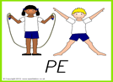
Topics
Free to be me.

Topics –
Summer 1 – Athletics.
Summer 2 – Cricket.


Topics -
Summer 1 – Mechanisms.
Summer 2 – Summer Salad.

Summer 2 – Basic food hygiene – Winter warmers.

Topics
Summer 1 – Tudor Christianity.
Summer 2 – Hindu Homes and Mandir.


Topics Summer 1 – All about School. Summer 2 – Tell Me When

