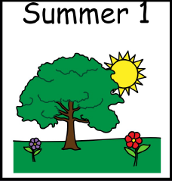
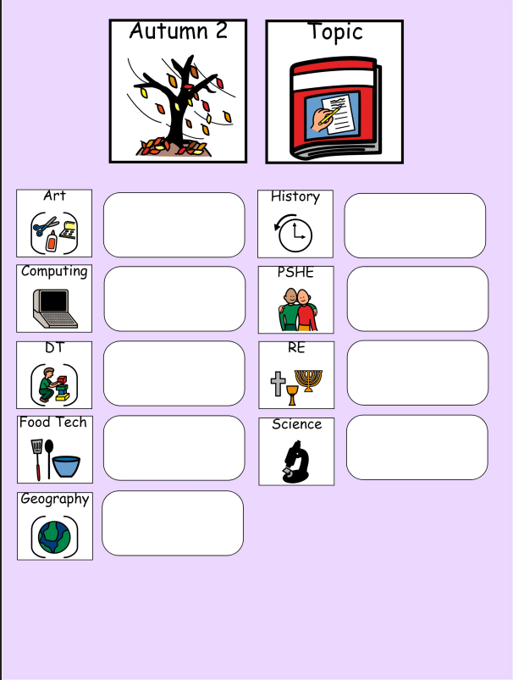
Places of worship
Rocks and soils
Houses and homes

Home cooked meals
Structures: houses and buildings

Modelling
Sculpture
Homes then and now
Technology around us

