Sparrow Summer Term
English - How to Train Your Dragon
Maths – Components 1 - 8 @ Entry Level 1
Art - Figures Keith Haring
Science - Performance in Sport
Asdan PSD - Bus Journey
then
Asdan PSD Parenting Awareness
Asdan PDP - Wider World
Foodwise - Entertaining S.Bani
Careers PP - J.Stunnell
PHSE/SRE - Asdan Short Course (J.Stunnell)
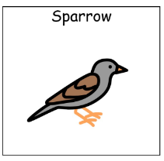
Computing – Developing IT skills PP (J.Stunnell)
PE - M.Gaskell

