

COMMUNITY SAFETY AND RESILIENCE TEAM

STANDARD OPERATING PROCEDURE SOP 07

DISPLAY SCREEN EQUIPMENT (DSE)

Issued by:

Warrington Borough Council
Family and Wellbeing Directorate
Community Safety and Resilience Team
1 Time Square
Warrington
WA1 2NT

Issued in:

August 2021

Version:

6

DOCUMENT CONTROL

Description and Purpose
This guidance note is intended to provide the procedures for Warrington Borough Council staff to follow in order to comply with the Display Screen Equipment Regulations

Record of Amendments
Active date | Review date | Amendment reference | Reasons for Change | Version | Number of pages
June 2012 | June 2013 | Re-written |  | 1 | 28
November 2013 | Following any significant changes to legislation or process. | Reviewed | Changes to eyesight screening provision. | 2 | 27
November 2014 | November 2016 | Review | Changes made to columns in Assessment pro forma | 3 | 28
September 2017 | September 2017 | Full Review | Changes to include working from 2 screens | 4 | 25
January 2019 | January 2019 | Review | To include information relating to undertaking assessment of chair. | 5 | 25
Aug 2021 | To be updated with the arrival of new legislation or every three years going forward. (August 2024) | Full Review | To include information relating to hybrid working. | 6 | 36

Author | Approved by
D Watson | T Whitfield

Contact Department | Email | Telephone ext.
Community Safety & Resilience Team  Health & Safety | Health&safety@warrington.gov.uk | 01925 44 2174 or 44 2681

Target audience
All WBC staff | Y | Agency workers | Y

Relevant legislation (if any)

The Health & Safety at Work Act 1974
The Management of Health & Safety at Work Regulations 1999
The Display Screen Equipment Regulations (as amended 2002)
The Workplace Health, Safety and Welfare Regulations 1992
 | Contents Page
 | 1. | INTRODUCTION | 4
 | 2. | THE DISPLAY SCREEN REGULATIONS 2002 | 4
 | 3. | MANAGERS DUTIES | 6
 | 4. | EMPLOYEES DUTIES | 8
 | 5. | RISK ASSESSMENT | 8
 | 6. | REVIEW OF RISK ASSESSMENT | 9
 | 7. | WHO IS COVERED BY THE REGULATIONS | 9
 | 8. | WHAT IS DISPLAY SCREEN EQUIPMENT | 10
 | 9. | HAZARDS ASSOCIATED WITH DISPLAY SCREEN EQUIPMENT (DSE) WORK | 10
 | 10. | SETTING UP THE WORKSTATION | 12
 | 11. | SUPPLEMENTARY EQUIPMENT | 19
 | 12. | LAPTOP & PORTABLE COMPUTERS | 19
 | 13. | SHARED WORKSTATIONS | 20
 | 14. | AGILE / HOME WORKING | 20
 | 15. | WORK BREAKS AND ACTIVITY CHANGES | 21
 | 16. | PREGNANCY | 21
 | 17. | TRAINING AND INFORMATION FOR DSE USERS | 22
 | 18. | ARRANGING EYESIGHT SCREENING | 23
 | 19. | GLASSES FOR DSE USE | 24
 | 20. | REFERENCES AND FURTHER INFORMATION | 24
 | 21. | USEFUL CONTACTS | 24
 | APPENDIX 1 - DSE WORKSTATION ASSESSMENT CHECKLIST  APPENDIX 2 – HOMEWORKING ASSESSMENT CHECKLIST |  | 25  30
 | 1. Introduction

1.1 This Standard Operating Procedure (SOP) supports Warrington Borough Council’s Health, Safety & Welfare Policy. Directorates may, if appropriate, add to this information to compliment specific guidance, standard operating procedures and systems of work relevant to the Display Screen Equipment Regulations.

1.2 The purpose of this SOP is to provide Managers and employees with the requirements of the Display Screen Equipment Regulations and the procedures required for Warrington Borough Council (SOP) to ensure legislative compliance.

2. The Display Screen Equipment Regulations (DSE) 1992 (Amended 2002)

2.1 The Health and Safety Display Screen Equipment Regulations 1992 came into force on 1st January 1993 and some minor changes were made in 2002 which lay down minimum health and safety requirements for working with display screen equipment (DSE). The DSE Regulations are intended to protect the health, safety and welfare of those who habitually use DSE as a significant part of their normal work activity.

2.2 The DSE regulations specify minimum requirements for the work station this includes the computer terminal, monitor, desk, chair, software, space requirements and levels of training.

2.3 The regulations also set requirements in relation to heating, ventilation, environment, regular breaks from the work activity and the provision of eye tests for the user.

2.4 The workstation should be designed to ergonomic standards which offer the best possible working environment, with the chair offering the best possible support and comfort for the user’s posture. Breaks from the task of inputting or retrieving data should be planned in to include carrying out other tasks which do not require the use of display screen equipment.

2.5 Every employer shall perform a suitable and sufficient DSE risk assessment of those workstations which have been provided. The employer shall reduce the risks identified to the lowest extent reasonably practicable.

2.6 The following information provides a brief summary of the DSE Regulations and the main duties the Council must take to ensure legislative compliance.

2.6.1 Regulation 2: Analysis of work stations
Employers must assess the workstation to reduce risk to the user;
The user is classed as: -

- Person employed by the Council;
- Users employed by others (for example employed agency workers).
- Employee working from home (Homeworkers)

2.6.2 Regulation 3: Requirement for work stations

Every employer must ensure that any workstation which may be used for work activities meets the requirements laid down in the Regulations. Areas covered:
- Monitor
- Keyboard
- Desk
- Document holder
- Footrest
- Chair
- Space requirements
- Lighting
- Noise
- Heat, radiation, humidity and software.

2.6.3 Regulation 4: Daily work routine of users

Every employer must plan the work activities of users so that their daily work on DSE is periodically interrupted by breaks or changes of activity. The employer’s duty under regulation 4 is satisfied by providing information or training on:

• Posture variation and activity variation;
• Stretching movements;
• Short frequent breaks v occasional longer breaks;
• 5 mins break after 55mins of continuous DSE.

2.6.4 Regulation 5 Eyes and eyesight
Regulation 5: Eyes and eyesight
Where a person is identified as a DSE user the employer shall, if requested by that person, ensure an eye sight test is carried out. Appropriate basic spectacles are provided when normal glasses cannot be used and when the eyesight test specifies that provision of spectacles is necessary when using DSE. (Please Note: there is no reliable evidence that working with DSE causes permanent damage to eyes)

2.6.5 Regulation 6: Provision of training

Where a person is classed as a user, the employer must ensure that they are provided with adequate health and safety training in the use of any workstation. For new employees, employees whose duties are changing, employees returning to work and all current users the complete the mandatory e-learn DSE module. The DSE module covers: -

• Chair adjustment
• Good DSE arrangement to help good posture
• The need to take breaks and change activity
• Communication routes to report a problem
• The user’s role in recognition of hazards
• Early warning signs of problems and how injuries can occur

Trained DSE assessors within each Directorate must complete the mandatory DSE e-learn module and also attend ‘DSE assessor training’ at Warrington Training Hub.

2.6.6 Regulation 7: The provision of information
Every employer must ensure that DSE operators and users at work are provided with adequate information about all aspects of health and safety (H&S) relating to their workstation, this should cover:

- The availability of DSE assessments
- Eyesight test availability
- Seating and posture
- Risks from DSE and how to report problems
- The need for breaks

3. Managers Duties

3.1 Managers must ensure the following:
3.1.1 The DSE regulations are complied with.
3.1.2 Decide who is covered by the Regulations – Manager must ensure all DSE ‘Users’ within the Team have been identified (see section 7 for further information).
3.1.3 Train Users – Managers must ensure all DSE ‘Users’ within their Service/Team have completed the Mandatory DSE e-learning via the ‘My Learning’ training platform on WINNIE.
3.1.4 Train DSE Assessors – Managers must nominate a number of staff members to be trained within their service areas/team to be the designated DSE assessor(s). Further information regarding this training can be found in the training prospectus or via The Training Hub (St Werburgh’s) email at talentmanagement@warrington.gov.uk or by telephone on 01925 442600. As DSE 'risk assessors' these members of staff will receive adequate information and training on the safe use of Display Screen Equipment to enable them to carry out and support the user during the DSE assessment process. The assessor must also check to ensure that the workstation is correctly set up for the user, answer any concerns and make adjustments to the workstation where required. The assessor must also report and make recommendation on any corrective action identified through the assessment process to the user’s manager, identified actions must also be monitored for completion by the manager. All training must be recorded to maintain competency and Managers must ensure DSE assessors are subject to three year refresher training.
3.1.5 Assess workstations and reduce risk – Managers are to ensure that all DSE risk assessments are undertaken for anyone classed as a DSE ‘User’ within their team or service area.

- The checklist can be completed by the user themselves if they have undertaken the mandatory DSE e-learn module.
- The user will need to complete the DSE checklist (see appendix 1) and share the findings with the team or services trained DSE assessor.
- The process must be overseen by the trained DSE assessor, this is to ensure the workstation is set up correctly for the user and to address any concerns identified during the DSE assessment process.
- Any concerns relating to the user or the equipment that cannot be rectified by the DSE assessor, must be reported to the manager to ensure further appropriate corrective action can be taken.
- DSE risk assessments must be subject to a periodic review, the frequency of the review will depend on the level of risk identified and this should be determined by the Manager (it would be deemed good practice for the trained DSE assessor to review the assessments at least every 2 years), however assessments should be reviewed earlier where any significant changes are made to workstations or where there are any medical conditions being experienced by the user that may be attributed to the way the workstation is set up or being used. For further information see section 5 and 6.

3.1.6 Plan changes in activity breaks for users – Managers are to make staff aware of the need to take regular breaks away from the screen, it is recommended that 5 minutes in every hour be taken to carry out alternative tasks that do not include using DSE equipment. If the user has a medical condition consider more frequent short breaks of activity change (2-3 minutes every ½ hour).
3.1.7 Provide eye tests and necessary glasses as required – Manager to ensure DSE ’Users’ are made aware of their entitlement to a full eye test, and corrective lenses for VDU work (if identified as required by the optician). For further information see section 18 and 19.
3.1.8 Inform Users of the outcomes of the assessment –The users must be present when the assessment is being undertaken to ensure they have a chance to provide any relevant information to the DSE assessor. Managers must ensure the user is aware of the outcome of the assessment along with any further actions to be taken following their DSE assessment.
3.2 If any health issues such as Work Related Upper Limb Disorders (WRULD’s for further information see section 9) are reported to the Line Manager or the trained DSE assessor and they are unable to resolve the issue at a local level through the assessment process, the manager should contact the Community Safety and Resilience Team for further advice. The Resilience Advisers (H&S) are also trained DSE Assessors and may decide a further assessment is required, the Manager may also want to get further advice regarding the users condition from the Occupational Health provider. If there are any potential issues then a recommendation will be made to the Line Manager to provide the necessary equipment.
3.3 Monitoring for DSE compliance is via the quarterly Directorate Health and Safety Committee meetings, Managers must provide up-dates for these meetings through the Health & Safety Audit checklist, which includes DSE assessments (these will be a standard agenda item). To underpin the audit checklist the Community Safety & Resilience Team will undertake annual audits within each Directorate these will incorporate monitoring of DSE assessments. Feedback from these audits will also be shared with the Directorates Health and Safety Committee.

4. Employees Duties

4.1 Employees are required to;
- Undertake the e-learn DSE mandatory training module via my learning platform;
- Complete the DSE assessment checklist and discuss the findings with the team or services trained DSE assessor.
- Comply with any safe systems of work, such as taking regular screen breaks where the DSE assessment has deemed them necessary;
- Use the equipment provided in line with the recommendations made in the mandatory e-learn DSE training module and the advice on set up from the trained DSE assessor;
- Inform the Line Manager where equipment is known or suspected to be defective or not suitable as it is causing discomfort. The Manager must be made aware of any health condition thought to be caused or aggravated by DSE use as soon as possible;
- Co-operate with the employer in the use and care of items provided in the interests of health and safety, such as, work station accessories or spectacles provided for DSE use.

5. Risk Assessment

5.1 The DSE Regulations require that a workstation risk assessment be carried out to identify any risks to the health and safety of DSE 'Users'. Within Warrington Borough Council it is the responsibility of Line Managers to ensure that risk assessments are carried out for DSE ‘Users’ under their control. All DSE assessments must be undertaken with the DSE user present.
5.2 Risk assessments must only be undertaken by ‘competent persons’, who have received adequate information, instruction and training. The DSE risk assessment checklist can be completed by the DSE user themselves but the process must be overseen by the team/service trained DSE assessor to ensure the workstation is set up in the correct position for the user and to address any issues identified during the completion of the DSE assessment checklist.

5.3 The attached DSE Workstation Assessment pro forma (see appendix A) covers all aspects of workstation risk assessment required by the DSE Regulations and should be used when carrying out a DSE assessment.

5.4 When the DSE assessments have been undertaken and all corrective actions have been completed the Line Manager should keep a record on file and ensure that the assessments are subject to a periodic review (review period to be determined by the level risk) or earlier if there are any significant changes such as moving office or if the user is experiencing any issues or health problems.

6. Review of Risk Assessments

6.1 Risk assessments should be regarded as an on-going process. DSE workstation risk assessments must always be reviewed periodically by the trained DSE assessor:

- Periodic reviews are to be determined by the Manager dependent on the level of risk (best practices would be to undertake this assessment every 2 years);
- Or as soon as there are developments to suggest that they are no longer valid (broken equipment, equipment not suitable or an individual reports they are experiencing aches and pains) or there has been a significant change in the workstation involved (the location or position of the workstation has changed with new furniture, new equipment or software).

6.2 As good practice it is also advised that risk assessments be undertaken before purchasing or installation of new equipment. This is to ensure that the equipment being supplied is compatible with the user (i.e. height, weight, etc.) and the work station.

7. Who Is Covered by the Regulations?

7.1 The Regulations apply where staff “habitually” uses DSE as a significant part of their normal work. An individual will be classified as a DSE ‘User’ if the following criteria apply:

- The individual depends on the use of DSE to do their job, as alternative means are not readily available for achieving the same results;
- Normally use DSE for continuous or near-continuous spells of an hour or more at a time and uses it in this way on a daily basis;
- Fast transfer of information between the user and screen is a requirement of the job;
- The performance requirements of the system demand high levels of attention and concentration by the individual, for example, where the consequences of error may be critical and training or special skills are required.

7.2 Due to the increasing impact of technology on people’s working lives, it is necessary to review whether individuals are identified as ‘Users’ at regular intervals to ensure that any increased use of DSE is taken into account.

Warrington Borough Council identifies DSE 'users' as any person using DSE constantly for 1 hour each day or 3 hours sporadic use each day.

8. What Is Display Screen Equipment?

8.1 The definition of DSE covers both conventional display screens such as computer screens, laptops, touch screens and other display processes such as microfiches and process control systems. The terms Visual Display Unit (VDU) and Personal Computer (PC) are also commonly used but within the context of the DSE Regulations they mean the same as DSE.

9. Hazards Associated with DSE Work

9.1 Most problems experienced by DSE ‘Users’ do not arise directly from the DSE but from the workstation or the way in which it is used or set up. DSE ‘Users’ may experience aches and pains in their hands, wrists, arms, neck, shoulders or back, collectively known as ‘Work Related Upper Limb Disorder (WRULD’s). Most problems of this nature can be prevented by good workstation layout and design and ensuring that ‘Users’ are aware of how to adjust the equipment/chair to suit their current requirements. In certain circumstances existing medical conditions may present a further risk that should also be considered and where appropriate assessed.

9.2 WRULD symptoms include any aches, pains, numbness or tingling sensations that may be caused through the use of DSE. If an employee feels they may be experiencing WRULD symptoms it must be reported to their Line Manager immediately. If any issues cannot be resolved at the local level by their trained DSE assessor or the Line Manager they should contact the Community Safety and Resilience Team for further assistance as a further assessment may be required. A referral to WBC Occupational Health provider (OHP) may be necessary, if OHP has identified that a further specialist assessment of the workstation is required this will be undertaken by the Community Safety and Resilience Team Assessor who will provide a summary report to the users Line Manager as to further control measures required.

9.3 Health problems associated with DSE work can include:

- Work related upper limb disorders (including pains in the neck, arms, elbows, wrists, hands, fingers, back, etc.);
- Fatigue and stress;
- Eye strain and headaches.

The causes may not always be obvious and can be due to a combination of factors. However implementation of effective DSE control measures can reduce the risks significantly.

9.3.1 Risk Factors for ‘Work Related Upper Limb Disorder (WRULD’s)

- Task repetition – break up work periods involving a lot of repetition with several short breaks instead of one break at lunchtime; Allow for short, frequent pauses of activity change throughout the day.

- Working posture - Design workstations to ensure desks and chair can be set up for the individual users taking into consideration their height, weight, size, reaching distance and comfort. Provide adjustable chairs (ensuring the weight restrictions set for the chair are not exceeded), footrest, monitor raisers, etc. to enable user to adjust working position where required.

- Duration – As many types of injuries are cumulative in nature and can be caused by spending long periods of time carrying out the same task. Ensure long duration tasks are broken up with short periods of activity change or perhaps share the task between several users where possible.

- Work environment - Ensure lighting is appropriate and does not cause glare on the monitor; ensure workstation layout allows space for the user to get in and out from the workstation. Ensure faulty or broken equipment is repaired or replaced and equipment required through the assessment process is provided. Ensure the temperature in the working environment is comfortable for the users working in the area. In open plan offices it can be difficult to get a comfortable working temperature for all; the aim should be to ensure the temperature is deemed comfortable for the majority of staff. (Further actions may include turning the heating up or down; or relocating staff member to another part of the office away from or closer to a heat source or an open window). Any heating issues should be firstly considered by the Line Manager, if they cannot resolve the issue, the Line Manager should liaise with the Premises Manager who should be able to offer further support.

- Psychosocial factors - causing the stress response: this is usually caused by high workloads which require tight deadlines: The planning of this work is vitally important in reducing the risk, as is taking regular breaks of activity change. Regular monitoring of these tasks must be undertaken by the Line Manager to ensure the workloads do not become excessive or result in the tasks affecting the user’s health.

10. Setting up the work station

10.1 When setting up the workstation, the following information may assist in the process.
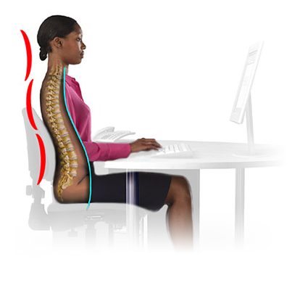
Neutral Position – is when your body is at rest with minimum amount of pressure on your muscles and joints. The three natural curves of your spine are naturally balanced and in alignment, which reduces the risk of stress and pressure on your spine. The neutral position helps to keep your back in the strongest supported position whilst seated.

10.2 Neutral Position
- The three curves of your spine (cervical (neck), thoracic (middle) and lumbar (lower) are relaxed and in good alignment
- Your shoulders are in a resting position
- Your head is naturally balanced, neither tilting nor twisting
- Your wrists are in line with your forearms

10.3 What is your work posture really like?
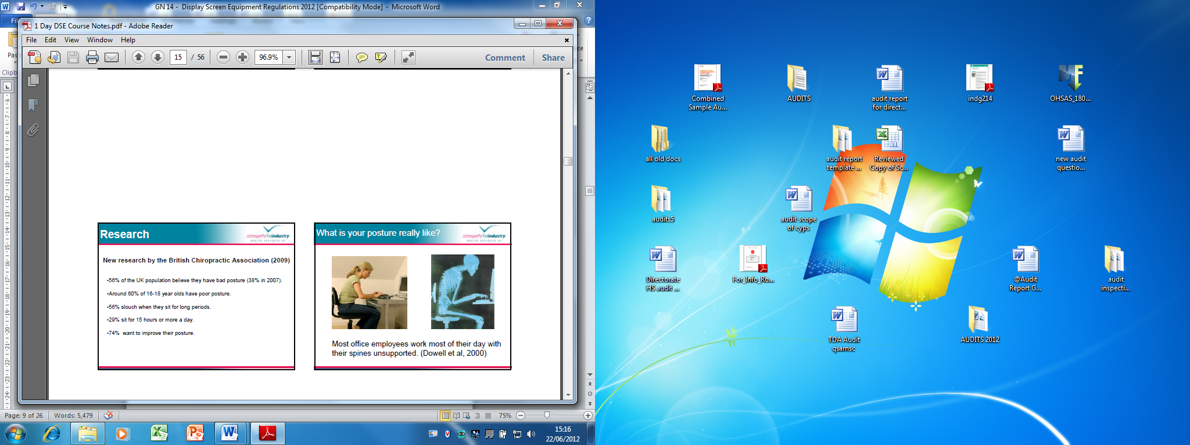
Most DSE users work most of their day with their spines unsupported without even realising; applying good DSE techniques can reduce the risk of adverse health effects and protect your health, safety and welfare.

Pay attention to any aches and pains developing in the back, neck and shoulders and check you’re the way you are sitting throughout the day to ensure the back is fully supported.

10.4 Setting up the workstation
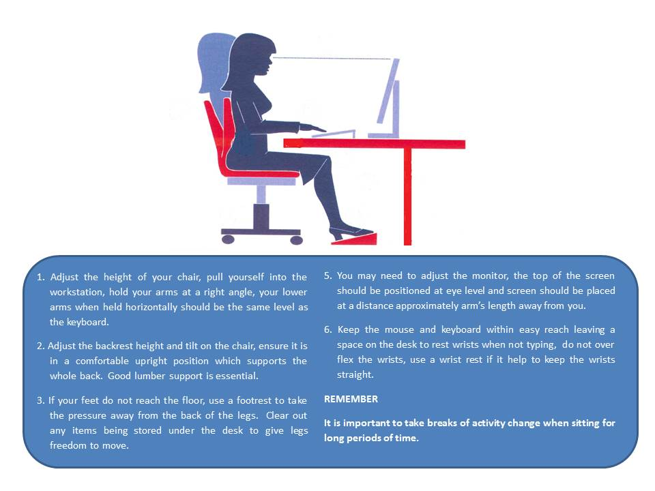
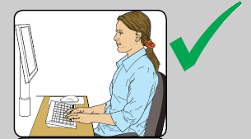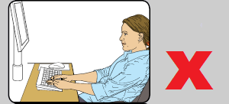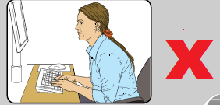

Move the chair close to the desk and sit back on the seat. Adjust the chair back so that you are sat in an upright position, your upper body should be relaxed and supported.

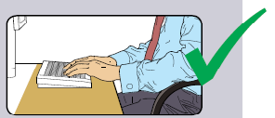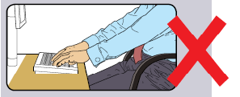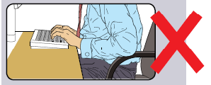

Raise the chair seat so that, with the upper arms vertical, the elbows are level with or just above the desk.
10.5 After setting the chair height and position, if you cannot place feet flat on the floor use a footrest. If the chair armrests restrict access to the desk consider removing the armrests altogether. Make sure there is a comfortable viewing distance between the eyes and the screen; ideally the screen should be at arms-length away when the chair is pulled in at the desk fully.
10.5.1 For any members of staff that use bi-focal spectacles to read from the screen, adjustments to the height of the monitor may be necessary, by placing the top of the screen at eye level will possibly result in the users head being tilted back to read from the screen. Ensure the screen is lowered so that the head is not tilted up or down whilst reading from the screen.
10.6 The office chair
A good office chair can help you achieve a neutral sitting position but it must be adjusted to fit the users’ body.

The chair acts as the bodies external support structure whilst working at the desk. The chair must have a number of components to provide adequate support.

The chair should have the following:

- At least 5 castors for stability and easy movement;
- A height adjustable seat with a firm cushion to support the legs;
- An adjustable backrest to support the lower back and stabilise the upper body, the backrest should be height and tilt adjustable;
- The correct seat depth so the user can sit back in the chair and ensure upper legs are supported.
- Weight capacity set for the chair – please note it is recommended that this is not exceeded.

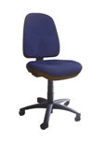
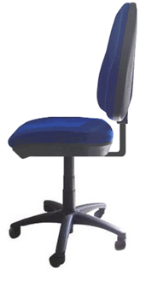

Note: More details regarding the weight capacity of the chair can be obtained from the manufacturer or supplier.

If the chair has arm rests they should be height and width adjustable so they do not restrict the user’s movements. The arms of the chair should support the forearms without hunching or shrugging the shoulders and should not stop the user from moving close enough to the desk to use the equipment without having to lean forward.

If your chair has a tilt mechanism this may help to achieve a comfortable seating angle whilst also promoting movement if set to free flow.

10.7 If the chair is not suitable and a more supportive chair is required it may be beneficial to identify if there are spare ergonomic chairs within the building/service area, or any being used by someone who does not necessarily need one before looking to purchase a new one. If a new chair is required, it is important that the trained DSE assessor should complete the anthropometric data sheet with the user in order to try to identify the most appropriate chair. The chair should be fully adjustable, high backed with lumbar support and adjustable arms. As there is no central budget, funding this would have to be agreed with the Manager of the Service prior to purchasing any equipment. WBC have a furniture Contract with Jenkinson’s who will allow the user to trial a chair for a period of a week. In order to do this they will require a completed anthropometric data sheet (see link) and a purchase order, please note it is important that if a purchase order is raised it must not be goods receipted until after the trial and only if the chair is suitable for the user. If the chair is not suitable and is to be returned, you will need to contact Jenkinson’s to pick up and ensure the purchase order is cancelled straight away.
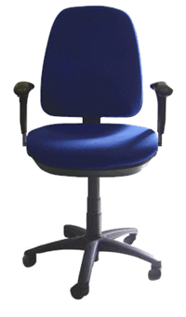
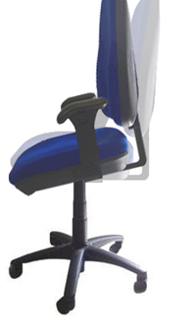
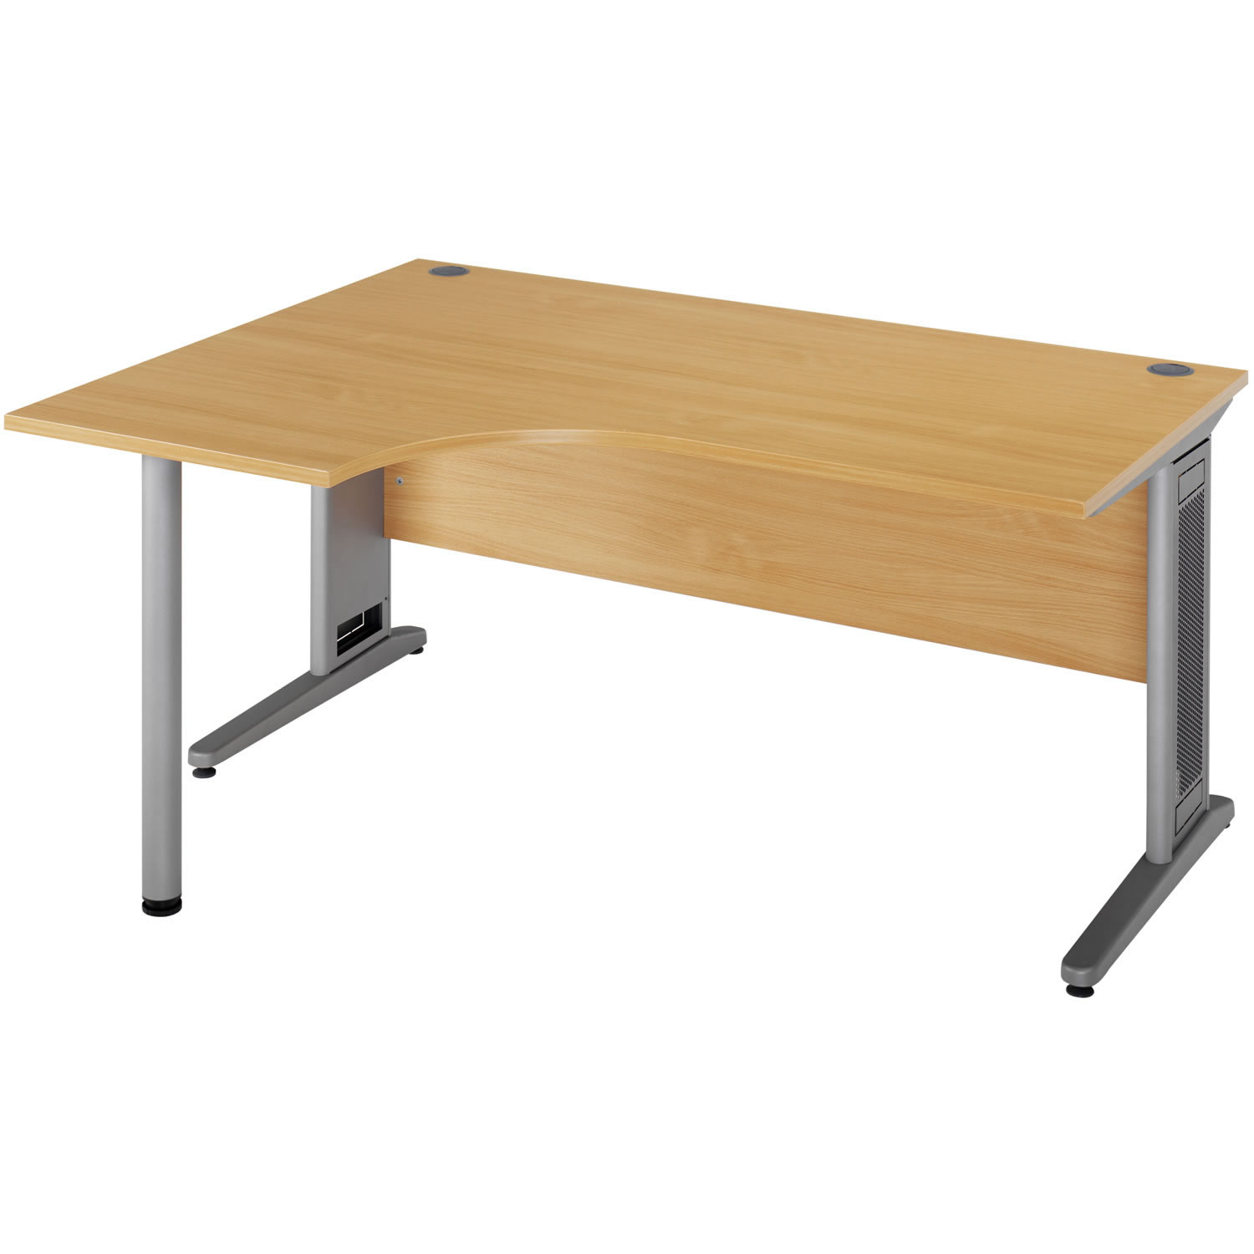
10.8 The work desk

The work desk should allow for flexible arrangements of DSE, low reflectance surface and of sufficient size to complete DSE work activities. If the desk is a fixed desk the desk should be set at a height between between 66 -73 cm. Height adjustable desk can also be used and should be able to be set up for the user when standing or sitting down.
Consider if the user has any medical condition or disability the make sitting at the desk for long periods painful, consider whether access to a sit/stand height adjustable desk may be better to allow the user to continue working in a more comfortable position. Also consider the depth of the desk, this should be deep enough to be able to position the monitor at arms-length away from the user when the user is pulled in close to the desk in a sitting or standing position.
The following should be considered for the desk:
• Is there adequate adjustment?
• If curved is it left or right handed set up?
• Can the layout be improved to reduce any strain on the user?
Ensure that there is enough space on the desk to accommodate the documents needed. A document holder correctly positioned could help to reduce excessive neck movements and thereby reduce risk.

Ensure access to the desk is not restricted, and there are no obstructions placed above or around the desk that may cause injury when going to sit down at the desk or standing up to move away from the desk.

10.9 Leg room:

- Ensure supporting elements should not restrain movements of the user;
- All the parts of the desk with which the user comes into contact with should be designed to reduce any risk of physical injury;
- Ensure height of desk surface, drawers or any other equipment being stored under the desk is not obstructing legs; ensure boxed pipework under the desk is not restricting where the user can place their feet.
- Ensure there is adequate legroom;
- Do not store bags, boxes or any objects that may restrict leg movement;
- If you change your desk ensure your chair is compatible and is not set too high or low for the desk height.

10.10 The Monitor (screen)

Ensure the screen is located directly in front of the user, so that the user is facing the screen without having to twist the upper body. The top of the screen should be at eye level.

10.10.1 When working from multiple screens the main screen should be set up directly in front of the user with the secondary or lap top screen set at an angle next to the main screen. The height of both screens should be set at eye level to ensure the user is looking straight ahead without having to look up or down to read from the screen.
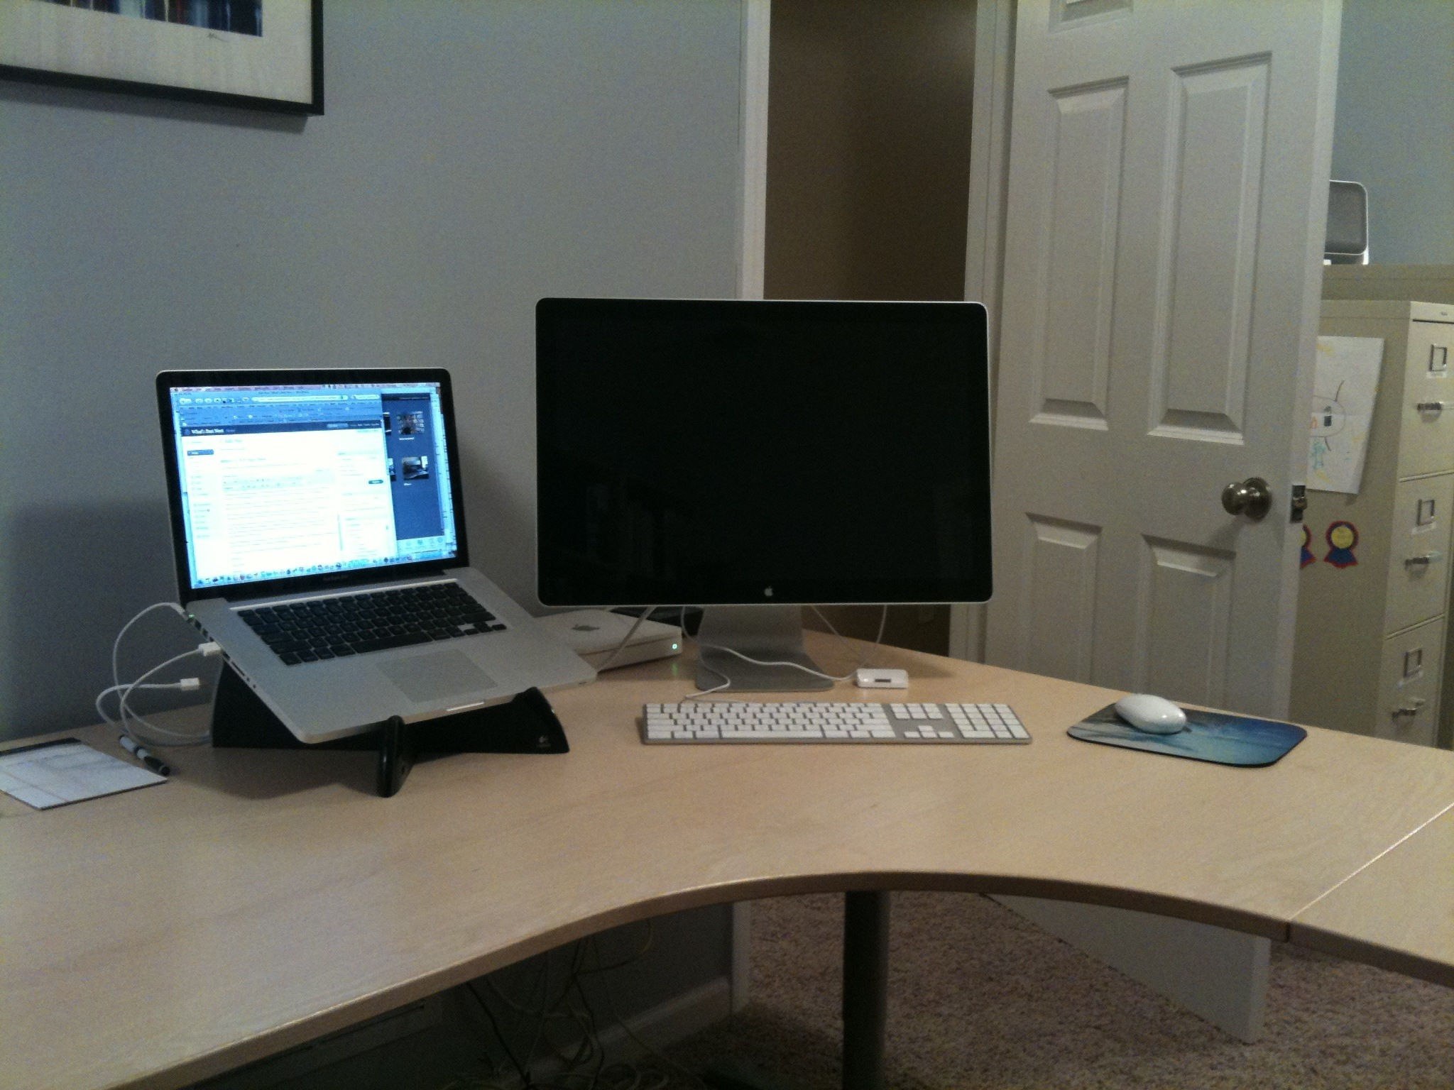

(Please note the screen(s) may need to be lowered if the user wears bi-focal spectacles to ensure the head is not held back at an angle when reading from the screen)

10.10.2 The screen should be stable and have a clear image, it should also have the ability to swivel and tilt and be free from glare.

The screen should also be placed: -

• 50 – 60 cm away from user = arm’s length;
• Screen should be adjusted so eyes level with top of screen casing.

10.10.3 If possible, arrange the desk and monitor so that bright lights are not reflected onto the screen. The screen should not directly face a window; ideally it should be placed at a right angle to the window.

10.10.4 GLARE: Users are advised to reduce glare on the screen by use of window blinds, if this is not possible, an anti-glare screen may help or adjusting or re-sighting of the monitor may reduce the risk.

10.10.5 Ensure the screen is cleaned at regular intervals to remove grime which can distort the screen clarity with approved products only.

10.11 The Keyboard

There should be a space in front of keyboard (10cm) this is helpful to support the wrists when the hands are not typing.
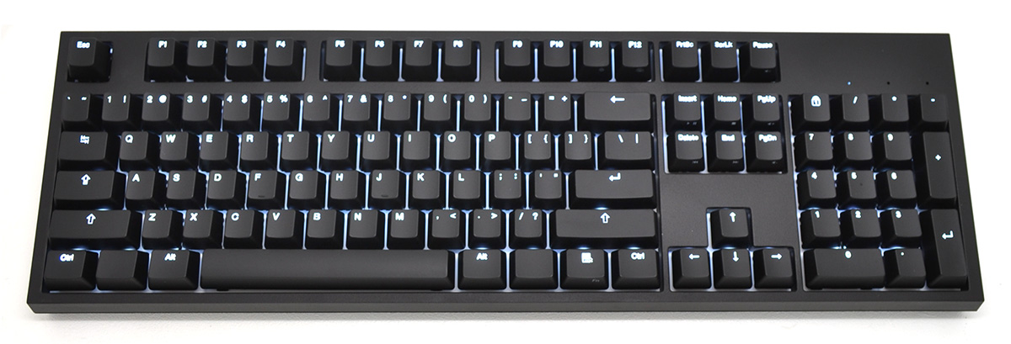

10.11.1 The keyboard should have a matt surface, have legible keys and also have feet on the keyboard to allow for the keyboard to tilt. Characteristics of the keyboard can also influence the posture that the user adopts.

10.12 The Mouse

Relax the hand, the user’s arm should be held at a right angle when using the mouse.

- Move the whole arm;
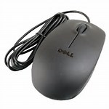
- Keep upper arm close to body do not overreach ;
- Keep the mouse close to keyboard;
- If using left hand to use mouse ensure controls adjusted (control panel);
- Use mouse mat in portrait not landscape and take your hand off the mouse when possible.

10.13 General workstation requirements
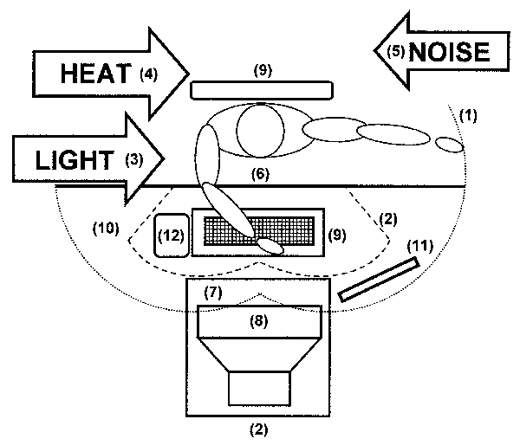

Workstation Layout key
- Maximum reach
- Comfortable work area
- Adequate lighting. Wherever possible light sources should be at right angles to the screen, where window coverings are necessary, vertical blinds are more effective than horizontal
- Comfortable heating levels, circulation of air and adequate humidity
- Distracting noise should be minimised
- Legroom and clearances allow changes in posture and position
- Software appropriate to task, adapted to user, provides feedback on system status, no undisclosed monitoring
- Screen; stable image, adjustable, readable, free of glare and reflections
- Keyboard - undamaged, adjustable, detachable, and legible
- Work surface; allows flexible arrangements, spacious, glare free
- Copy holder adjacent to screen (where necessary)
- Mouse within easy reach

10.14 New Workstations
If obtaining DSE equipment for the first time, or increasing the amount of equipment in use, or where existing desks and chairs may be unsuitable for use as part of a DSE workstation, or unsuitable for the needs of individual DSE ‘Users’. The DSE assessment proforma can be used to assess the suitability of the proposed workstation, including its suitability for individual DSE ‘Users’.
10.14.1 The needs of the individual must be taken into consideration when setting up the workstation especially the needs of anyone with a long term illness or disability. The Equality Act 2010 must be adhered to (where applicable). Under this Act 'Reasonable Adjustments' must be applied if the user is classed as having any long term illness or form of a disability.

10.14.2 If anyone has a long term illness or disability, reasonable adjustments should be made to the workstation to ensure the user is not at a disadvantage when carrying out the DSE work. Where specialist equipment may be required the ‘Access to Work Scheme’ may be able to assist in identifying specialist equipment or support and may also help with funding in some cases. The access to work scheme is a self-referral scheme so the user will need to contact them initially, we advise that the user also discuss accessing this scheme with the manager first as there may be costs that need to be also funded by the Council if specialist equipment is recommended.

11. Supplementary Equipment

11.1 In some circumstances additional equipment may be required to help the ‘User’ achieve an optimum work posture. Examples of additional equipment are listed below. (Further advice can be obtained from your trained DSE assessor or the Community Safety and Resilience Team).

- Footrests – should be made available for any ‘User’ who cannot put their feet flat on the floor when the chair is set at the correct height;
- Telephone headsets – should be considered for people who are required to frequently use a telephone and DSE at the same time;
- Wrist rests – some ‘Users’ benefit, while others do not, they may help avoid resting hands on the desk during keyboard use;
- Document Holders – Should be stable and adjustable and aid for people who transfer information from documents to computer. (Most users now have access to a monitor and a lap top, so can use one of the screens like a document holder).
Please Note – Following a DSE assessment and where it has been identified (due to experiencing pains in arm or wrist) that a new different shape mouse may be required, the ICT Team have a variety of different shape mice available that users can trial prior to purchase. For further information contact ICT or log a 2200 request with the ICT team.

12. Laptop / Portable Computers

12.1 Laptops and other portable computers have to be compact enough to be easy to carry. This results in design compromises, such as smaller keyboards and screens, which make portable computers less comfortable in prolonged use than normal DSE. As a general rule, it is best to ensure that personnel do not use standalone laptop computers for long periods of time.

12.2 PORTABLE DSE (LAPTOP)
If someone uses a laptop and has been identified as being a DSE ‘User’ they should be provided with an appropriate ‘docking station’ or monitor raiser. The docking station must consist of a separate keyboard and mouse, with a separate monitor or riser blocks to raise the laptop screen to eye level. Once the docking station is in place, the set- up of the workstation is exactly the same as for full sized display screen equipment.

12.3 Laptops are subject to a DSE assessment as per the normal DSE process. Laptops and other portable equipment should not be used in vehicles whilst they are moving. Managers need to ensure staff working from home or alternative locations using laptops are suitably trained to undertake their own DSE risk assessments, the trained DSE assessors must oversee this process and should of already shown the user in the office how the workstation should be set up, this just needs to be replicated by the user in their home environment.

13. Shared Workstations

13.1 Where workstations are a shared facility, an assessment of the workstation should take into account the needs of all individuals using it; the Line Manager and the DSE assessor should ensure assessments are undertaken with each individual users to ensure they are able to replicate the same set up at different locations. The Manager needs to ensure that the appropriate equipment is in place and made available at each workstation. (This may include the need for members of the team to access monitor raisers, footrests, wrist rests, etc.)

13.2 The office desk and DSE equipment can contain a large amount of bacteria and viruses, especially around keyboards, the mouse and telephone handsets and headset. It is essential for staff to keep the workstation clean and clear of dust or food debris, this is more important if you share a workstation. Bacteria and viruses can be kept to a minimum simply by making sure the workstation and equipment is wiped over after use with the appropriate cleaning materials.

13.3 Where possible eating lunch at the workstation should be avoided, if a kitchen facility or a canteen is provided this area should be utilised. Remember a clean desk is a healthy desk.

14. Agile / Home Working

14.1 The DSE Regulations apply:

- If a user is employed to work at home or at different locations;
- Whether or not the workstation is provided by the employer.

14.2 Risks may arise from homeworking due to the following:

- Lack of supervision;
- Social isolation;
- Stress;
- Difficulties in undertaking DSE assessments;
- The user does not know who to contact if there is a problem.

14.3 Managers need to ensure staff members working from home or in different locations are suitably trained to complete the homeworking assessment checklist (see appendix 2).
- The user should complete the Homeworking checklist and discuss the findings and working arrangements with their trained assessor and line manager. Taking a photo of the workstation once set up can also allow the DSE assessor to check the workstation is set up correctly.
- Ensure all users complete the DSE mandatory e-learning training via the ‘My learning platform’ on WINNIE.
- Ensure trained assessors attend DSE Assessor training on a 3 yearly basis.
- Ensure users are shown how to set the workstation up in the office environment by the trained DSE assessor, this will the enable the user to replicate the set up at home or in another location.
- Instruct the homeworker to inform the trained DSE assessor or the team manager if there is a defect with DSE equipment or they start to experience any ill health conditions that affect the use DSE equipment.
14.4 All DSE users that work in the office and at home should also be aware of the requirements of the Agile Working Policy and the Corporate Working Arrangements (which include guidance on home and hybrid working).

15. 'Work Breaks’ and Activity Changes

15.1 DSE ‘User’ activities must be planned and controlled to avoid long uninterrupted periods of DSE work. However, the regulations do not require that a precise and detailed timetable for DSE work and ‘work activity breaks’ is drawn up.
- In the first instance long periods of DSE work should be avoided wherever reasonably practicable by enabling 'Users' to vary their tasks between DSE and non-DSE work;
- If long periods of DSE work are unavoidable 'Users' should be made aware of the need to take ‘work activity breaks’ away from DSE work. These breaks can be used to carry out other work-based activities.
(We would recommend DSE users take 5 minutes in every hour to carry out non DSE tasks)

16. Pregnancy

16.1 An employee who is pregnant will require regular DSE assessments reviews by the trained DSE assessor as the pregnancy progresses to avoid any potential health problems; this can be undertaken and discussed in-conjunction with the Line Managers maternity risk assessment. For further regarding new and expectant mothers can be found on the HSE website here.

16.2 The DSE assessment should form part of the pregnant employee's maternity risk assessment. Further information can also be obtained from the HSE's New and Expectant Mother home page.

17. Training and Information for DSE ‘Users’

17.1 The DSE Regulations require that all DSE ‘Users’ receive adequate health and safety information and training regarding the safe use of DSE workstations. It is recommended that all DSE users are made aware of this Standard Operating Procedure (SOP 07 – DSE)
17.2 All DSE users must undertake the mandatory E-learn DSE training module which can be found my learning on WINNIE.
17.3 Managers must nominate a number of staff within their service areas to be the trained DSE assessors, this training is available at Warrington Training Hub. As the trained DSE 'risk assessors' these members of staff will receive adequate information and training on the safe use of DSE and be able to guide and support DSE users through the assessment process ensuring that the workstations are set up correctly and appropriate advice and action (where required) is taken.

17.4 The training includes information relating to the user, the workstation and equipment and the working environment, such as comfort factors (for example heating as what may be comfortable for one person may not be for another.

17.5 The temperature for indoor comfort should be in the range of at least 16°C, the ideal for office work being around 20°C, however if the work involves severe physical effort the temperature should be at least 13°C in accordance with the Workplace, Health, Safety and Welfare Regulations 1992. Some personnel may find these temperatures not suitable for comfort and consideration may be required for alternative means of maintaining warmth such as moving round the office, warm drinks and wearing warm clothing, as a balance for all staff working within the environment has to be considered.

17.6 Lighting, noise and all environmental factors should also be considered within the training.

17.7 All training must be recorded to maintain competency and Line Managers must ensure that the DSE assessors are subject to three year DSE refresher training.

17.8 DSE workstation risk assessments must be overseen by a competent persons who have received appropriate training. For further information regarding this training please contact St Werburghs Training Centre.

18. Arranging Eyesight Tests

18.1 The regulations state that DSE 'Users' are entitled to: -

- An eyesight test on request to check (their middle distance is ok to continue to work with DSE equipment) and;
- Provide glasses if the user needs them for DSE use.

18.2 It should be noted that working with display screen equipment does not cause permanent damage to the eyes, but long spells of DSE work can lead to: -

- Tired eyes
- Discomfort
- Temporary short-sightedness
- Head aches

18.3 DSE work is visually demanding, so it can make the user aware of eyesight problems they have not noticed before (including changes that happens with age). Users can help their eyes by: -

- checking the screen is well positioned and properly adjusted
- making sure lighting conditions are suitable
- taking regular breaks from screen work

18.4 Organising eyesight tests
It is important to recognise that the DSE eye sight tests are different to the tests for long and short sight, as it only takes into account of the nature of DSE use, including the distance at which the screen is viewed.

18.5 Eyesight tests for users
DSE users who are experiencing any issues or feel that they require an eyesight test to check their vision are entitled to have a full eyesight test, if any costs are incurred this will be reimbursed irrespective if glasses are required or not for working with DSE equipment.

18.6 On request for an eyesight test from a user, the Manager should ask the user to visit an optician of their choice and have a full eyesight test. The user will be required initially to pay for this test but a reimbursement back into the salary payment will be made once the receipt is provided to the manager as evidence. The manager will need to send a copy of the receipt to bscpayroll@warrington.gov.uk for reimbursement stating who the user is and that the receipt is for a DSE eyesight test. Payroll will then organise the payment back into the user salary.

19. Glasses for DSE Use

19.1 Employees are advised that if they fail their middle distance and are deemed to be a 'Display Screen Equipment (DSE) users' under the Health and Safety (Display Screen Equipment) Regulations, they are then entitled to a reimbursement of £35 towards the cost of corrective lenses.
19.2 This reimbursement only applies where the user has attended an eyesight test with an optician and the optician has specified that corrective lenses are required for middle distance or for VDU use.
19.3 Reimbursement will only be made on submission of a report from the optician stating that the user has failed their middle distance test and glasses are required for using the computer.
19.4 The DSE user will initially be required to pay for the glasses but a reimbursement of £35 towards the cost of the glasses will be made into the salary payment once the report and receipt is provided to the manager as evidence. The manager will need to send a copy of the report and the receipt to bscpayroll@warrington.gov.uk for reimbursement stating who the user is and that the report and receipt is for glasses for DSE use. Payroll will then organise the payment back into the user salary.

20. References and Further Information
WINNIE Health and Safety Website
DSE e-learn training module (mandatory for all DSE users)
WINNIE - Display Screen Equipment
HSE Display Screen Equipment Website
Health and Safety (Display Screen Equipment) Regulations 1992 as amended by the Health and Safety (Miscellaneous Amendments) Regulations 2002 L26 HSE books
Working with Display Screen Equipment (DSE) a brief guide
Access to Work
Other useful links
Please note this Standard Operating Procedure provides an indication of the main requirements of the Regulations, however it is not an exhaustive list. For further information please refer to the DSE Regulations and the accompanying Approved Code of Practice (ACOP).

21. Useful Contacts

The Community Safety and Resilience (H&S) Team Tel: 01925 442174 / 442169
Warrington Training Hub Tel: 01925 442600

Appendix 1

DISPLAY SCREEN EQUIPMENT WORKSTATION ASSESSMENT
The Health and Safety (Display Screen Equipment) Regulations 2002

The aim of this assessment is to ensure that DSE workstation users are working in optimal conditions and to highlight any areas were workstations may need to be improved to comply with the Health and Safety (Display Screen Equipment) Regulations (as amended 2002). During the assessment process any simple measures, which can be taken to enable the workstation to comply, should be put into effect straight away by the user or DSE Assessor. Any additional problems must be referred to the user’s line manager for appropriate action. It is therefore of extreme importance that answers given are accurate.

Please note if this assessment is being filled in by the DSE user, the form must be checked over by a Trained DSE Assessor who will then ensure the workstation is set up correctly and check through the assessment and provide further advice and guidance on any corrective action that may be required.

USER NAME: ………………………………………………….. DIRECTORATE: ………………………….…………………………..

SECTION: …………………………………………..…………… LOCATION: …..……………………….………………………………
RISK FACTORS: | YES/NO | HELP/SUGGESTIONS: | FURTHER ACTION TO BE TAKEN:
GENERAL  - Is the operator classed as a user? |  | - Does this person use the Display Screen Equipment for 1-hour constantly each day?  - Does this person use the Display Screen Equipment for 3 hours sporadically through the day?
- Has the user received appropriate training to use the equipment provided?  - Has the user completed the DSE mandatory e-learn module. |  | - Is there the need to refer to the equipment supplier?  - Has a manual been issued with the equipment?  - Has the DSE user been shown by the trained DSE assessor how to set the workstation up and have checks been carried out to ensure it is set up correctly for the user?
- Has the user received information relating to the Council’s policy for receiving eyesight tests? |  | - Has the user been informed of the policy for eyesight tests – information included within the SOP 07 Display Screen Equipment?
- Is the user aware of the Display Screen Equipment regulations? |  | - Has any guidance been issued to the user regarding these regulations?
5. Does the user take breaks from DSE work? |  | - Does the user take 5 minutes in every hour away from the screen; this can be performing other work-related duties?
6. Does the user have any long-term medical condition, which affects the use of DSE equipment? |  | - Does the user need any specialist equipment?  - Do you require the help of the CSRT team to provide advice on assessment/equipment/funding?
7. Does the user ever work from home using DSE equipment? |  | - Has the user been shown how to set the workstation up – so they can set their own workstation up at home?  - Has the user completed the Homeworker Assessment checklist?  - Does the person use DSE equipment for personal use in own time, i.e. games console, PC, laptop, etc., or does the user have any hobbies which may involve repetitive movements, i.e. piano or drum use.
RISK FACTORS: | YES/NO | HELP/SUGGESTIONS: | FURTHER ACTION TO BE TAKEN:
SCREEN IMAGE  1. Are the characters readable? |  | - Is the image clear?  - Is the screen clear?
2. Is the image free of flicker and movement? |  | - Is there a need to try altering contrast of colour to reduce flicker?
3. Are the brightness and contrast controls adjustable?  Is the screen cleaned and free from dirt and smudges? |  | - Is there the need to refer to the equipment Supplier?
4. Does the screen swivel and tilt? |  | - Is there sufficient cable to allow the screen to be adjusted?
- Is the screen free from glare and reflection?  (If necessary, use a mirror in front of the screen to check the source of reflections.) |  | - Can the screen be moved or tilted to remove reflections?  - Can the desk or the source of reflections be moved?  - Can lighting be adjusted or window coverings utilised? (Check that any blinds work. Vertical blinds are more effective then horizontal ones.)  - If there are still problems, consider an anti-glare screen be used as a LAST resort?
KEYBOARD  - Can the keyboard be tilted?  - Can the user find a comfortable keying position?  - Is the keyboard separate from the screen? |  | - Are the hands bent up at the wrist?  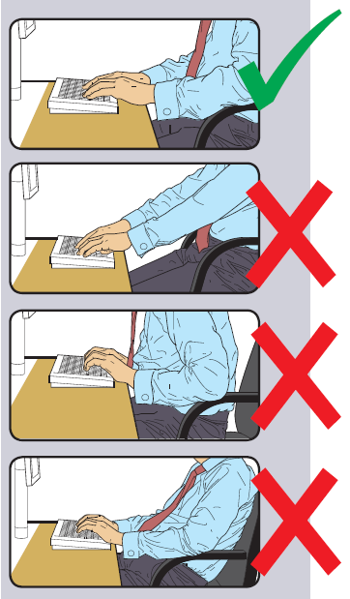  - Is the user applying a soft touch on the keys?  - Is the user over stretching the fingers?  - Is the keyboard separate from the screen?  - Does the keyboard need to be repositioned or is it comfortable to use?
- Is there enough space in front of the keyboard for the user to rest their hands? (E.g. 50 mm) |  | - Can the monitor be moved further back?  - Is a wrist rest for the keyboard provided?
4. Is the keyboard free from glare?

5. Is the keyboard clean and free from dirt and food debris?
6. Are the characters easily readable? |  | - Does the keyboard need to be cleaned, modified or replaced?
MOUSE WORK  - Is there intensive use of a mouse or trackball?  (If having difficulties with the mouse or experiencing pain in the wrists, ICT have various different shaped mouse that can be used for a week on loan) |  | - Is the user taking work breaks?  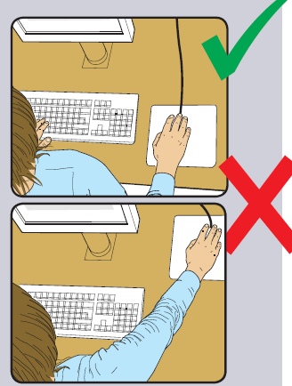  - Is the mouse located as close as possible to the keyboard?  - Is the mouse within easy reach to ensure the user is not overreaching.  - Is the user gripping the mouse too hard?  - Could a different size or shape mouse be used?  - Is there support for the users arm wrist and forearm? Is a wrist rest required?
RISK FACTORS: | YES/NO | HELP/SUGGESTIONS: | FURTHER ACTION TO BE TAKEN:
FURNITURE  - Is the work surface large enough for documents, monitor, keyboard, etc.? |  | - Can the printer, files, etc. go elsewhere to make more room?  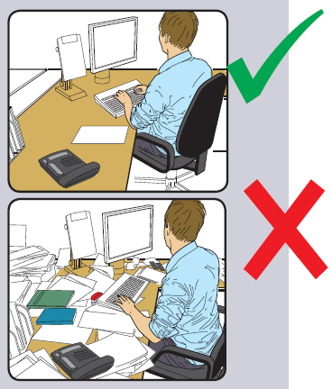  - Is the user making repeated or awkward stretching movements?  - Can the equipment, paper or work be re-arranged to avoid discomfort?  - Is there a need to provide more space or more sockets?
- Is the surface free of glare and reflections? |  | - Can mats or blotters be used for larger areas?
- Is the desk free from dirt and food debris?
4. Is the chair stable to support the user? |  | - Has it got 5 castors?  - Is it fully adjustable? (i.e. seat height, back support height, back support tilt)  - Does it swivel?  - Do all the adjustments work?  - Does the user know how to adjust them?  - Has the chair capacity weight limit been exceeded?  - Most operator chair have a 110kg (approx. 17.5 stone capacity) Specialist ergonomic chair may have a higher capacity – this information can be obtained by the manufacturer or supplier.  - Please note: If a new chair required an anthropometric data sheet may be required to ensure the correct chair for the user is obtained. (See SOP 07 for process.)
- Is the user sitting comfortable?   |  | - Can the chair be adjusted?  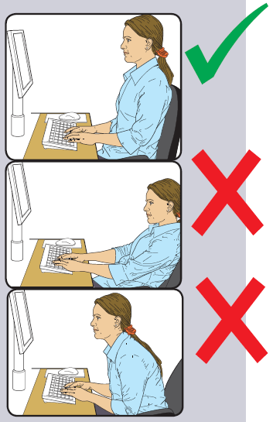  - Are the user’s arms roughly horizontal to the floor and the wrist straight, i.e. in line with the hand and forearm?  - Are the user’s eyes roughly the same height as the top of the VDU casing?  - Are the user’s feet flat on the floor?  - Is there too much pressure on the back of the legs and knees? (If so a footrest may be required.)  - Is the small of the back supported by the chair?  - Is the users back supported by the chair? (Is the user relaxed or leaning forward?)  - Are the arms of the chair preventing the user from getting close enough to key comfortably?  - Are there any obstructions under the desk that need to be moved?
RISK FACTORS: | YES/NO | HELP/SUGGESTIONS: | FURTHER ACTION TO BE TAKEN:
SOFTWARE  - Is the software suitable for the task? |  | - Has the user had enough training?  - Is the software user friendly to minimise stress?  - Does it give adequate ‘help’ messages?
ENVIRONMENT  - Is there enough room to change position and vary movement? |  | - The user needs room to alter their position from time to time
- Are the levels of  - Light  - heat  - noise |  | - Is the lighting suitable?  - Is it too bright, or not bright enough to comfortably read by?  - Is there a need to provide shading or provide more light?  - Can the heat be controlled?  - Is there need to distance the user from sources of noise, or to provide sound proofing, e.g. for printers?
- Is the work environment comfortable?  Does the air feel comfortable? |  | - Is circulation of fresh air required?  - Has the user ever complained that they experience headaches / dry eyes?  (Plants can help to create moisture in the environment)
LAPTOPS/PORTABLE COMPUTERS  - Is there any use of laptops/portable computers?  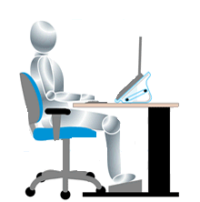 |  | - Is full-sized equipment available to use instead of a laptop/portable computer?  - Can the laptop be placed on a docking station with the use of a mouse and full size keyboard?  - Is the user aware of how to minimise risks? (E.g. maintaining good posture, reducing screen glare, and taking work breaks.)  (If someone who uses a laptop is identified as being a DSE ‘User’ they must be provided with an appropriate ‘docking station’ at their main base. A docking station must consist of a separate keyboard and mouse, with a separate monitor or riser blocks to raise the laptop screen to eye level.)

TO BE COMPLETED BY THE DSE USER:

Have you completed this DSE assessment checklist?
Are you aware of your entitlement to a free eyesight test?
Are you aware of the need to take breaks from continuous screen/keyboard work?
Is your workstation comfortable, are you happy with your current workstation set up?
Do you have any concerns relating to your workstation?
Please state concerns here: -

Please sign and date below and pass a copy of this completed checklist to the trained DSE assessor for your team.

Signed: ……………………………………………………………………. Dated: …………………………………………………..
TO BE COMPLETED BY THE TEAM/SERVICE TRAINED DSE ASSESSOR: (Please note the DSE assessment process must be overseen by the Trained DSE Assessor)

Have you completed this DSE assessment checklist on behalf of the user?
If not - have you overseen the process by showing the user how to set the workstation up correctly and looking over this assessment checklist in order to provide advice and identify any areas of concern that require corrective action?
Have you already made the required changes to the workstation?
Have you made your manager aware of any outstanding issues relating to this assessment that require further attention?
Please state any issues that require further attention here: -

DSE Assessors Name: ……………………………………………………..

Signed: ……………………………………………………………………... Dated: ……………………………………………………….

TO BE COMPLETED BY THE MANAGER:

Have all the action points listed above been dealt with?
If all action points have not been undertaken please state what further action is to be undertaken: -

Managers Name: ……………………………………………………..

Signed: ……………………………………………………………………... Dated: ……………………………………………………….
Note for the manager.
DSE assessments for this user should be subject to a periodic review, ideally every 2 years or earlier if there are any significant changes to the time spent using DSE equipment, any changes to + or relocations of the workstation, or if the user start to experience any aches reports a condition that could be affected by the use of DSE.

Appendix 2

HOMEWORKING ASSESSMENT CHECKLIST

The aim of this assessment is to ensure that as a homeworker you are working in optimal conditions and to highlight any areas that may need to be improved in order to comply with the Management of Health and Safety at Work Regulations 1999, the Workplace (Health, Safety and Welfare) Regulations 1992, the Health and Safety (Display Screen Equipment) Regulations (as amended 2002), and associated legislation.

Please complete the following assessment checklist regarding your current homeworking arrangements. During the process any simple measures you can take yourself to create a safer more comfortable homeworking environment including any changes to the workstation and any associated equipment should be taken. If you have any concerns related to DSE/workstation set up you can get further advice and guidance from your teams trained DSE Assessor.

The completed checklist should be shared and discussed with your line manager in order for appropriate action to be taken. It is therefore of extreme importance that answers given are accurate.

HOMEWORKERS NAME: …………………………………… DIRECTORATE: ………………………….…………………………..

SECTION: …………………………………………..…………… LOCATION: …..……………………….………………………………
RISK FACTORS: | YES/NO | HELP/SUGGESTIONS: | FURTHER ACTION TO BE TAKEN:
General  - Are you classed as a DSE user? |  | - Do you use Display Screen Equipment for 1-hour constantly each day or do you use Display Screen Equipment for 3 hours sporadically through the day? If so you are a DSE user.
- Have you received appropriate training in the use of the equipment provided? |  | - Has your trained DSE assessor shown you how to set the workstation up in your main WBC office?
- Have you completed the DSE mandatory e-learn module? |  | - See link to the WINNIE My Learning pages where you can access the DSE mandatory e-learn training module.
- Have you received information relating to the procedures for receiving eyesight tests? |  | - Information relating to eyesight tests is available via the link to SOP 07 DSE.
- Are you aware of the Display Screen Equipment regulations? |  | - Information relating to the Display Screen regulations can be found within SOP 07 DSE.
Health  1. Are you aware of the need to take breaks from DSE work? |  | - Do you take 5 minutes in every hour away from the screen; this can be performing other work-related duties?
2. Are you aware of the need to report any musculoskeletal discomfort to you manager or trained DSE assessor?  3. Do you currently have any long-term medical condition, which affects your use of DSE? |  | - Discuss with your trained DSE assessor to identify if any specialist equipment is required?  - It is recommended that any medical conditions that affect you working at home or with DSE are discussed with your line manager to ensure you have the right level of support and equipment in place.
4. How many days do you currently work from home? |  | - Do you use DSE equipment for personal use or do you have any hobbies that involve repetitive movements i.e. piano.
5. Does your manager keep in regular contact with you to keep you up to date, monitor workloads and your wellbeing? |  | - This could be regular time to talk sessions, supervision, team meetings, catch up sessions, etc.
RISK FACTORS: | YES/NO | HELP/SUGGESTIONS: | FURTHER ACTION TO BE TAKEN:
Lone Working  1. Do you currently work on your own when homeworking? |  | - Are you in regular contact with other team members through the day?
2. Do you have any medical conditions that increases the risk of working alone at home? If so have these been discussed with your line manager?
3. Do you have suitable means of communication or other means of summoning assistance should help be required? (Telephone, Mobile, etc.)
4. Are you aware of the need to report accidents or incidents including any near misses to your line manager if carrying out work tasks whilst homeworking? |  | - Further information can be found in SOP05 Accident, Incident and Ill-Health Reporting
Equipment / Resources
1. Please state what resources you have access to when working from home?
- Dedicated room
- Workstation/desk
- Fully adjustable chair
- Laptop
- Monitor
- Keyboard
- Mouse
- Monitor raiser
- Document holder
- Foot rest
- Wrist rest (mouse)
- Wrist rest (keyboard)
- Broadband
- Mobile phone
- Headset
- Printer

Electricity  1. Is equipment subject to regular inspections to ensure plugs, cables and leads remain in good condition and there are no missing screws or loose parts, frayed cables, signs of burning or staining that may suggest equipment is overheating? |  | - If electrical equipment is found to be damaged, faulty or dangerous, do not use and report to your line manager and the ICT team so that repairs or replacements can be made.  - Household electrical supply and equipment for example sockets, lighting, RCD, heaters that are not provided by the employer should be checked on a regular basis by the homeowner to ensure in good condition.
RISK FACTORS: | YES/NO | HELP/SUGGESTIONS: | FURTHER ACTION TO BE TAKEN:
Electricity Cont.  2. Is equipment PAT tested periodically? |  | - Ensure you are aware when PAT testing is available in the main office so you are able to bring cables and leads in for testing. Discuss when this is being undertaken with your line manager.
3. Is all equipment provided for working at home switched off at the end of the working day when not in use?
4. Are there adequate numbers of plug sockets available? |  | - If using an extension lead, it must not be daisy chained (this is when 1 extension lead is connected to another).
5. Are there any trailing cables in the area where you are working that could cause a trip hazard to you or others in the household? |  | - Can cables be re-routed to eliminate a trip hazard?
Fire  1. Do you have a smoke alarm installed in your home? |  | - It is the homeowner responsibility to check any fire detection equipment regularly to ensure in good working order and to consider a plan for evacuation in case of emergency.
2. Is the alarm checked to ensure in good condition on a regular basis. |  | - It is the homeowner responsibility to check any fire detection equipment regularly to ensure in good working order.
3. Have you considered a evacuation plan if you need to leave your home in the event of an emergency. |  | - Consider what you may need to do or take if you need to leave the house in the event of an emergency.
4. Have you informed your home insurers that you currently work from home for part of your working week? |  | - If you are working from home due to Covid-19 your insurers may waiver the need to update your insurance policy. If you are now working from home through choice your insurers may need to update the policy to acknowledge this.
Screen Image  1. Are the characters readable? |  | - Is the image clear?  - Is the screen clear?
2. Is the image free of flicker and movement? |  | - Is there a need to try altering contrast of colour to reduce flicker?
3. Are the brightness and contrast controls adjustable?  4. Is the screen cleaned and free from dirt and smudges? |  | - Are you aware of how to alter the brightness/contrast levels?
5. Does the screen swivel and tilt? |  | - Is there sufficient cable to allow the screen to be adjusted?
6. Is the screen positioned so that the top of the screen is at eye level to avoid sustained bending/twisting of the neck?  7. Is the screen set up at a comfortable distance?  (ideally an arm’s length away) |  | - If you wear bi-focal glasses the screen height may need to be slightly lower to minimise any raising/twisting of the head when reading from the screen.
8. Is the screen free from glare and reflection?  (If necessary, use a mirror in front of the screen to check the source of reflections.) |  | - Can the screen be moved or tilted to remove reflections?  - Can the desk or the source of reflections be moved?  - Can lighting be adjusted or window coverings utilised? (Check that any blinds work. Vertical blinds are more effective then horizontal ones.)  - If there are still problems, consider an anti-glare screen be used as a LAST resort?
RISK FACTORS: | YES/NO | HELP/SUGGESTIONS: | FURTHER ACTION TO BE TAKEN:
Keyboard  - Can the keyboard be tilted?  2. Can you find a comfortable keying position?  3. Is the keyboard separate from the screen?  4. Can you read the characters on the keyboard? |  | - Are the hands bent up at the wrist?  - Is the user applying a soft touch on the keys?  - Is the user over stretching the fingers?  - Does the keyboard need to be repositioned or is it comfortable to use?  - Does the keyboard need replacing?
5. Is there enough space in front of the keyboard for the user to rest their hands? (E.g. 50 mm) |  | - Can the monitor and keyboard be moved further back to allow room for the wrist placement?  - Is a wrist rest for the keyboard provided?
6. Is the keyboard free from glare?
7. Is the keyboard clean and free from dirt and food debris?
Mouse Work  - Is there intensive use of a mouse?  (If you are having difficulties with the mouse or experiencing pain in the wrists, ICT have various different shaped mouse that can be used for a week on loan) |  | - Are you taking breaks of activity change?  - Is the mouse located as close as possible to the keyboard and within easy reach?  - Are you gripping the mouse too hard?  - Is there support for your wrist and forearm? Is a wrist rest required?
Furniture  - Is the work surface large enough for documents, monitor, keyboard, etc.? |  | - Can the printer, files, etc. go elsewhere to make space?  - Are you making repeated or awkward movements?  - Can the equipment, paper or work be re-arranged to avoid discomfort?  - Is there a need to provide more space or have access to more sockets?
- Is the surface free from glare? |  | - Can blinds or curtains be closed to minimise reflections?
- Is the desk free from dirt and food debris?
4. Is your chair fully adjustable?  5. Does the chair fully support your back in a comfortable upright position? |  | - Has it got 5 castors?  - Is it fully adjustable? (i.e. seat height, back support height, back support tilt, seat swivel)  - Do all the adjustments work?  - Do you know how the adjust work?  - Has the chair capacity weight limit been exceeded?  (Most operator chair have a 110kg (approx. 17.5 stone capacity)  Please note: If a new chair is required, an anthropometric data sheet should be required to ensure the correct chair is obtained. (See SOP 07 for process.) Please discuss with your line manager or trained DSE assessor.
RISK FACTORS: | YES/NO | HELP/SUGGESTIONS: | FURTHER ACTION TO BE TAKEN:
Furniture Cont.  4. Are you sitting comfortable? |  | - Can the chair be adjusted?  - Are your arms roughly horizontal to the floor and the wrist straight, i.e. in line with the hand and forearm?  - Are your eyes roughly the same height as the top of the Monitor?  - Are your feet flat on the floor?  - Is there too much pressure on the back of the legs? If so a footrest may be needed.  - Is your back supported by the chair?  - Are the arms of the chair preventing you from getting close enough to key comfortably?  - Are there any obstructions under the desk that need to be moved?
Software  - Is the software suitable for the task being undertaken? |  | - Have you been trained in the use of the software?  - Is the software user friendly to minimise stress?  - Does it give adequate ‘help’ messages?
Environment  - Is there enough room to change position and vary movement? |  | - Is there enough room to alter position from time to time
- Are the levels of  - Light  - heat  - noise |  | - Is the lighting suitable?  - Is it too bright, or not bright enough to comfortably read by?  - Is there a need to provide shading or provide more light?  - Can the heat be controlled?  - Is there need to distance yourself from sources of noise?
- Is the work environment comfortable?  Does the air feel comfortable? |  | - Can a window be opened to allow fresh air to circulate?  - Is adequate heating available?  - Have you ever complained or experience frequent headaches / dry eyes?
Laptop and portable devices  - Is there any use of laptops/portable computers? |  | - Is a separate monitor available to use with the laptop/portable device?  - Can the laptop be placed on a docking station with an additional mouse and full size keyboard connected?  - Are you aware of how to minimise risks? (E.g. maintaining good posture, reducing screen glare, and taking work breaks.)  (If someone who uses a laptop at home and is identified as being a DSE ‘User’ they must be provided with an appropriate ‘docking station’. A docking station must consist of a separate keyboard and mouse, with a separate monitor or riser blocks to raise the laptop screen to eye level.)

TO BE COMPLETED BY THE HOMEWORKER:

Have you completed this homeworking assessment checklist?
Are you aware of your entitlement to an eyesight test?
Are you aware of the need to take breaks from continuous screen/keyboard work?
Is your home workstation comfortable, are you happy with your workstation set up?
Do you have any concerns relating to your workstation or equipment?
Please state concerns here: -

Insert a photo of your current home workstation set up here.
Please sign and date below and pass a copy of this completed checklist to the trained DSE assessor for your team.

Signed: ……………………………………………………………………. Dated: …………………………………………………..

TO BE COMPLETED BY THE TEAM/SERVICE TRAINED DSE ASSESSOR: (Please note the homeworking assessment process must be overseen by a Trained DSE Assessor)

Have you overseen the homeworking process by showing the user how to set the workstation up correctly in the main office environment? Have you looked over this checklist in order to assess if the homeworker is working safely and to provide advice and identify any areas of concern that require corrective action?
Have you already advised the homeworker on the required changes to the workstation?
Have you made the homeworkers line manager aware of any outstanding issues relating to this assessment that require further attention?
Please state what actions have been taken and also any issues that require further attention here: -

DSE Assessors Name: …………………………………………………… Signed: ……………………..…………………..……………… Dated: …………………………

TO BE COMPLETED BY THE MANAGER:

Have all the action points listed above been dealt with?
If all action points have not been undertaken please state what further action is to be undertaken: -

Managers Name: ……………………………………………………… Signed: ………………………………………………………… Dated: .….…………………………

Note for the manager.
Homeworking assessments should be subject to a periodic review, ideally every 2 years. A review may be needed earlier if: -
- There have been any significant changes to the time spent using DSE equipment;
- The workstation is relocated or there are changes to the environment;
- The user start to experience any aches and pains or reports a condition that could be affected by using DSE equipment or working from home.

Date of next review ………………………………………..

