
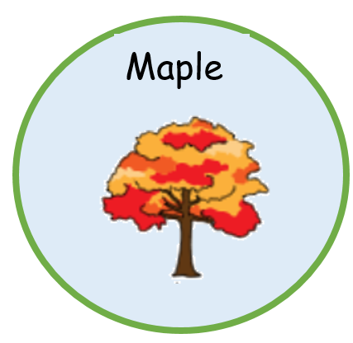
Within all pathways, the overall intent is to provide a motivating and engaging curriculum in which pupils can make progress in relation to their starting points in a personalised way. All pupils are encouraged to access trips in the community and our weekly assemblies and other key themed events across the school calendar.
In the maple pathway pupils need to access learning in smaller steps and require a sensory based learning environment. The curriculum focuses on achieving the 5 key skills of the engagement model: exploring, realising, anticipating, persisting and initiating.

Pupils require support through a total communication approach which is reflected across the curriculum. The curriculum is also highly structured but within it offers many opportunities for social interaction, engagement, independence and making choices.

