

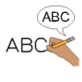


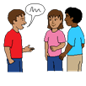

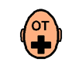



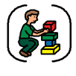

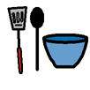




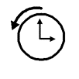

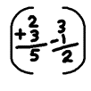
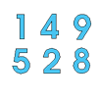
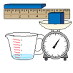

Hedgehog Class Autumn Term Overview 26 – 27

Topic/SCERTS

Science - Our Bodies and Senses/Exploring Materials Around Us.
History - Significant People Who Changed Our Lives/Local History.
Geography - Places and belonging/Our local area.
RE - International Day of peace/Christmas and Advent.
Art - Art for Self Expressions/Architecture and Design.
DT - What helps us feel calm, alert or engaged/Exploring how objects, fit, stack, balance and connect.
Food Technology - Comfort foods and favourite foods/Foods from different places
Computing - Digital Communication and Capturing/ Exploring Places Digitally.
PSHE - Managing thoughts and emotions/First Aid.
MFL - European Languages Day/Christmas Around Spain.
PE - Dance and gymnastics/Multi Skills Focus on: throwing and catching. running and jumping.
Music - Songs from Musicals/Christmas production.
Careers - Making changes - healthy living.



Maths

- Number - Counting.
- Geometry – Shape and pattern.
- Number – Adding more.
- Measurement – Time (Days, routines, day/night)
English

- Stories exploring emotions well and being
- Understanding emotions.
- Feelings poetry and performance poetry.
- Stories set in different places and communities.
- Homes and Places Around the World.
- Places and environment poems.
(Ongoing English skills- fine motor skills, intensive interaction sessions, SALT targets, reading skills and phonics lessons)

Overall Topics
Understanding Our Feelings
Buildings and Places

