Dormouse Class Autumn topic overview (year 3)
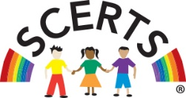
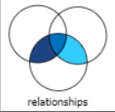
2026 – Autumn 1 topic theme – ‘Relationships’
Maths
Number
Counting

English
Relationships- Friendship and Relationship Stories
Building Positive Relationships
Feelings and Friendship Poetry
Phonics
Letters & Sounds / Twinkl
Reading books
Handwriting


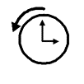





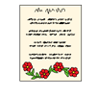

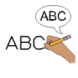


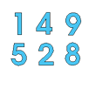
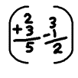


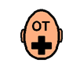

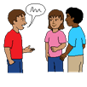



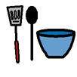
Science
Relationships – Human Growth, Change and Wellbeing

Topic / SCERTS / ASDAN (KS4)
History – Relationships- Relationships Through Time
Geography-Communities and Connections
Art – Relationship-Identity and Self-Portraits
RE – Relationships- International Day of Peace
Food Technology – Enterprise-Working in the Bungalow
Computing – Relationship- Online Relationships and Communication
Careers- Making changes – healthy living
PE – Relationship- Dance and gymnastics
PSHE / RSE – Consent- saying no
Speech and Language therapy – Use of PECS & communication books
Occupational Therapy – Self and emotional regulation & Sensory awareness skills

