Caterpillar Autumn 1 Topic Overview
2026 – Autumn 1 topic theme – ‘Nursery rhymes’
English
Traditional Nursery Rhymes and
Stories
All about Nursery Rhymes
Rhyme and Repetition
Phonics
Reading books
Fine motor

Maths
Place Value- Counting
Number- Addition and subtraction

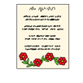




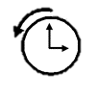









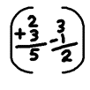
Topic (KS1)
Science- Exploring sounds
History – Then and now stories
Geography- Places in our stories
Art – Mark making and story illustrations
RE – International Day of Peace
Design Technology – Nursery prop making
Food Technology – Nursery rhyme baking
Computing – Interactive nursery rhymes
MFL – European languages day
Music- Recognising different sounds
PE – Movement & Dance
PSHE / RSE – Celebrating me
Speech and Language therapy – Use of AAC and total communication
Occupational Therapy – Self and emotional regulation & Sensory awareness skills








