Pupils will:
Share stories about neighbour hood
Non-fiction our community
Poetry about home and community
Reading for pleasure
Daily phonics / Reading eggs

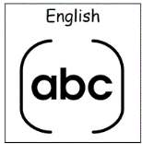

Asking for help - SCERTS
Taking turns
Belonging to a group
Sharing during play
Recognising friends /staff by names/pictures
Recognising things in the community.
Key texts – Stories about our neighbourhood - 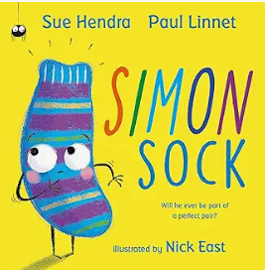 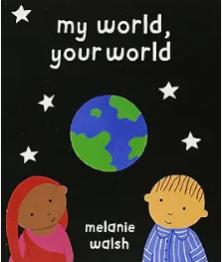 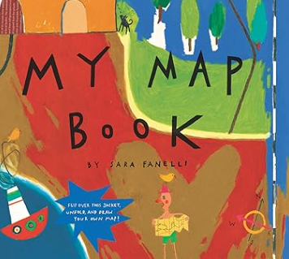 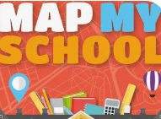
Poems about home and community – Hello bus, hello shop, Hello people when we stop. Wave to neighbours up the street – Community is who we meet.
My home is warm, my home is bright, A cosy place by day and night. I eat, I play, I sing a song. My home is where I feel I belong.

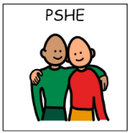

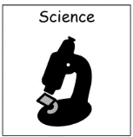

Topic - Our Community
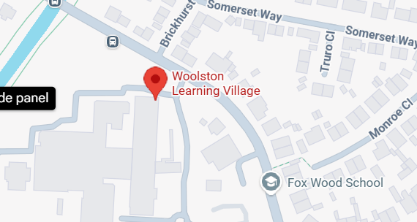Autumn 1 – Butterfly and Bumblebee
Pupils will:
Learn about everyday materials around us.

Pupils will:
Move and Dance
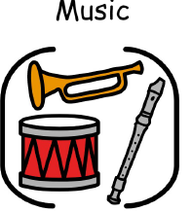
Pupils will:
Learn about pulse, rhythm and pitch.

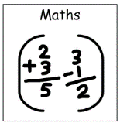
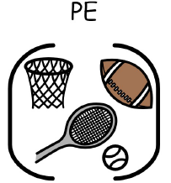

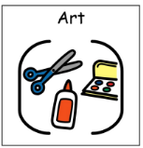
Pupils will:
Explore community, colour and collage.

Pupils will:
Make healthy snack we can eat in our community – fruit kebabs, mini quiches, cheese twists, sandwiches.
Pupils will:
International Day of peace
Rosh Hashanah
Harvest
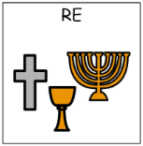

Pupils will:
Explore the local Area.
People and places around us.

Pupil will:
Explore the flag, food, music about Spain.
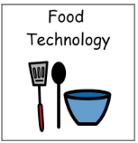
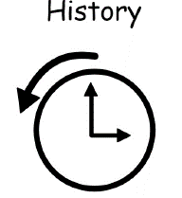
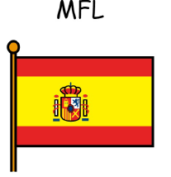
Pupils will:
Explore Number bots


Pupils will:
Build our community – construction and junk modelling.

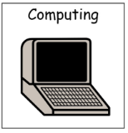
Technology in the community
Talk tins / sound buttons
Cause and effect
Scanning at the shop /library.

