
Primrose Class Autumn Term Topic Overview

Our Autumn Topic: Emotions
This term, Primrose Class will be exploring emotions through a range of engaging, sensory-rich experiences.
Learning opportunities will be carefully planned around the Engagement Model, supporting pupils to develop skills in:
- Exploration – investigating new sensory experiences and materials
- Realisation – recognising the impact of their actions
- Anticipation – predicting familiar routines and events
- Persistence – maintaining focus and engagement in activities
- Initiation – communicating choices, preferences, and responses

Areas of Learning
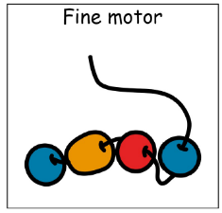
Our topic will be explored through a variety of curriculum areas:

Fine Motor

Developing hand strength, coordination, and control through emotion-themed activities, mark making, and practical tasks.

Communication Focus
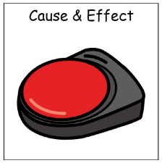
Encouraging pupils to express feelings, make choices, and interact with others using their preferred communication methods.

Cause and Effect

Exploring how actions create outcomes through interactive resources, switches, and motivating emotional-themed experiences.

Attention Autism
Building attention, engagement, and shared enjoyment through exciting and highly motivating emotion-focused sessions.


Themed Exploration
Investigating emotions through seasonal sensory activities, role play, stories, objects, and creative experiences.

Music and movement
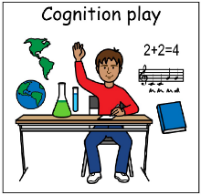
Using songs, rhythm, movement, and sound to explore different feelings and emotional expression.
Cognitive Play
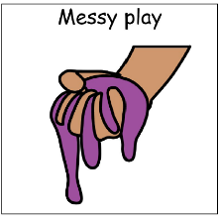
Developing problem-solving, thinking, matching, sorting, and early concept skills through engaging emotion-based activities.

Messy Play
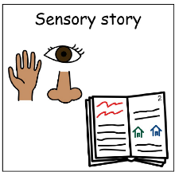
Exploring a range of textures, colours, and materials to encourage sensory engagement and creative expression.

Sensory Story
Experiencing immersive stories that bring emotions to life through sensory stimuli, repetition, and participation.

