

Preparing for adulthood is about taking action with young people with special educational needs and/or disabilities (SEND). The aim is to achieve the best outcomes in the following areas:


- Employment



- Independent living


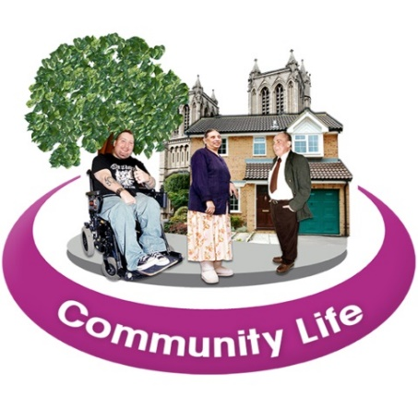

- Being part of the local community

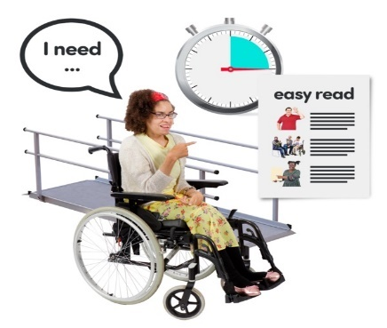

- Being Healthy


From the age of 14, individuals can be referred to the Preparation for Adulthood (PFA) team, a Council adult social care unit. The team offers information on the PFA journey and provides contact details for supporting services.

Around the age of 16, a social worker often joins to assess the young person's needs and collaborates with the family to plan for future support, known as a Care Act assessment.


Annual discussions occur between ages 16 and 18, acknowledging evolving needs. The young person's input is prioritized, involving family and various organizations.


Social workers actively participate in EHCP annual reviews, planning future provisions.

At 18, if young adults continue education or training with care and support needs, the PFA team's social worker remains involved, facilitating services such as short breaks.


For inquiries, the PFA team can be reached at 01925 446170 (Monday to Friday), while urgent matters can be directed to the Council's number 01925 443322 during office hours or outside of office hours, please contact our out-of-hours service on 01925 44440.

The PFA social worker will:
- Attend EHCP annual review.
- Confirm the details of the support plan.
- Arrange support for the young person from the most suitable provider.
- Provide a copy of the support plan to the young adult.
- Offer a carer’s assessment for parents of the young adults.
- Arrange a financial assessment of a young person’s income.
- Monitor and review the package of support.


Short Breaks: Once a young person reaches 18 years, of age short breaks including overnight support is available and provided by:
- Catalyst choices at Honeysuckle cottage in Warrington.
- Shared Lives: a shared lives carer can support someone in their own home or in the shared lives carer’s home on a sessional or fulltime basis, providing respite to families and giving an opportunity for the young adult to develop independent living skills.
- A number of care agencies are, at times, able to offer short break in a supported living home in an emergency situation if they have vacancies at the time.
- Some care agencies e.g. Catalyst choices offer an outreach service which can provide a short break and an opportunity for a young person to follow their interests and to access their community.



Direct Payments
Some young people have received a direct payment which has been used to pay for a personal assistant (PA) or for particular services prior to their 18th birthday. Once a young person reaches 18 years of age they can continue to be supported by the same PA and the direct payment will continue if the young person still needs this support.



Day opportunities
Being occupied is important to all of us and this means different things to different people. It’ll be important for a young adult to be able to follow their own interests.


Warrington has day services run by different organisations including:
- Walton Lea partnership: https://www.waltonlea.org.uk/
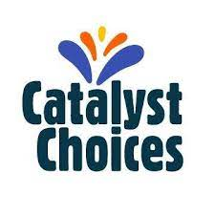
- Gorse Covert centre run by Catalyst choices www.mylifewarrington.gov.uk

- Macintyre day opportunities and a disco in the town centre https://www.macintyrecharity.org/for-adults/day-opportunities/warrington-learning-centre/


A short list of examples of other services which can be used by young adults include:
- Ella Together, an inclusive performance group. https://ellatogether.org.uk

- Creative Remedies; a program of arts activities that aim to improve the health and wellbeing of Warrington residents. https://www.warrington.gov.uk/creativeremedies

- Young adults with a learning disability can be referred to the Wellbeing service to pursue interests including music and sports groups.

- Accessible swimming is available at Orford Jubilee Hub. https://livewirewarrington.co.uk/leisure/our-locations
- The Puddle project; info@thepuddleproject.org

- Youth zone – info@wyz.org.uk
- Warrington Wolves – wheelchair rugby/ youth group.
- M-power- activities for young people


Paying for social care services
Adults who have social care services may have to pay towards the cost of these services.

At 18 years the council will complete a financial assessment to calculate the amount of money a person has to pay towards the cost of the services they receive. The council assess the young adult’s income not the income of the whole family. The young adult will be sent a bill each month requesting payment for this contribution.
Please refer to Eligibility and Paying for Adult Social Care | warrington.gov.uk for detailed information regarding the financial assessment process.


Carer’s assessment – if caring for a adult
Parents who are caring for a young adult over the age of 18 years can ask for their needs to be assessed by the carer support team at the Council. Carers can request a carer’s assessment, either a social worker or carer’s support worker will complete an assessment of a carer’s needs. This will include talking about how caring responsibilities are having an impact of wellbeing.

If a carer is eligible for support an offer of a direct payment will be made. Examples of services that be purchased using a direct payment include:
- Therapeutic
- Cleaning
- Laundry
- Gardening
- Sitting Services


To Contact the PFA team you can ring 01925 446170 (Monday to Friday), or send an email to Transitionteam@warrington.gov.uk
In a crisis outside of office hours, please contact our out of hours service on 01925 44440.

