

**Green Lane School**

**CPD Brochure & Outreach Support**

**2024-2025**

**Outreach Offer**

|  |
| --- |
| **LA lead teacher referrals**  Green Lane School currently has three Lead Teachers for Autism and SEMH. These referrals are not directly made to Green Lane School. Autism lead teacher referrals are completed through the local authority. SEMH lead teacher referrals are completed through Oakwood Avenue / SEMH hub at One Community Trust.  Lead teachers will receive the referral from the appropriate organisation and then meet with and set a referral / observation date. Following this, a report will be completed, including actions and next steps.  **SEMH Lead Teacher:**  Mike Gaskell (Head of Behaviour)  **Autism Lead Teachers:**  Joanna Capewell (Head of Autism, SCERTS lead, NPQLBC, NPQSL)  Mike Gaskell (Head of Behaviour / Assistant Autism Lead)  Hannah Willams (NPQLTD – Communication and Emotional regulation pathway Teacher) |
| **Autism Support**  Green Lane School holds advanced status with the National Autistic Society (2023). Moreover, 66.3% of our pupils have an autism diagnosis and our Autism lead is an NAS moderator.  A trained and experienced teacher could come to your setting to offer advice and support for strategies for pupils with autism and help set up an autism friendly classroom environment.  In addition to this, Green Lane offers internal meetings where professionals can come to speak to our autism leadership team and observe our autism-friendly classrooms for top tips.  Cost: £100 |
| **SEND Outreach and Support**  A member of our team can come out to your setting to meet with you and offer SEND support and strategies.  Cost: £100 |
| **Behaviour and Emotional Regulation Support**  Green Lane School can send out an experienced member of staff in behaviour support to your setting to offer support and strategies around behaviour and regulation.  Cost £100 |

**Team Teach – Level 1 (6 hours)**



**Course Aims/outline:** Team Teach is a holistic de-escalation and positive handling approach that supports staff in managing challenging behaviour in their setting. Team Teach focuses on how to reduce the need for and risk of positive handling. The Positive Handling Strategies are suitable across age and ability ranges and the courses are delivered by experienced and knowledgeable staff. There are a number of training options available:

**Level 1 (6 hours)** – Aimed at lower risk settings (e.g. mainstream schools, nurseries, sports coaches, supply staff etc.) where staff are typically supporting children without documented challenging behaviours or who do not generally pose a significant physical risk.

This course covers: Personal safety, team building, non-verbal and verbal de-escalation communication strategies, some positive handling techniques- if required, together with documentation and legal guidance, listening and learning, recording, reporting and reviewing.

**Course Leader(s):** Mike Gaskell – Lead Advanced Team Teach Tutor, Deputy ASD Lead/Behaviour Lead, Specialist lead teacher for autism / SEMH, Laura Owen – EYFS Lead/Intermediate Team Teach Tutor, Joanna Barnes – ASD lead, Advanced Team Teach Tutor, Specialist lead teacher for autism, Adam Garrod – Intermediate Team Teach Tutor

**Course Dates:** 6th November 2024**,** 29th January 2025 (Autism focus), 2nd April 2025

**Time:** 9am – 4pm

**Venue:** Green Lane School

**Cost:** £100 per delegate (refreshments available, lunch not included)

**Please Note:**

100% attendance of the course is mandatory to be able to achieve a pass grade.

Should you be attending the course for a specific young person(s) that currently requires restrictive physical intervention, please contact us for further advice. The majority of restrictive physical interventions **can only be taught on a Level 2 (12 hour) course.**

We are also in a position to offer whole or partial staff training for organisations within Warrington. This is where we come to you to deliver either Level 1 or Level 2 course. There is also an option to deliver the courses as twilight sessions.

Level 1 certification period is 2 years.

Team Teach Connect: From January 2024, it is mandatory for all organisations to pay an annual fee of £200, directly to Team Teach, for access to the Team Teach Connect platform. Only one licence per organisation is required. All training and notifications will now be through this training platform. All staff who have completed Team Teach training and are within date, will be able to access the resources on the training platform. For further information on this training platform, please visit <https://connect.teamteach.com/> . If the organisation does not already have a subscription to Team Teach Connect, you will receive an automatic invoice and further instructions.

**Challenging Behaviour**



**Course Aims/outline:**

Behaviour is perhaps the most pressing issue in education nowadays. This course aims to help staff understand behaviour and how to deal with it by:

* Building strong relationships – keeping channels of communication open, preventing breakdowns in communication
* Understanding challenging behaviour – how to speak the language of behaviour.
* Responding to challenging behaviour – do’s and don’ts.
* Planning for success – how to produce behaviour plans that are fit for purpose.
* Relational and restorative practices.

**Audience:**

Open to all staff working in both mainstream and special, primary and secondary settings.

**Course Leader:** Mike Gaskell – Lead Advanced Team Teach Trainer, Head of Behaviour / Deputy ASD lead, Specialist lead teacher for autism/SEMH.

**Course Dates:** 5th March 2025

Venue: Green Lane School

**Time**: 9.00am – 1.00pm

**Cost**: £75 per delegate

**Performance Management for Teaching Assistants**



**Course Aims/outline:**

This half day course is designed for schools wishing to implement or adapt a Performance Management Structure for Teaching Assistants within a school setting.

The course will cover:

* Rationale behind good performance management
* Importance of recognising and raising achievement of staff
* OFSTED expectations
* Samples of successful performance management proforma’s
* Lesson Observations
* Targets
* Evidence

The course would ideally suit Teaching Assistant team leaders, HLTA’s, SENCO’s.

This course is relevant for Primary and Secondary settings.

**Course Leader:** Gary Sykes–SLE in TA Development

**Course Date:** 10th March 2025

**Venue:** Green Lane School

**Time:** 1/2 day 9.30am - 1pm

**Cost:** £50 per delegate

**SEND - Outstanding Teaching & Learning**



**Course Aims/outline:**

A one day course led by Green Lane School focussing on improving Teaching and Learning practice for teachers and teaching assistants working with SEND pupils.

This includes:

* Planning an interactive, creative curriculum
* Using formative and summative assessments
* Resources
* The opportunity to engage and network with other teachers
* Observe outstanding practice in a special school through learning walks in a cross-phase provision (KS1/KS2/KS3/KS4).

**Audience:** Primary Teachers, Teaching Assistants and SENCOs who want to develop the quality of Teaching & Learning for pupils with SEND & make their classrooms more inclusive.

**Course Leaders:** Jo Mullineux – Head Teacher, SLE in SEND T&L, Lead for the LA & SIA SEND Peer Reviews, Trained facilitator for the ITP & OTP Programmes / Sarah Delaney – Deputy Head teacher, SLE in SEND T&L

**Course Date:** Thursday 24th April 2025

**Venue:** Green Lane School

**Time:** 9am - 3pm

**Cost:** £100 per delegate

**Team Teach – Level 2 (12 hours)**



**Course Aims/outline:**

Level 2:

This course is aimed at staff at medium to higher risk settings facing challenging behaviours (e.g. Designated provisions, special schools, PRU’s, children’s homes etc.). Typically staff supporting individuals with documented challenging behaviours / special needs that foreseeably poses a physical risk to self or others. This course covers: personal safety, team building, non-verbal and verbal de-escalation communication strategies, positive handling techniques, together with documentation and legal guidance, listening and learning, recording, reporting and reviewing. This is a two-day course.

Course Leader: Course Leader(s):– Mike Gaskell – Lead Advanced Team Teach Tutor, Deputy ASD Lead/Behaviour Lead, Specialist lead teacher for autism / SEMH, Laura Owen – EYFS Lead/Intermediate Team Teach Tutor, Joanna Barnes – ASD lead, Advanced Team Teach Tutor, Specialist lead teacher for autism, Adam Garrod – Intermediate Team Teach Tutor

**Course Dates:** ~~1~~~~st~~ ~~& 2~~~~nd~~ ~~October 2024~~ (**FULLY BOOKED**) and 20th & 21st May 2025

**Time:** 9am – 4pm

**Venue:** Green Lane School

**Cost:** £150

**Please Note:**

100% attendance of the course is mandatory to be able to achieve a pass grade.

We are also in a position to offer whole or partial staff training for organisations within Warrington. This is where we come to you to deliver either the Level 1 or 2 course. There is also an option to deliver the courses as twilight sessions.

This course can also be delivered using the ‘blended learning approach’, which includes 3 hours online and then a 9-hour face-to-face session. Please contact for further details.

We are also able to offer Team Teach Advanced modules. Please contact for further details.

Level 2 certification period is 12 months – please contact for further information on certification periods.

**Team Teach Connect: From January 2024, it is mandatory for all organisations to pay an annual fee of £200, directly to Team Teach, for access to the Team Teach Connect platform. Only one licence per organisation is required. All training and notifications will now be through this training platform. All staff who have completed Team Teach training and are within date, will be able to access the resources on the training platform. For further information on this training platform, please visit <https://connect.teamteach.com/> . If the organisation does not already have a subscription to Team Teach connect, you will receive an automatic invoice and further instructions.**

**The Role of the Teaching Assistant**



**Course Aims/outline:**

This half day course is designed to cover the everchanging role of the Teaching Assistant.

During the course we will cover:

* The role of the teaching assistant
* Expectations of the School, Teachers and OFSTED
* Public Perceptions of Teaching Assistants
* Responsibilities
* Differentiation
* Getting the most out of your day.

This course would ideally suit new Teaching Assistants, Teaching Assistants wanting to progress and develop their role, HLTA’s and SENCO’s.

This course is relevant for Primary and Secondary settings.

**Course Leader:** Gary Sykes – SLE in TA Development

**Course Date:** 20th January 2025

**Venue:** Green Lane School

**Time:** 1/2 day 9.30am - 1pm

**Cost:** £50 per delegate



**Course Aims/outline:**

This training will include strategies to support autistic learners with sensory needs, communication supports and emotional regulation.

The trainers will discuss the benefits of using SCERTS (Social Communication, Emotional Regulation and Transactional Supports) for our autistic learners. You will hear from SHINE occupational therapy who will provide sensory integration strategies on how best to support pupils to regulate. Delegates will spend time in our autism friendly classrooms and see strategies in action. The trainers will share our work in action and the support we give to families (described by the NAS as exceptional in its nature of a very high quality). Green Lane School holds advanced status by the National Autistic Society and our training package has had outstanding feedback and benefitted professionals in supporting autistic learners.

**Audience:** This course will ideally suit professionals who want to develop ideas and strategies to best support autistic pupils within their care.

**Course Leader:** Joanna Capewell – Head of Autism and NAS moderator supported by Mike Gaskell – whole school behaviour Lead and Lisa Hamer- Head of SHINE therapy services.

**Course Date:** 26th February 2025

**Venue:** Green Lane School

**Time:** 9:30am - 2:45pm

**Cost:** £85 per delegate (refreshments available, lunch not included)



**Course Aims/outline:**

This training will include an insight into what autism is and to enhance people’s understanding of autism. You will get the opportunity to have a Q+A with an autistic adult who has found employment, and parents of our autistic learners to learn what it is like to live with autism.

We will cover sensory issues and dysregulation and emotional support and how you can make reasonable adjustments to your workplace. You will see strategies that we use at school that can be transferrable for our autistic learners when out in the community, (described by the NAS as innovative, extremely valuable and exceptional in nature of a very high quality).

 Our trainers have worked alongside and supported over 100 employers to support them to make reasonable adjustments in the workplace and in addition have supported a variety of workplaces to build their inclusion training packages.

**Audience:** This course will ideally suit employers, public services and community workers.

**Course Leader:** Joanna Capewell – Head of Autism and Michael Gaskell- Assistant Autism lead and Amy Johnston- careers lead

**Course Date:** Thursday 9th January 2025

**Venue:** Green Lane School

**Time:** 9:30am - 2:45pm

**Cost:** £50 per delegate (Refreshments available, lunch not included)





**Course Aims/outline:**The teen life programme is a six-session programme for parents/carers of young people (10-16 years) on the autism spectrum. The teen life programme aims to empower parents and supporting professionals to understand more about how autism is experienced by autistic teenagers. It will discuss useful strategies and share ideas of how to support the autistic person through their teenage years. The sessions covered will be hidden presentation, self-esteem, stress and anxiety, puberty and understanding the diagnosis.

**Audience:**   Parents of children aged 10-16. 2 family members are allowed to attend, we can only take a maximum of 8 families so book fast!

**Course Leaders:** Joanna Capewell and Michael Gaskell

**Venue:** Green Lane School

**Dates:** Times and Dates TBC (This course will take place from November 2024- February 2025).

**Time:** TBC

**Cost:** £35 for Green Lane families. External families £55 (all includes workbook).

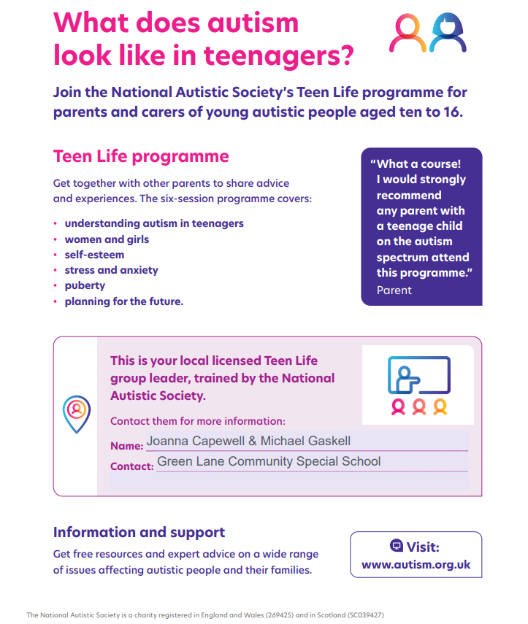 



**Course Aims/outline:**Early Bird Plus programme is a national autistic society three-month (8 sessions) parent programme which aims to support families by developing parental understanding of why their child may behave differently so they can begin to think about how best to support their development. Sessions covered are sensory differences, communication, interaction, socialisation and self-awareness and behaviour.

 **Audience:**   Parents/Carers of autistic children ages 4-9. We can only have a maximum of 6 parents so book interest fast!

**Course Leader:** Joanna Capewell and Michael Gaskell

**Venue:** Green Lane School

**Date:** Times and Dates TBC (This course will take place from February 2025- April 2025)

**Time:** TBC

**Cost:** £35 to Green Lane families. £55 to external families.



**Course Aims/outline:**This training will allow you to spend time in a classroom which is set up for pupils who need an engagement style of learning and intensive interaction to encourage engagement and progress. This training will share a range of strategies, supports and give examples of activities and learning ideas.

**Audience:**   This course is for professionals who need ideas and strategies to support pupils on the engagement model.

**Course Leader:** Joanna Capewell- Head of Autism

**Course Date:** Thursday 1st May 2025

**Venue:** Green Lane School

**Time:** 9:30am - 2:30pm

**Cost:** £50 per delegate (refreshments available, lunch not included)



**Course Aims/outline:**

This half day course is ideal for teaching assistants wanting to professionally develop their role within the classroom.

**During the course we will cover:**

* Different ways of supporting
* Questioning
* Recording and reporting
* Understanding Level and Targets
* Keeping Evidence
* Target setting.

**Audience:** The course would ideally suit existing Teaching Assistants wanting to have a better understanding of pupil need and how to aid them in making progress, Teaching Assistant Team leaders and SENCO’s. This course is relevant for Primary and Secondary settings.

**Course Leader:** Gary Sykes–SLE in TA Development

**Course Date:** 10th February 2025

**Venue:** Green Lane School

**Time:** 1/2 day 9.30am - 1pm

**Cost:** £50 per delegate

**Manual Handling**



**Course Aims/outline:** This training will include: This 1 day course deals specifically with the moving and handling of children with impaired movement. It is designed to cover theoretical and practical requirements of the Manual handling operations regulations 1992.  
The information on this course should help carers of all kinds to perform their client handling duties more safely and comfortably.

**Audience:** All staff who work with pupils with impaired movement and their equipment in both mainstream and special, primary and secondary.

**Course Leader:** Joanne Milnes – Manual Handling Trainer

**Course Dates:**

**Spring Term:** Monday 13th January 2025

**Spring Term:** Monday 28th April 2025

**Venue:** Green Lane School

**Time:** 9am - 3:30pm (refreshments available, lunch not included)

**Cost:** £100 per delegate

If you are interested in any of the above courses or have any further questions, please contact the school directly via email office@greenlaneschool.co.uk or on the main school number 01925 811617.