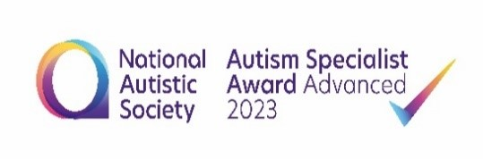

Mrs Capewell and Mr Gaskell our autism leadership team have gained the license from the NAS to deliver the following programmes. Please telephone the office to book 01925 811617.

**NAS early bird plus: Aimed at families of autistic children aged 4-9.**

**Our 8 session programme for families of autistic children aged 4-9**

* **Session 1:** Understanding autism
* **Session 2:** Understanding and supporting sensory differences
* **Session 3:** Communication
* **Session 4:** Supporting and developing interaction
* **Session 5:** Socialisation and self-awareness
* **Session 6:** Understanding and interpreting behaviour
* **Session 7:** Behaviour
* **Session 8:** Moving forwards

**Where: Green Lane Community Special School**

**When: 9:30- 12pm**

**Session 1: Thursday 5th December 2024**

**Session 2: Thursday 23rd January 2025**

**Session 3: Thursday 13th February 2025**

**Session 4: Thursday 6th March 2025**

**Session 5: Thursday 27th March 2025**

**Session 6: Thursday 8th May 2025**

**Session 7: Thursday 5th June 2025**

**Session 8: Thursday 26th June 2025**

**Total Cost: £25 for families of Green Lane pupils and £35 for external families.**

**Maximum: 12 families (2 adults per family)**



NAS teen life programme: Aimed at families of autistic children aged 10-16.

* **Session 1:** Understanding autism
* **Session 2:** Understanding autistic identity
* **Session 3:** Stress and anxiety / Understanding behaviour
* **Session 4:** Health and wellbeing
* **Session 5:** Puberty
* **Session 6:** Education / Transition to adulthood

**Where: Green Lane Community Special School**

**When: 9:30- 12pm**

**Session 1: Wednesday 15th January 2025**

**Session 2: Wednesday 5th February 2025**

**Session 3: Wednesday 19th March 2025**

**Session 4: Wednesday 23rd April 2025**

**Session 5: Wednesday 14th May 2025**

**Session 6: Wednesday 11th June 2025**

**Total Cost: £25 for families of Green Lane pupils and £35 for external families.**

**Maximum: 12 families (2 adults per family)**