**2023-2024 MENU 1 – WEEK 2**

|  |  |  |  |  |  |  |  |  |  |  |  |  |  |
| --- | --- | --- | --- | --- | --- | --- | --- | --- | --- | --- | --- | --- | --- |
| **OPTION** | **MONDAY** | | **TUESDAY** | | | **WEDNESDAY** | | | **THURSDAY** | | | **FRIDAY** | |
| 1 | Margarita pizza served with baked jacket wedges & sweetcorn | 23,400+ Margherita Pizza Stock Photos, Pictures & Royalty ... | |  | | --- | | Roast turkey,  roast & mashed potatoes, carrots & broccoli | |  | | Spaghetti Bolognese served with garden peas | [Pasta Bolognese Stock Illustrations, Cliparts And Royalty Free ...](https://www.google.co.uk/url?sa=i&url=https://www.123rf.com/clipart-vector/pasta_bolognese.html&psig=AOvVaw3p4HDtZVKtXQhNxqYpuH-S&ust=1595507156626000&source=images&cd=vfe&ved=0CAIQjRxqFwoTCLCw9rrt4OoCFQAAAAAdAAAAABAE) | | Brunch lunch – sausage, beans, hash brown & omelette | main product photo | | Crumb coated chicken served with chips & peas or beans |  |
| **2** | Chinese-style quorn with rice/noodles   |  | | --- | |  | | chinese chicken with noodles and rice photos from www.onceuponachef.com | Homemade cheese pasty, roast & mashed potatoes & beans or veg | cheese pasty photos from www.carrspasties.co.uk | | Garlic & herb chicken pitta with vegetable rice & broccoli | chicken pitta photos from www.flora.com | | Meatball sub served with diced potatoes & salad | https://encrypted-tbn0.gstatic.com/images?q=tbn:ANd9GcSACtnxScKTIeHFnTBrdXOYvMKGFmuYVUh131qurUT6tQaLivgdXdJX2XTF5oT70npe-g&s | | Oven baked battered salmon served with chips & peas or beans |  |
| **JP** | Jacket Potato |  | Jacket Potato |  | | Jacket Potato |  | | Jacket Potato |  | | Jacket Potato |  |
|  |  | | | | | | | | | | | | |
| **DESSERTS** | | | | | | | | | | | | | |
|  | Fresh fruit salad or yoghurt | | Raspberry ripple ice cream roll | | Jelly and fruit | | | Cook’s choice homemade carrot cake or banana and oat cake | | | Homemade cook’s choice biscuit | | |
| Available daily as an alternative:- Fruit yoghurt, a selection seasonal fresh fruit, soreen and cheese & biscuits | | | | | | | | | | | | | |
| **Unlimited fresh salad and unlimited wholemeal bread**  **LUNCH WILL BE SERVED WITH FRESH MILK OR WATER** | | | | | | | | | | | | | |
| **Menu Cycle Week 2: 24th Jun, 15th Jul, 9th Sep, 30th Sep, 21st Oct, 11th Nov, 2nd Dec** | | | | | | | | | | | | | |



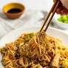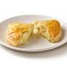 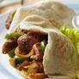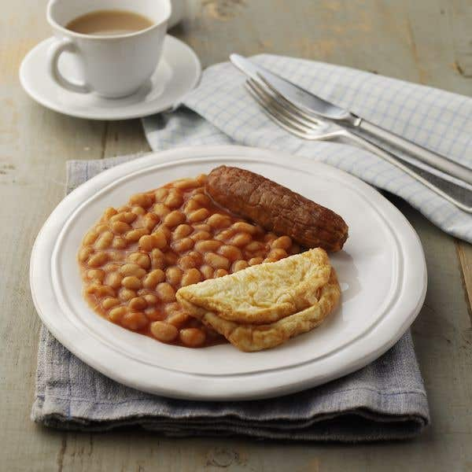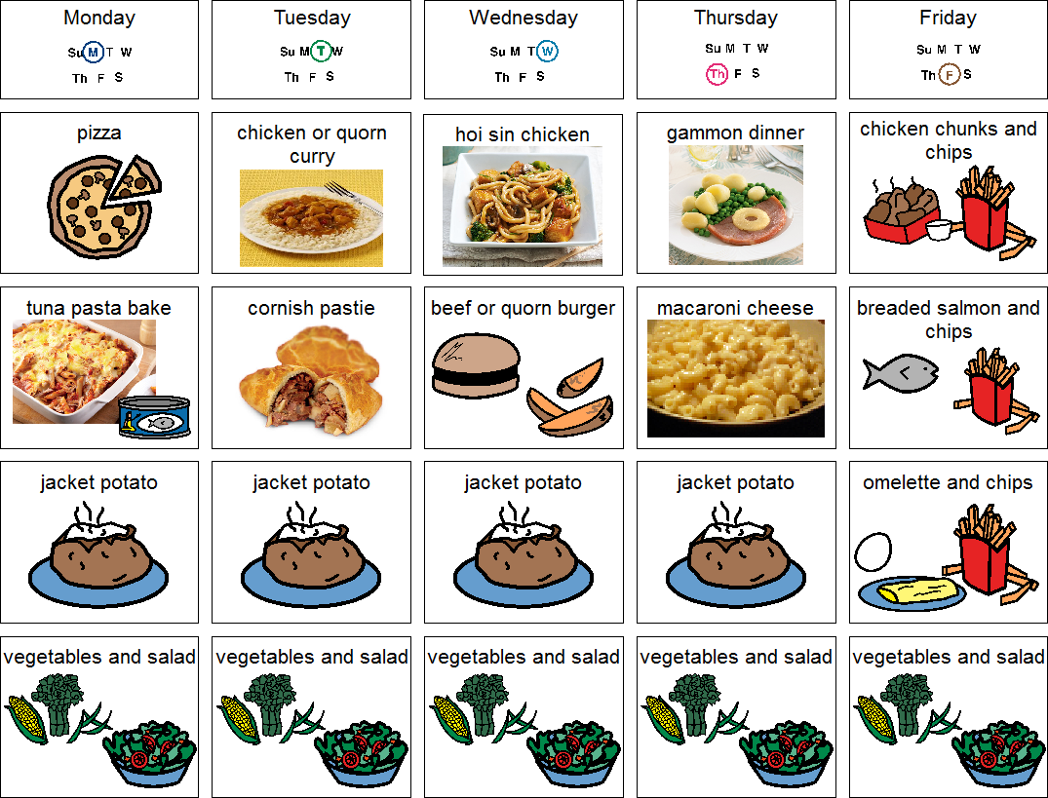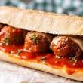

[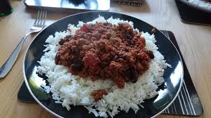](https://www.google.co.uk/imgres?imgurl=http://ukcdn.ar-cdn.com/recipes/originals/f3a60d68-d9d1-4a1c-9f4b-16c142da5c7f.jpg&imgrefurl=http://allrecipes.co.uk/recipe/9908/easy-chilli-con-carne.aspx&tbnid=z_933KpGuyioTM&vet=12ahUKEwiOsd_q9-DqAhUjgHMKHfxuDdsQMygjegUIARDKAg..i&docid=uY5Wr5KH1SapgM&w=3840&h=2160&q=chilli%20and%20rice%20&safe=strict&ved=2ahUKEwiOsd_q9-DqAhUjgHMKHfxuDdsQMygjegUIARDKAg)