Charlie and the Chocolate Factory – Chapter 2

Look at some of the fantabulous inventions from Charlie and the Chocolate Factory. For example, use this quote from Chapter 2

“Mr Willy Wonka can make marshmallows that taste of violets, and rich caramels that
change colour every ten seconds as you suck them, and little feathery sweets that melt away deliciously the moment you put them between your lips. He can make chewing-gum that never loses its taste, and sugar balloons that you can blow up to enormous sizes before you pop them with a pin and gobble them up. And, by a most secret method, he can make lovely blue birds’ eggs with black spots on them, and when you put one of these in your mouth, it gradually gets smaller and smaller until suddenly there is nothing left except a tiny little pink sugary baby bird sitting on the tip of your tongue.”

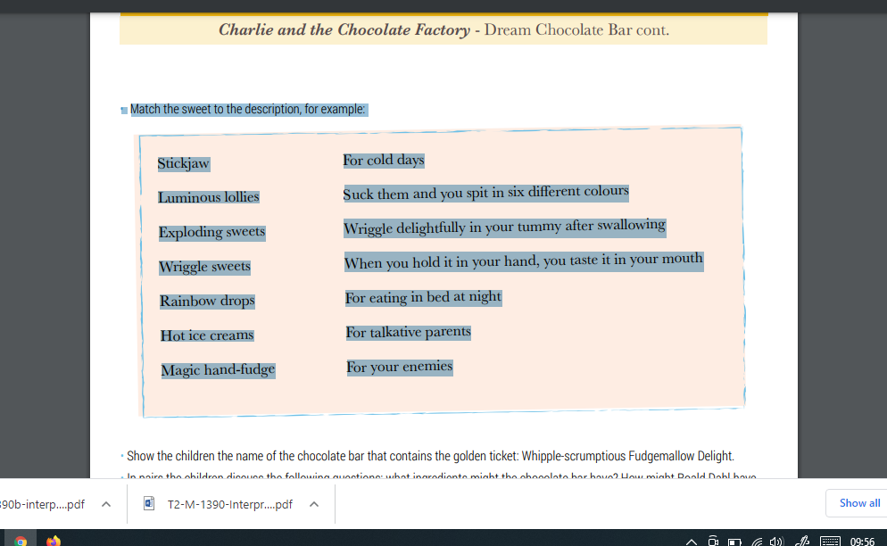

Main task - Design your own chocolate or sweet, using these guidelines:
Who is it for? A goodie, a baddie, your friend, your teacher?
What happens when it is eaten?
What ingredients does it contain?
What is the name?

Be creative – extend by creating a script for a t.v. advert to make people want to buy your sweet. Video yourself and send it in on evidence for learning.

Have fun! Ms White

