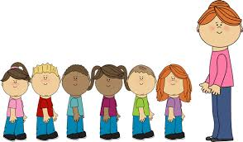

Letters and sounds.

Nursery rhymes.

Sharing texts and stories.



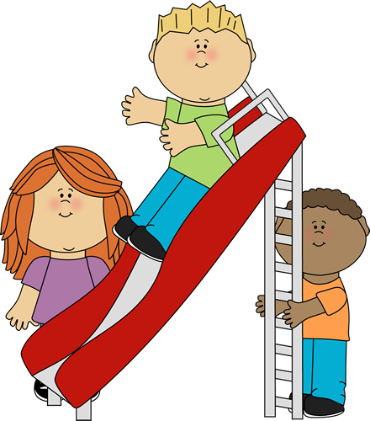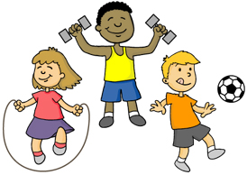

Using PECS/ Makaton.

Identifying naming words.

Copying familiar words and expressions.

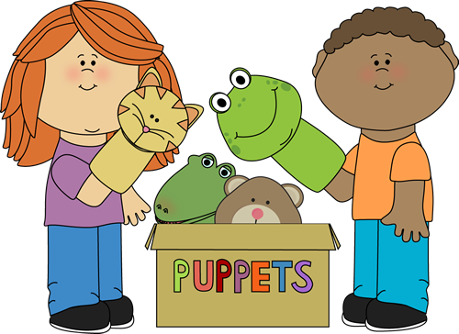

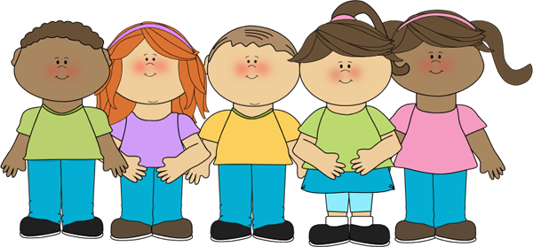

Physical Development

Communication and language.

Class 1 Staff

Mrs C Skermer

Miss H Chadwick

Mrs K Lothrop

Mrs G Phillips

Our curriculum is based on the EYFS strategy. We encourage the children to explore and learn through play.

Class 1 Autumn 2020

Developing fine and gross motor skills.

Using sensory regulation activities.

Enjoying mark-making.

Expressing preferences.

Playing alongside others.

Sharing joint attention.

Understanding the emotions happy and sad.

Mixing colours.

Creating patterns.

Dance.

Music.

Exploring using all the senses.

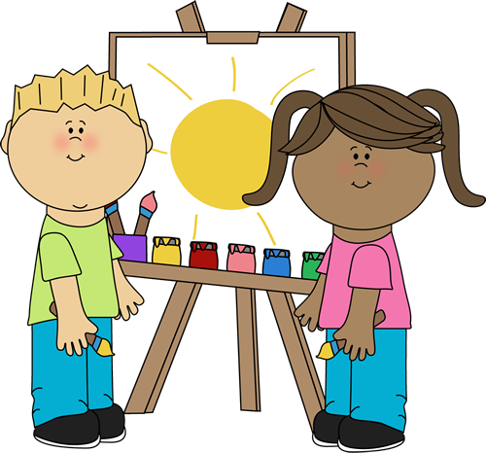

Using technology- cause and effect.

Harvest, Divali, celebrations and Christmas

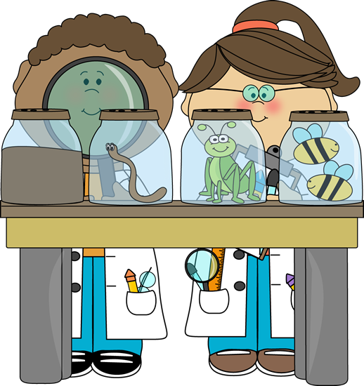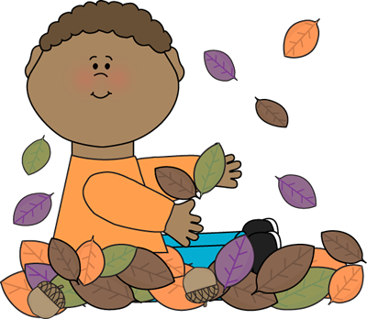

Counting and recognising numbers.

Becoming familiar with simple shapes.

Matching patterns.

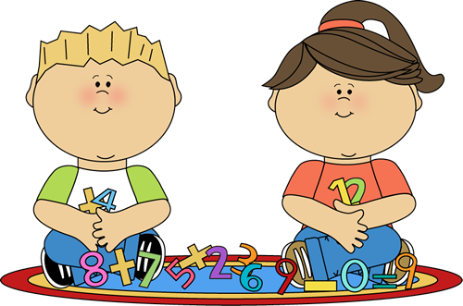

Personal, Social and emotional development.

Expressive Arts

Knowledge and understanding of the world.

Mathematics

Literacy

A Unique + Positive + Enabling = Learning and

child relationships environments development