Green Lane School EYFS Curriculum
EYFS Intention
We aim for children following our Early Years Curriculum to develop their knowledge, skills and understanding through a combination of both play-based learning and focused teacher led sessions. We aim to equip them with the skills they need to form a firm foundation for future learning. We strive to support children to become enthusiastic, independent learners.

EYFS curriculum implementation
Children in our Early Years classes follow the Early Years Foundation Stage Curriculum (EYFS). The EYFS Curriculum has seven main areas of learning:
- Personal, Social and Emotional Development
- Communication and Language
- Physical development
- Literacy
- Mathematics
- Understanding the world
- Expressive Arts and Design
A practical, learning through play approach, based on the needs and interests of our children, is delivered mainly through topic based planning.
We teach children in a variety of ways including individually, in small groups and in whole class groups. Through a combination of teacher input and continuous provision opportunities, learning is planned to encourage children to develop their learning independently through exploration and challenge.
The “Characteristics of Effective Learning” are at the heart of the Early Years Curriculum and explore the different ways in which children learn. They highlight the importance of playing and learning, active learning and thinking critically. All the learning experiences we plan for, allow children to utilise and develop these skills.
Through the utilization of our indoor and outdoor learning environments, children access stimulating and exciting learning opportunities that are relevant to their individual needs.

Impact of the EYFS curriculum
We expect to see excellent progress for all of our pupils taking into account their starting point and their abilities. This impact will be measured and monitored by way of regular assessments and recorded in pupils individual learning journals on EFL.

Long Term Topics
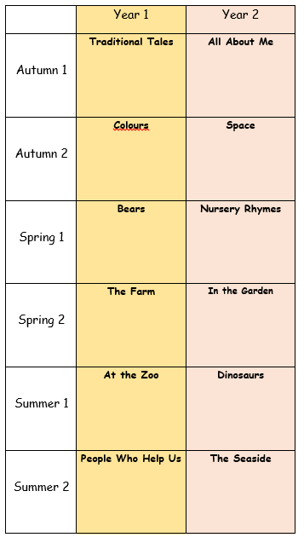
All lessons in the EYFS in Green Lane School are intended to develop a child’s learning skills, enabling them to acquire new knowledge and demonstrate their understanding through 7 areas of learning and development.

Children should develop the 3 prime areas. These are:
- Communication and language;
- Physical development; and
- Personal, social and emotional development.
These prime areas are those most essential for a child’s healthy development and future learning.
As children grow, the prime areas will help them to develop skills in 4 specific areas. These are:
- Literacy;
- Mathematics;
- Understanding the world; and
- Expressive arts and design.
These 7 areas are used to plan a child’s learning and subsequent activities. We ensure that planned activities are suited to each child’s unique needs. Children in the EYFS learn by playing and exploring, being active, and through creative and critical thinking which takes place both indoors and outside.
Mathematics
Mathematics is all about understanding and using shape, space and measures and numbers to solve everyday problems. Helping children to enjoy mathematics is important so that children realise that mathematics is a way of finding things out and solving problems.
Each year activities and challenges will focus on:
Number- counting, ordering, number formation, addition and subtraction, sorting, pattern, position, mathematical language, time- times of the day, days of the week, months of the year and seasons, money, capacity, size and shape.

Some aspects of number work and shape work must be taught each half term and every academic year the above mathematics topics must be covered.

Literacy
Phonics
Phonics will be taught daily in the EYFS. Pupils access daily phase one phonics activities and will move on to follow Essential Letters and Sounds or POPAT depending on the needs of each pupil. The class teacher will assess the pupils regularly and record their progress in phonics.
English
Literacy development involves encouraging children to read and write, both through listening to others reading, observing them writing, and beginning to read and write themselves. Children must be given access to a wide range of reading and writing materials to ignite their interest.
Literacy is made up of two aspects:
- Reading
- Writing

Each year activities and challenges will include
Fine and gross motor skill development
Mark-making
Writing
Reading
Text studies to include; fiction texts, non-fiction texts, rhymes, traditional stories, cultural stories, action verses, print in the environment, labels and captions and information texts.

Physical Development
How children gain control of their bodies, develop independence skills, learn about keeping themselves active and healthy and how they use equipment and materials successfully and safely is the ethos behind Physical Development.
Pupils will have access to a wide range of fine and gross motor activities, both indoors and outdoors. Some of our pupils will have access to OT activities, sensory diets and physiotherapy exercises which will help them to make progress towards their individual targets. All of our pupils have access to a weekly dedicated P.E. lesson led by the Warrington Wolves Foundation SEND sports coaches. Pupils may also access the sensory integration room, or hydrotherapy room if appropriate to their needs.

PSED and Communication
Personal, Social and Emotional Development is one of the prime building blocks of success in life and this can be achieved by supporting children to interact effectively and develop positive attitudes to themselves and others. This requires positive feedback and the modelling of appropriate behaviour, in their early years, this is a very important area of learning. We want the children to develop a sense of emotional well-being and a confidence in themselves, build on their awareness of the needs and feelings of others and ensure that their experiences of making relationships with both adults and peers is positive, warm and special. We endeavour to create a safe and nurturing environment so that our children feel secure and respected.
We hope that the children will be eager to learn, explore and develop their independence but still feel confident to ask for help. We hope that they will learn to take turns and share fairly, and show consideration for others and the environment. By giving the children greater choice and allowing them to foster this in a safe and secure environment this will in turn encourage and foster their own self esteem.
Children’s communication is supported through a wide range of strategies, dependent on individual need. Many of our children are supported by SALT and have programmes that are used in school. Some strategies used to support our children’s communication include intensive interaction, PECS and Makaton.
SCERTS
In addition pupils in the Early Years ASD discrete provision class will take part in the SCERTS programme.
Communication and language development involves giving children opportunities to speak and listen in a range of situations, and to develop their confidence and skills in expressing themselves.
By focusing on listening and attention, and separating receptive language (understanding) from expressive language (speaking).
Developing individuals communication skills is of paramount importance to all that we do in the EYFS at Green Lane School.
All pupils in the EYFS will also take part in Attention Autism sessions to develop joint attention.

KNUW and Expressive Arts
Teachers are to plan activities related to each topic that encourage pupils learning and development in the areas of expressive arts and knowledge and understanding of the world. This involves guiding children to make sense of their physical world and their community through opportunities to explore, observe and find out about people, places, technology, and the environment.
Expressive Arts and Design involves supporting children to explore and play with a wide range of media and materials, as well as providing opportunities and encouragement for sharing their thoughts, ideas, and feelings through a variety of activities in art, music, movement, dance, role-play, and design and technology.
Children’s learning and development in this area will be enhanced as they sing songs, make music and dance, and experiment with different ways of doing these activities. As they develop they will use and explore a variety of materials, experimenting with colour, design, texture, shape, and form.

