
Home Learning Activities
Class: P2 Week: 2 Week Beg: 18th January 2021
Introduction to the week from Miss White https://www.loom.com/share/6138ca6a73994775aae4cba22b237d7a (Please use google chrome to access this if it does not work)
Maths  https://wrm-13b48.kxcdn.com/wp-content/uploads/2020/12/Year-2-Spring-block-2-Statistics.pdf  Here is a link to the White Rose Maths Statistics pages that we also follow in P2.  I have also sent out some Venn and Carroll diagram activities to use as an additional resource. | Maths  Pictograms – I have sent out some sheets for you to work on over the next couple of days.  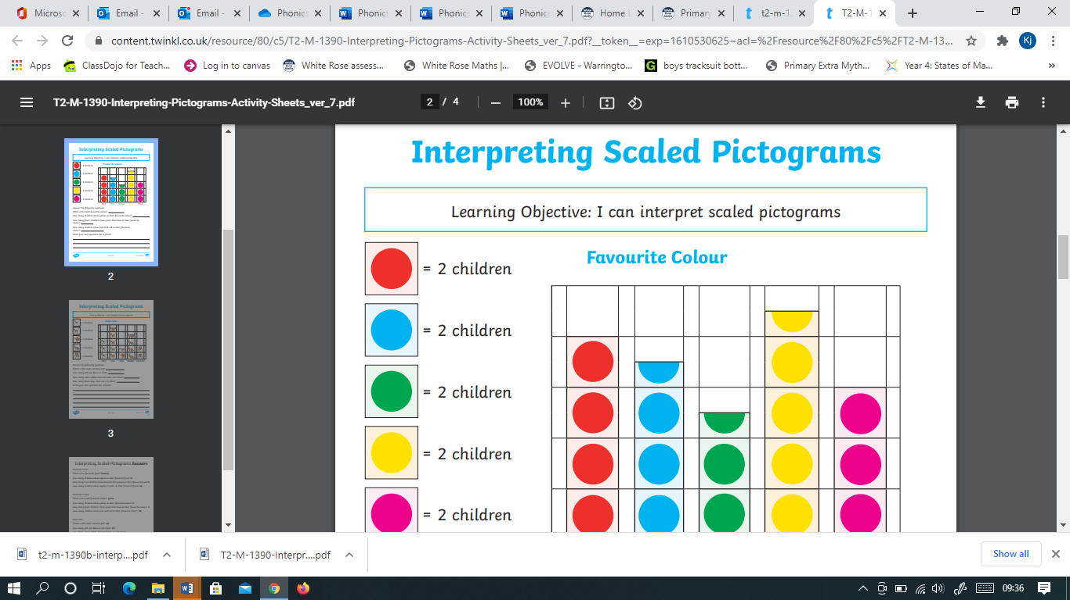 | Maths  https://www.numeracyworkout.co.uk/legacy/pictograms.php  Numeracy work out (Not Numeracy warm up)  User – greenlane  Password – Total 57 | Maths  https://www.topmarks.co.uk/maths-games/daily10  X Tables please and I have sent you a x tables challenge page.  How many can you do? | Maths  https://www.bbc.co.uk/bitesize/articles/zr23c7h  Odd and even numbers activities  If this is too easy try…  https://www.bbc.co.uk/bitesize/articles/zgdstrd  Division with remainders.  Try bigger numbers and challenge yourself if you can.
English  Work on learning 10 new words from the spelling lists that have been sent home – Write sentences for each of your words that include a connective and adjectives. | English  https://www.youtube.com/watch?v=P3dfdZzc2G0  A different version to listen to today.  Class Novel – Charlie and the chocolate Factory.  Chapter 2 work continued this week.  I have sent out a worksheet that has an interesting challenge for you. | English  Answer the comprehension questions about Chapter 2. I have included these in your pack.  Extend this by writing down what has happened in Chapters 1 and 2. | English  Adverbs activity sheet.  An adverb tells us how we do something e.g. Walked slowly | English  https://www.bbc.co.uk/bitesize/articles/zcxnm39  Describing a setting.  You can try to use adjectives and feelings to describe where Charlie and his family live.  Create a setting of your own – draw and describe.
PSHE  Well being activity – I can goals. Think about each statement and colour in. | PSHE  Play a game with someone in your house. | PSHE  Changing adolescent bodies from our Spring term plan.  Use the sheet provided to label changes that happen during puberty.  I have included a guidance sheet for you to use. We have discussed all of these changes in school. | Computing  Visit the cbc.ca/kids/games  website and play on the games | Computing  www.discoveryeducation.co.uk  Log on to Espresso – Key stage 2 Computing. Other subjects are available to explore too.  Username: student7070  Password: green3
PE  Walk up and down stairs 10 times. | PE  Go for a walk/run/walk the dog. | PE  Do a circuit – 20 press ups, 20 sit ups, 20 burpees, 20 squats. Repeat 3 times. | PE  Do some jobs in the garden or house for 20 minutes. | PE  Cosmic kids Yoga
Geography  https://www.bbc.co.uk/bitesize/topics/zvsfr82/articles/zjk46v4  Time zones clip and a quiz | Art  Everyday objects – Can you use everyday objects to create art work? You could try string, bottle tops, paper clips etc. Have fun!  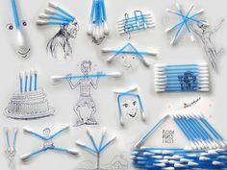 | History  https://www.bbc.co.uk/bitesize/topics/z8w3n9q/articles/zq36qfr  Crime and punishment in Ancient Rome.  Create a fact sheet. | SCIENCE  Earth and Space  https://www.bbc.co.uk/bitesize/topics/zwccwmn/articles/zqbxb82  What is the Earth?  https://www.bbc.co.uk/bitesize/topics/zdrrd2p/articles/zqn7y4j  What is the sun?  Write down what you have found out. | DT  https://www.bbc.co.uk/bitesize/topics/zxhtyrd/resources/1  Lots of clips to help us to learn about electricity.

