Week | Literacy  -That’s Not my Dinosaur  -Harry and his Bucketful of Dinosaurs  -Daily phonics/motor skills | Maths  Song –5 Little Dinosaurs  -10 Little Dinosaurs  Book – Ten Little Dinosaurs | Attention Autism | Topic | Food Tech | Sensory
1 | Daily shared read  Sensory story  Sensology | Counting 0-10  Numbered buckets, eggs, dinosaurs | Stage 2 – Meteor crashes | -Dinosaur fossils (salt dough)  -pasta skeletons | Dinosaur eggs (rice crispie cakes) | -Dinosaur swamp (gloop)
2 | Daily shared read  Sensory story  Sensology | Shape dinosaurs | Stage 2 – Dino egg splat | -Dinosaur hunt around the track  - | Dinosaur feet biscuits | -Frozen dinosaur eggs
3 | Daily shared read  Sensory story  Sensology | Comparing different length dinosaurs, bones, dinosaur feet | Stage 2 – Bicarbonate soda egg melt to reveal | -Volcano eruption experiment | Ice cream cone volcanos | -Green rice, dinosaur sensory bin
4 | Daily shared read  Sensory story  Sensology | Ordering dinosaurs by size/sorting big and small | Stage 2 – Popping eggs (paint balloons) | -Fossil discovery with brushes | Dinosaur fruit shapes | -Fossil ‘dig’ sensory bags
5 | Daily shared read  Sensory story  Sensology | Sequencing dinosaurs 0-10. | Stage 2 – Flour shake dinosaur shapes | -Design a dinosaur DT | Dinosaur pizza toast | -Dinosaurs in shredded paper
6 | Daily shared read  Sensory story  Sensology | Representing groups of dinosaurs with numeral | Stage 2 – Dinosaur slime ribbons | -Dinosaur | ‘Dig for Dino’ cups | -Dinosaurs in green foam
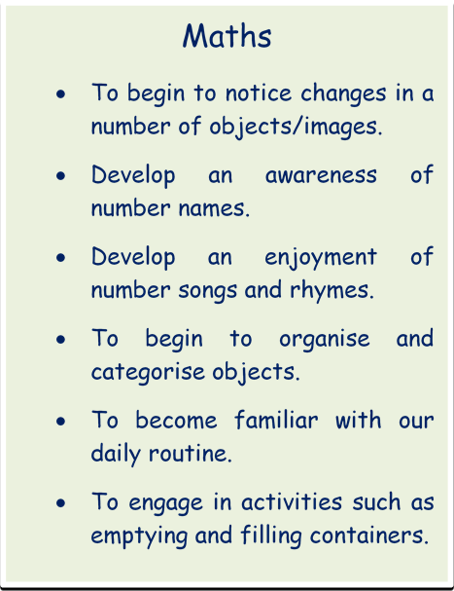
Expressive Arts/ Physical development
- To explore and experiment with a range of media through sensory exploration.
- To enjoy the experience of mark making, using a variety of media and materials.
- To take part in a variety of musical experiences.
- To take part in daily fine/gross motor activities e.g. threading/ribbon dance.
- To begin to explore tools and use these for purpose.
- To further develop our independence and self help skills.

Phonics
- To develop listening and attention skills.
- To begin to listen to familiar sounds.
- To begin to pay attention to a dominant stimulus.
- To listen to and begin to enjoy rhythm and rhyme activities.
- To blend and segment CVC words and to recognise none decodable words
- To hear the initial sound in words.
English (C&L and Lit)
- To begin to develop an interest in familiar books, stories and rhymes.
- To begin to handle books with interest.
- To begin to develop an interest in mark making, using a range of media.
- To continue to develop listening and attention skills.
- To engage with topic work linked to familiar stories.

